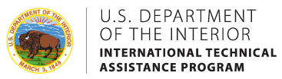
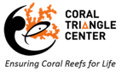
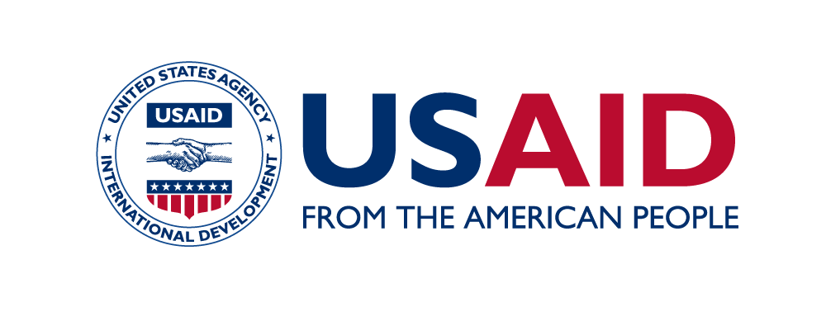
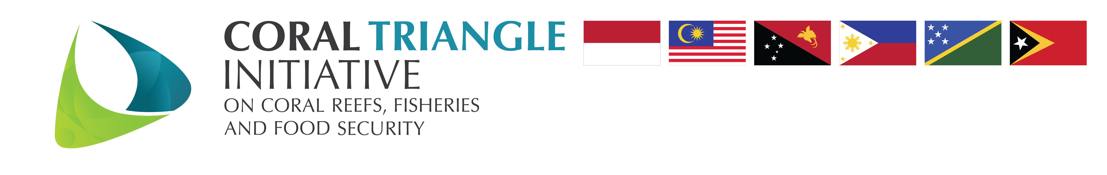

WOMEN’S INTERGENERATIONAL LEADERSHIP LEARNING FORUM
Commencing November 13-17, 2017

For collective change in the area of coastal and marine conservation
in the Coral Triangle

Application Form

Please fill in your personal information:

Title:
First name:
Other names:
Last name:
Date of birth:
Email:
Phone number:
Skype ID:
Please indicate if you are applying as a mentor or mentee
Country of origin:
Country of residence:
Spoken language(s):
Describe your level of fluency in the English language (high level of proficiency necessary due to interactive and participatory design of program.
Education:
Institution:
MPA or other institution associated with:
Current position:
Description of your responsibilities:
Supervisor name & contacts:
List capacity building activities you have undertaken:
List other leadership development activities you have undertaken:

Please answer the following questions. There are no right or wrong answers, they only require your honest reflection. Please limit your answers to 3 sentences or less.

1. Personal statement on the meaning of leadership

2. Interest in and anticipated outcome from the Leadership Learning Forum

3.Example of personal experience of leadership (role models for leadership)

4.Global example of leadership and the qualifiés that exemplify and define leadership (scaled-up models of leadership)

5. An example of a collaborative leadership model that has affected change in addressing coastal or marine conservation challenges (real or idealized)

6. What do you believe you have to gain from engaging in a mentor/mentee relationship?

7. What kind of value do you see in, or what do you hope to gain from, an intergenerational learning experience?

Please return this questionnaire together with the other required documents (C.V. & letter of support from supervisor) by October 09, 2017 to:
Hesti Widodo, Coral Triangle Center, email: hwidodo@coraltrianglecenter.org

Upon your acceptance into the program, you will be asked to develop in advance or bring to the Learning Forum the following 3 items:
- SHARED ISSUES: Develop a list of what you believe to be the three most compelling and pervasive coastal or marine resource management issues across the Coral Triangle region, including a brief explanation (3-5 sentences for each issue) why you think these issues should be considered a priority. Please submit these to us one week in advance of the Learning Forum Workshop.
- CONSERVATION CHALLENGE FOR YOUR MPA: Using the provided template, please develop an issue characterization of the single greatest Conservation Challenge for your MPA. Solving this Conservation Challenge will be the focal point of your practicum for the next 9-10 months, so please pick a Challenge that you feel strongly about. We will spend time during the Learning Forum workshop further developing and refining the issue(s) surrounding your Conservation Challenge. Please submit these to us one week in advance of the Learning Forum Workshop.
- BRING TO LEARNING FORUM WORKSHOP: Please bring a tasting sample for everyone of a traditional food from your country.

