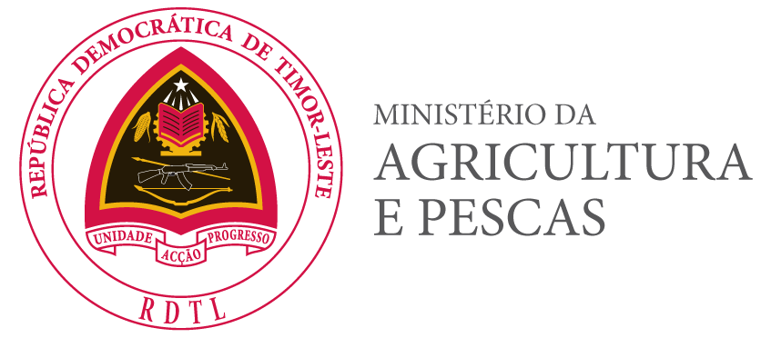
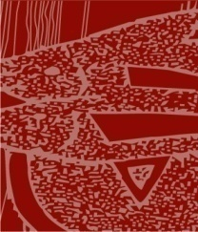
Gabinete do
Director Geral das Pescas

Remarks of Director General for Fisheries, Ministry of Agriculture and Fisheries (MAF) Timor-Leste,
at the Seventh Ministerial Forum of CTI-CFF
(in Dusit Thani Manila Hotel, Makati City Manila
– Philippines, 14 December 2018)

Excellencies,
Distinguished delegates,
Ladies and gentlemen,

First of all, on behalf of the Ministry of Agriculture and Fisheries of Democratic Republic of Timor-Leste, I would like to convey my sincere gratitude to the National Coordinating Committee (NCC) of the Philippines, the Government Republic of the Philippines and the Coral Triangle Initiative Regional Secretariat make the event happen. It is a great honor for me to deliver a statement on behalf of His Excellency Joaquim José Gusmão dos Reis Martins, Minister of Agriculture and Fisheries who actually would like to attend, but unfortunately, due to other urgent commitments, he could not be present here today with all of us.

Distinguished delegates,
Ladies and gentlemen,

In this very especial event, Timor-Leste would like to re-afirm our commitment to work with the CTI-CFF Regional Secretariate for the conservation of the marine environment and the marine ecosystem include; sea grass, mangrove and coral reefs in very sustainable of fsheries resources both in the national territory and in the coral reefs triangle region. Timor Leste also firmly to continue to partnership with CTI since the organisation is regional in nature with strong commit for the envirnmnetal conservation and for the sustainability of fisheries resources, food security and enhanced household economy. Last but not least Timor Leste prefere Coral Triangle Initiative as partners with in future.

Distinguished delegates,
Ladies and gentlemen,

To conclude my statement, I would like to reiterate that the Government of Timor-Leste has a commitment to adopt the Regional Plan of Action for CTI-CFF into our National Action Plan. We are ready to sign a joint ministerial statement, and flexible to appreciate, approve and adopt the provisional agenda of the Seventh Ministerial Forum of CTI-CFF as scheduled. The Government of Timor-Leste is committed to achieve sustainable development by 2030 and hope for the same thing in our region. For that I would like to express our sincerely appreciation for the support from international friends, especially CT 6 member countries, in implementing sustainable management of marine and coastal resources to benefit our generation, while conserving those resources for future generation to meet their demand. With our joint efforts and collective actions, I believe we can achieve our joint objective and leave this world a better place for our next generation.

Thank you for your kind attention!!!!!!

