DRAFT
PROVISIONAL AGENDA
The 7th CTI-CFF Ministerial Meeting (MM-7)

14 December 2018
Makati City, Philippines
INFORMATION

Venue:

The 7th Coral Triangle Initiative on Coral Reefs, Fisheries and Food Security Ministerial Meeting (MM-7) will be held at Dusit Thani Manila Hotel, Makati City, Philippines. The management of the said Hotel may be contacted at the following:

Address: 1223 Epifanio de los Santos Ave., Makati City, Metro Manila, Philippines

Website: https://www.dusit.com/dusitthani/manila/
Tel. No. +63 (2) 238 8888
Fax No. +63 (2) 238 8800
Email: dtmn@dusit.com
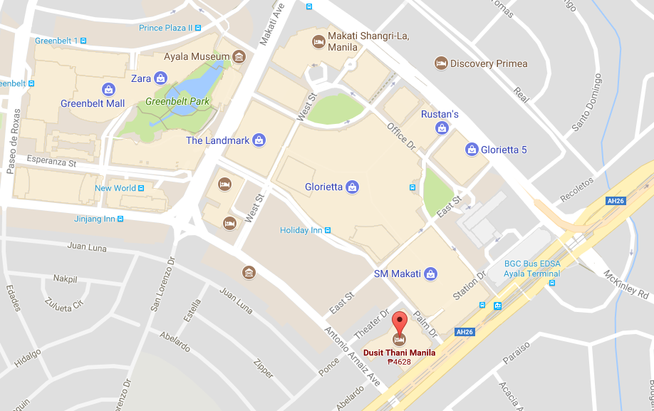

Organizing Committee of National Coordination Committee (NCC) of the Philippines

NCC Philippines  Name: Ms. Nilda S. Baling  Position/Department: Supervising Ecosystems Management Specialist  Email:nildasbaling@yahoo.com  Mobile No: +63 9088935863 | NCC Philippines  Name: Mr. Pablo G. de los Reyes Jr.  Position/Department: Senior Ecosystems Management Specialist  Email: ogie821@gmail.com  Mobile No: +63 9661795022
NCC Philippines  Name: Ms. Carina Manlapaz  Position/Department: Ecosystems Management Specialist  Email: carinamanlapaz@gmail.com  Mobile No: +63 9276066971 | NCC Philippines  Name: Mr. John Erick Avelino  Position/Department: Ecosystems Management Specialist  Email: avelinojohnerick@gmail.com  Mobile No: +63 9674004621

OBJECTIVES OF THE 7TH MINISTERIAL MEETING

- To open the 7th Ministerial Meeting;
- To accept and endorse the Chairman Summaries of SOM-13 and SOM-14;
- To accept and endorse 2017-2018 Council of Ministers’ Chairmanship Report;
- To accept and endorse way forward for CTI-CFF based on CT6 Member Parties and Development Partners input in the form of the development of the Regional Plan of Action 2.0;
- To accept and adopt the Chairmanship and Vice-Chairmanship of CTI-COM for period of 2019 – 2020 to Solomon Islands and Timor-Leste;
- To accept and endorse the audit reports and related financial statements;
- To endorse the appointment process for the positions of Executive Director and Deputy Executive Director for Corporate Services;
- To endorse the 2019 Organization Chart of the Regional Secretariat;
- To accept and endorse Wildlife Conservation Society (WCS) as CTI-CFF new Development Partner;
- To endorse and adopt the establishment of an "Internal Resource Committee";
- To endorse the proposed plan for the development of the Regional Plan of Action (RPOA) 2.0; and
- To endorse and sign the Joint Ministerial Statement.

PROVISIONAL AGENDA
The 7th Ministerial Meeting (MM-7)
14 December 2018
Dusit Thani Manila Hotel, Makati City, Philippines

Chair: Gen. Roy Agullana Cimatu
Secretary of Department of Environment and Natural Resources of the Philippines

No | ACTIVITY | TIME | ACTION
SESSION 1. OPENING CEREMONY BY HOST COUNTRY
1.1 | Arrivals | 08:00 - 08:30 | Arrivals of guests / delegations by Organizing Committee
 |  |  | Arrival of VIPs by Organizing Committee
 |  |  | Arrival of CTI Ministers by Organizing Committee
1.2 | Opening Ceremony | 08:30 - 08:35 | Welcome Remarks by NCC Philippines
 |  | 08:35 - 08:40 | Opening Address by Hon. Roy A. Cimatu; Chair of Council of Ministers
1.3 | Round of Introduction | 08:40 - 08:50 | Ministers / Heads of Delegation
1.4 | Photo Session | 08:50 – 09:00 | Chair of COM & Organizing Committee
 | Coffee Break | 09:00 - 09:15 | Organizing Committee
SESSION 2. ADOPTION OF PROPOSED MEETING AGENDA
2.1 | Deliberation and adoption of proposed meeting agenda | 09:15 - 09:25 | Chair of COM (Philippines)
SESSION 3. REPORT BY CHAIR OF CSO & COM
3.1 | 2017 - 2018 COM Chairmanship Report | 09:25 - 09:40 | Chair of COM
SESSION 4. STATEMENT BY INTERIM EXECUTIVE DIRECTOR OF CTI-CFF REGIONAL SECRETARIAT
4.1 | Statement on CTI-CFF activities & plans for stronger presence in international agenda | 09:40 – 09:50 | Interim Executive Director (Regional Secretariat)
SESSION 5. MESSAGES BY MEMBERS OF COM
5.1 | Messages from Ministers & Heads of Delegation | 09:50 - 10:20 | Ministers & Heads of Delegation shall convey messages and call for actions in areas of critical interest. (each member is allocated 5 min)
SESSION 6. PARTNERS' DIALOGUE
6.1 | Partners' Dialogue with CTI COM | 10:20 - 10:50 | Partners’ Dialogue  “What must the CTI and RPOA 2.0 deliver?”  The world is a competitive place. Agendas, resources, attention. The CTI recognises its past successes but does not shy away from the need to evolve to meet the current and emerging demands of the region that it serves. In that spirit this is a discussion to help shape that evolution by understanding the viewpoint of its key decision makers. Participants are invited to comment on inter alia:  - What is the specific value proposition of the CTI to your country going forward?  - Why is it important to you to continue supporting CTI?  - What can CTI do that other fora can’t?  - What other ministries/agencies/institutions do you flag it with and why should they care?  - What measurable thing (s) should we do in the next 24 months to show its value to your country?
SESSION 7. MATTERS FOR ADOPTION
7.1 | Acceptance Remark by Wildlife Conservation Society (WCS) as CTI-CFF new Development Partner | 10:50 – 10:55 | Dr. Noviar Andayani  Country Director of Wildlife Conservation Society-Indonesia Program
7.2 | Deliberation and Adoption | 10:55 – 11:10 | Chair of COM shall table decisions for adoption
SESSION 8. SIGNING OF THE JOINT MINISTERIAL STATEMENT
8.1 | Signing of the Joint Ministerial Statement | 11:10 -11:15 | CT6 Ministers and Heads of Delegation
SESSION 9. HANDOVER OF CHAIRMANSHIP
9.1 | Handover CTI COM Chairmanship from Philippines to Solomon Islands | 11:15 - 11:30 | Remarks by outgoing CTI COM Chair (Philippines)
 |  |  | Ceremonial Handover of CTI COM Chair and Vice Chair
 |  |  | Remarks by the new CTI COM Chair (Solomon Islands)
SESSION 10. CLOSING SESSION
10.1 | Brief closing salutations | 11:30 – 11:35 | Host Country closing remarks
END OF THE 7th CTI-CFF MINISTERIAL MEETING
 | Press Conference | 11:35 – 12:00 | Organizing Committee
 | Lunch | 12:00 onwards | Organizing Committee

