CTI-CFF Regional Secretariat
Annual Report 2017

© Coral Triangle Initiative for Coral Reefs, Fisheries and Food Security (CTI-CFF) Regional Secretariat, 2017.

This report can be viewed from (insert link)

Prepared by: CTI-CFF Regional Secretariat

Comments and enquiries on this document should be addressed to:

CTI-CFF Regional Secretariat
Jl. A.A. Maramis Kayuwatu, Kairagi II
Manado, North Sulawesi 95254
Indonesia

Telephone: +62 431 724 1927, +62 4317 242 026
Email: regional.secretariat@cticff.org
Web: www.coraltriangleinitiative.org

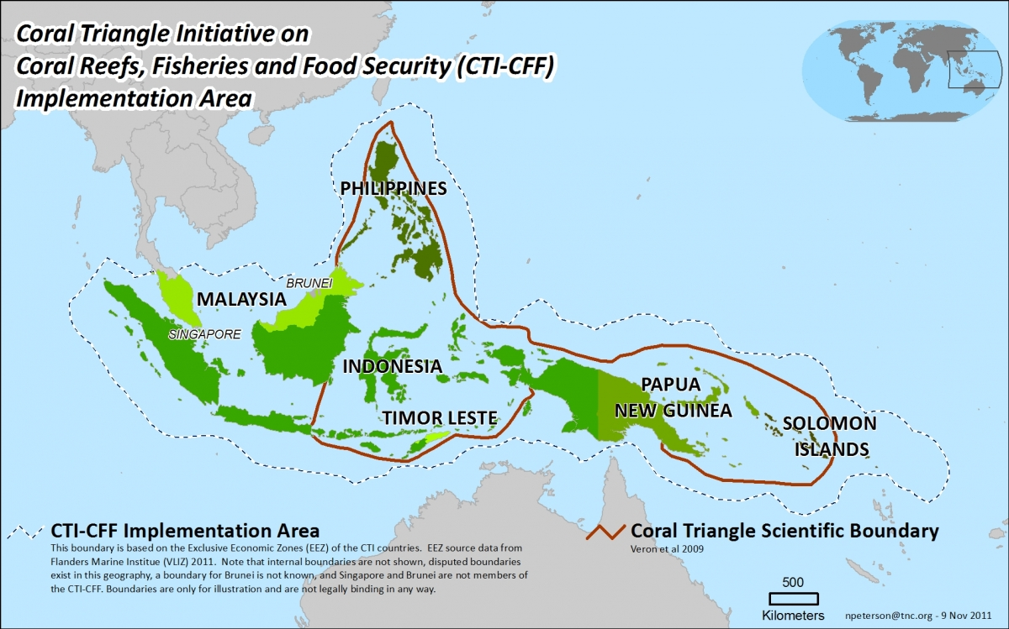
Figure 1. Coral Triangle Regional Boundary Map

The Coral Triangle Initiative for Coral Reefs, Fisheries and Food Security Regional Secretariat
The Coral Triangle Initiative for Coral Reefs, Fisheries and Food Security (CTI-CFF) Regional Secretariat (interim) was created during the First CTI-CFF Senior Officials Meeting in Bali in December 2007. The permanent Regional Secretariat was officially established with the appointment of the first Executive Director in April 2015, where the office is located in Manado, Indonesia.
The Mandate

It is mandated to promote regional cooperation, sharing of lessons, and facilitate learning across the six Coral Triangle countries - Indonesia, Malaysia, Papua New Guinea Philippines, Solomon Islands and Timor-Leste. The Regional Secretariat also coordinate and monitors the progress in achieving the CTI-CFF Regional Plan of Action goals. Its main activities cover the following areas: Technical Working Groups, Governance Working Groups, Cross Cutting Themes, Technical Program, Corporate Services (e.g. organizational development, capacity development). It also serves as the main liaison and for all CTI-CFF official functions such as the bi-annual CTI-CFF Senior Officials Meetings and the annual CTI-CFF Ministerial Meetings

The Mission Statement
The CTI-CFF Regional Secretariat’s mission is to initiate, to coordinate, and to facilitate communication and activities across CTI-CFF Member Parties (Indonesia, Malaysia, Papua New Guinea, Philippines, Solomon Islands, and Timor-Leste). These efforts will implement the goals and objectives of the Regional Plan of Action to address emerging and transboundary issues on sustainable management of marine resources and food security in the Coral Triangle Region.

Contents
The CTI-CFF Regional Secretariat
Mandate
Mission
Message from Executive Director
Executive Summary
List of Tables
List of Figures
Part I. Overview
The Coral Triangle Region
The CTI-CFF
The Regional Plan of Action (RPOA)
The Host Country Agreement (HCA)
The Regional Secretariat
Management and Staff of the Regional Secretariat
Financial and Administrative System
Part II. Regional Activities
- Technical Working Group
A.1. Seascape Working Group
A.2. Ecosystem Approach for Fisheries Management Working Group
A.3. Marine Protected Areas Working Group
A.4. Climate Change Adaptation Working Group
A.5 . Threatened Species Working Group
B. Governance Working Group
B.1. Coordination Mechanism Working Group
B.2. Financial Resources Working Group
B.3. Monitoring and Evaluation Working Group
- Cross-cutting themes
C.1. Capacity Building
C.2. Local Government Network (LGN)
C.3. Regional Business Forum (RBF) and Business Advisory Council (BAC)
C.4. Scientific Advisory Group (SAG)
C.5. Women’s Leaders Forum (WLF)
- Technical Program
D.1. The CTI-CFF University Partnership
D.2. Program initiation and potential collaboration with other international / regional organization
D.3. CTI-CFF and International Community
D.4. Other Activities of Technical Program
Part III. National Activities
- Indonesia
- Malaysia
- Papua New Guinea
- Philippines
- Solomon Islands
Part IV. Development and Government Partners
Part V. Communication and Outreach Activities
Part VI. Financial Performance
Part VII. 13th Senior Officials Meeting
Appendices
Appendix A: 2017 CTI-CFF Staff
Appendix B: 2017 CTI-CFF NCC Focal Points
Appendix C: Development and Government Partners
Appendix D: 2017 Newsletters
Acronyms and Abbreviations

List of Figures
Figure 1. Coral Triangle Regional Boundary Map
Figure 2. USAID Support Program Objectives and Activities

List of Tables
Table 1. Chair and Co-Chair of the Technical Working Groups
Table 2. Activities of the Seascapes Working Group
Table 3. Focal points of the Seascapes Working Group from CT6 member countries
Table 4. Activities of the EAFM Working Group
Table 5. Focal points of the EAFM Working Group from CT6 member countries
Table 6. Focal points of the MPA Working Group from CT6 member countries
Table 7. Focal points of the MPA Working Group from CT6 member countries
Table 8. Focal points of the MPA Working Group from CT6 member countries
Table 9. Status of the Deliverables of CMWG
Table 10. Status of the deliverables of the FRWG
Table 11. Status of the Deliverables of the MEWG
Table 12. 2017 Activities of the RBF
Table 13. 2017 Activities of the WLF
Table 14. Status of Indonesia’s NPOA
Table 15. Malaysia’s Partners and Status of Partnership
Table 16. Malaysia’s 2017 Activities
Table 17. Status of Malaysia’s NPOA
Table 18. Papua New Guinea’s Partners and Status of Partnership
Table 19. Status of Papua New Guinea’s NPOA
Table 20. Philippines’ Partners and Status of Partnership
Table 21. Other Activities Implemented and Supported by the Philippines
Table 22. Status of Philippines’ NPOA
Table 23. Solomon Island’s Partners and Status of Partnership
Table 24. Status of Solomon islands NPOA
Table 25. Projects with Timor-Leste’ Partners
Table 26. Status of Timor Leste’s NPOA
Table 27. 2017 Fund Utilization of CTI-CFF Regional Secretariat
Table 28. Country Contribution from 2014-2017 (in USD)
Table 29. Breakdown of Funding Support Received from Development Partners from 2015-2017 and Projected
Funding Support from 2018-2018

Message from the Executive Director

The year 2017 had been a productive year for the CTI-CFF Regional Secretariat. The Regional Secretariat has been unceasing in its efforts to provide technical support and coordination through its Technical Working Groups, Governance Working Groups, Cross-Cutting Themes and Technical Program to realize the goals of the RPOA.

We have also been aggressive in pursuing new partnerships, particularly with universities with the aim of further advancing marine and coastal conservation, sustainable fisheries, and food security through capacity building, research, and outreach activities within CT6 member countries under the CTI framework.

Our efforts have not been futile since CTI-CFF have been recognized by international bodies under UN which will pave way for more cooperation with international organizations.

Before the year ended, we welcomed a new addition to the Regional Secretariat. Dr. Sharifah Nora Ibrahim was appointed as the new Deputy Executive Director (DED) for Program Services. As DED for Program Services, she will manage the three divisions namely, Technical Program (TP), Technical Working Groups (TWGs); and Governance Working Group and Cross Cutting Themes.

In the year ahead, I am looking forward to continue implementing and supporting activities that will help realize the goals of the RPOA through the support and cooperation of our partners. We will also intensify our efforts to further advance and promote marine conservation and protection of the Coral Triangle.

I thank all the CTI-CFF Regional Secretariat staff for their commitment, hard work, and dedication which enabled us to deliver our targets for the year. I thank our partners, for their continuing support, confidence, and trust in CTI-CFF Regional Secretariat.

We assure our stakeholders that we will efficiently use our resources to be able to advance and sustain marine and coastal conservation and protection.

DR. WIDI A. PRATIKTO
Executive Director

Executive Summary
The Annual Report highlighted the programs of activities undertaken by the CTI-CFF and Regional Secretariat in the year of 2017. In pursuing the RPOA goals, the activities under TWGs, GWGs, CCT, and Technical Programs have shown, gradually but steady, significant progress.

The Regional Secretariat coordinated and consolidated the activities of the TWGs, GWG, CCT, and Technical Program with a view of synergizing and aligning the CTI-CFF activities. Efforts were also pursed to initiate engagement, strengthen current partnership, and explore potential cooperation at the national, regional and international levels. Cooperation arrangement and collaborative efforts with U.S. Department of Interior – International Technical Assistance Program (USDOI-ITAP), U.S. Agency for International Development/Regional Development Mission for Asia (USAID/RDMA), USAID Oceans and Fisheries Partnership (USAID Oceans) are on the pipeline. The support from USAID will be from 2017-2019 comprising seven activities, including Public-Private Partnership engagement. The objective of this collaborative effort is to strengthen regional cooperation to combat IUU fishing, promote sustainable fisheries, and conserve marine biodiversity in the Asia-Pacific region. Moreover, the CTI-CFF also has the Wildlife Conservation Society as its new development partner. This partnership is hoped to provide future collaboration in protected areas, species conservation, integrated coastal management, climate change adaptation, community-based resource management and the like.

Further, the Regional Secretariat entered a Memorandum of Understanding with 13 universities from CT6 member countries with the goal of promoting marine conservation, sustainable fisheries, and food security through educational and professional accredited capacity building, research, and outreach activities within CT6 member countries under the CTI framework.

At the international level, the CTI-CFF and Regional Secretariat has gained considerable recognition from the different bodies of the UN such as the United Nations Department of Economic and Social Affairs (UNDESA) and the United Nations Industrial Development Organization (UNIDO). The Regional Secretariat was invited and sponsored by the UN and was given a significant role as a speaker and panelist in various events. These opportunities signified more steps ahead in pursuing international recognition, which would open the pathway for further possible cooperation with international bodies under the UN.

The Annual Report also presents the progress made by the member countries in the implementation of their respective National Plan of Actions. Though significant gains had been achieved, there is still the need for some member countries to review and finalize their financial structure to support the implementation of their respective NPOAs. Development partners’ assistance to complete this task and also to provide technical assistance to effectively implement programs and activities on the areas of seascapes, EAFM and threatened species are still crucial.

The significant investments of the CT6 countries and its partners to the Regional Secretariat in the past years have shown positive returns not only to the organization but to the CT6 countries as well. This is revealed in the Cost-Benefit Analysis Report undertaken by an external finance expert. The results of the initial review suggested CT6 countries’ US$1.74million investment resulted in over US $15.39 million returns to the CT6 countries combined, from projects delivered by seven CTI-CFF Partners. This showed that the Regional Secretariat’s activities had created value for money in terms of economic gain of US$12.96million—which was among the most important metrics for evaluating an investment as it signalled the entire economy from CT6 countries investments. The sensitivity analysis suggested that the investment was robust; in that the return would not be severely affected by normal change in risk factor in economy, i.e.,inflation.

The progress made to support the goals of the RPOA will be follow-up with CTI-activities with the Regional Secretariat providing the necessary administrative, technical and logistical support. The appointment of the Deputy Executive Director for Program Services, Dr. Sharifah Ibrahim, will help facilitate and expedite implementation of the RPOA.

Part I. Overview
The Coral Triangle Region
CORAL TRIANGLE FACTS
- 2.3 million square miles (6 million square kilometers) area, covering parts or the entirety of 6 countries (Indonesia, Malaysia, Papua New Guinea, the Philippines, the Solomon Islands and Timor-Leste).
- 76% of the world’s coral species (605 of 798 species), the highest coral diversity in the world.
- 15 regionally endemic coral species (not found elsewhere in the world) and shares 41 regional endemic species with Asia.
- 37% of the world’s coral reef fish species (2,228 of 6,000 species) and 56% of the coral reef fishes in the Indo-Pacific region (2,228 of 4,050 species), highest coral reef fish diversity in the world.
- 8% (235 species) of the coral reef fishes in the Coral Triangle are endemic or locally restricted species.
- 6 of the world's 7 marine turtle species.
- Frequented by the blue whales, the sperm whales, dolphins, porpoises, and dugongs.
Supports the livelihood of and fuels the economy for more than 120 million p
In the late 1950s, zoogeographers were fascinated with the elusive spot at the confluence of the Indian Ocean and Western Pacific for its rich biodiversity. The triangular-shape spot was first referred to in 1967, which then was adopted by other zoogeographers in later years. They, however, called the spot in different terminology and differed on its boundaries.

Perhaps the first use of the name Coral Triangle was in a British Broadcasting Corporation (BBC) television documentary to describe the seas within an imaginary Malayan triangle so rich in marine life. Its use in scientific literature was first introduced in 1994. Today, it has been established that the Triangle is over 2.3 million square miles seas, stretching from the Philippines in the north to Indonesia in the south, and over to the Solomon Islands in the east. It is home to over 76 percent of the world’s coral species, six of the world’s seven marine turtle species, over two thousand species of coral reef fish, and an awe-inspiring array of marine wildlife.

The importance of the Triangle is undisputable. It supports the livelihood of and fuels the economy for more than 120 million people living in its area. Being the tuna spawning and nursery grounds, the Triangle contributes to multibillion-dollar tuna industry. Its marine resources also provide to a growing nature-based tourism industry valued at over twelve billion dollars annually. However, like other marine marvels, the Triangle has been facing wide and intensifying threats—those of overfishing, destructive fishing, disturbances arising from coastal development, watershed-based pollution and, to a certain degree, marine-based pollution, all compounded by anthropogenic climate change. Warming seas alone have already caused widespread damage to the reefs all over the world in the form of a thermal stress response called coral bleaching. This phenomenon is projected to intensify in coming decades. In the light of these threats, leaders of the six countries in the Triangle were determined to implement transformational actions to ensure the sustainable flow of benefits from marine and coastal ecosystems of the Coral Triangle for present and future generations. Thus, the CTI-CFF was born.

The CTI-CFF
The CTI-CFF is a multilateral agreement and partnership for ecosystem-based management of coastal and marine resources in the Coral Triangle, a vast marine ecosystem at the confluence of the Indian Ocean and the Western Pacific. Signatories of the partnership—six Coral Triangle (CT6) countries consisting of Indonesia, Malaysia, Papua New Guinea, the Philippines, the Solomon Islands, and Timor-Leste—were determined to implement transformational actions to ensure the sustainable flow of benefits from marine and coastal ecosystems for present and future generations.

The path to partnership began in March 2006 when country leaders from around the world gathered at the 8th UN Climate Change Conference in Brazil to address global biodiversity conservation. A year after in August, President Susilo Bambang Yudhoyono proposed to five neighbouring countries to initiate the CTI-CFF. He also took measures to mobilize support for the CTI-CFF from the Asian-Pacific Economic Cooperation (APEC). As the CT6 countries and APEC leaders welcomed the proposal, discussions for possible ways of initiating the CTI-CFF took place in December of the same year, when Indonesia hosted the 13th UN Climate Change Conference in Bali. The United States, Australia and Asian Development Bank (ADB) were asked to work with the CT6 countries to help get the initiative off the ground.

RPOA
In Bali, the CT6 countries agreed to pursue the CTI-CFF and develop the RPOA to transform marine resource management by 2020. To protect the marine biodiversity in the Coral Triangle from the various threats, the CTI-CFF has identified five (5) goals in the RPOA which it aims to achieve by 2020. The goals are as follows:
- priority seascapes are designed and effectively managed;
- an ecosystem approach to management of fisheries and other marine resources is fully applied;
- marine protected areas (MPAs) are established and effectively managed;
- climate change adaptation measures are achieved; and
- threatened species' status is improved.

The Bali meeting also endorsed a roadmap pointing out concrete steps for developing the partnership, including a set of new governance arrangements that could enhance organizational capacity and the effectiveness of multilateral convening. More precisely, preparations were made to establish the CTI-CFF Coordination Committee, Senior Officials Meetings (SOM), National Coordination Committees (NCCs), and the CTI-CFF Regional Secretariat. In short, the Bali meeting led to a series of multilateral meetings culminating in the adoption of the CTI-CFF at the World Ocean Conference in Manado, Indonesia in May 2009.

The Regional Secretariat
The CTI-CFF Regional Secretariat (interim) was created during the First CTI-CFF Senior Officials Meeting in Bali in December 2007. During the CTI-CFF Ministerial Meeting (MM) in October 2011, the CT6 endorsed a suite of legal documents that will guide the operations of the organization, including putting in place merit-based recruitment of staff, coordination procedures, and financial contributions to be borne by each country. This suite of foundational agreements will allow a fully independent Regional Secretariat to coordinate the implementation of the CTI Regional Plan of Action.

All of the CT6 countries ratified the “Agreement on the Establishment of the Regional Secretariat of the Coral Triangle Initiative on Coral Reefs, Fisheries and Food Security (CTI-CFF)” which forms the foundation from which the Regional Secretariat shall operate.

The appointment of Dr. Widi Praktikto as Executive Director of CTI-CFF Regional Secretariat on 1 April 2015 officially established the permanent Regional Secretariat.

The Host Country Agreement
In 1 December 2015, the formal signing of the Host Country Agreement (HCA) between the CTI-CFF Regional Secretariat and the Government of the Indonesia took place in Manado, Indonesia. The agreement includes privileges and immunities of the Secretariat. Following the signing of the HCA, the Regional Secretariat periodically coordinated with the Indonesia’s Ministries of Finance, Foreign Affairs, Marine Affairs and Fisheries, and State Secretariat particularly for the protection of the Regional Secretariat (Article 8), Tax Exemption (Article 11) and Privileges and Immunities (Article 13).

In 2017, the Regional Secretariat had two internal coordination meetings in the months of January and September to discuss how to implement the HCA particularly taxation and permit residence for expatriate staff.

The Management and Staff of the Regional Secretariat
At the early stage, the Regional Secretariat was a very small and compact organization. The office had only six (6) personnel which were as follows: Executive Director, Regional Secretariat Coordinator, Technical Working Group Coordinator, Junior Clerk, Legal Specialist and Administrative Specialist. Through the generous support of Australian Government in mid-2015 and early 2016, the Regional Secretariat expanded its staff structure with the recruitment of Finance Manager, Human Resources Manager, replacement of TWG Coordinator, GWG and Technical Program Coordinator and Communication Manager with support from World Wide Fund for Nature (WWF).

In 2017, the Regional Secretariat received two seconded staff, one from ADB and the other one from GIZ. The staff from ADB had the position of Project Initiation Specialist (PIS) whose main function was to seek potential grants and funding to support the activities/programs under the CTI-CFF toward the implementation of the RPOA. Further, the PIS also prepared the Cost-Benefit Analysis (CBA) regarding the role of country contribution as well as CTI Partners’ supports to CTI-CFF. However, due to short-term assignment and limited funding resources to support the PIS, the function of PIS was not optimized accordingly.

On the other hand, the staff from GIZ among others, helped the CTI-CFF Regional Secretariat in liaising knowledge management and capacity development activities; coordinating mechanism activities related to Sulu-Sulawesi Seascape programs/projects in the Sulu-Sulawesi region; and establishing CTI-CFF Library and e-Library.

Appointment of Deputy Executive Director for Program Services
In December 2017, the Deputy Executive Director (DED) for Program Services officially joined the CTI-CFF Regional Secretariat. Dr. Sharifah Nora S. Ibrahim from Malaysia was selected and appointed as DED for Program Services during the 12th Senior Officials’ Meeting (SOM-12) and the 6th Ministerial Meeting (MM-6) held on 1-3 November 2016 in Port Moresby, Papua New Guinea. The presence of Dr. Ibrahim will help facilitate and expedite implementation of the RPOA. In addition to that, she will help the Regional Secretariat in exploring possible financial and technical assistances from funding entities to support RPOA and National Plan of Action (NPOA) implementation.

As per December 2017, the CTI-CFF Regional Secretariat has 17 personnel. (See Appendix A for the list of personnel).

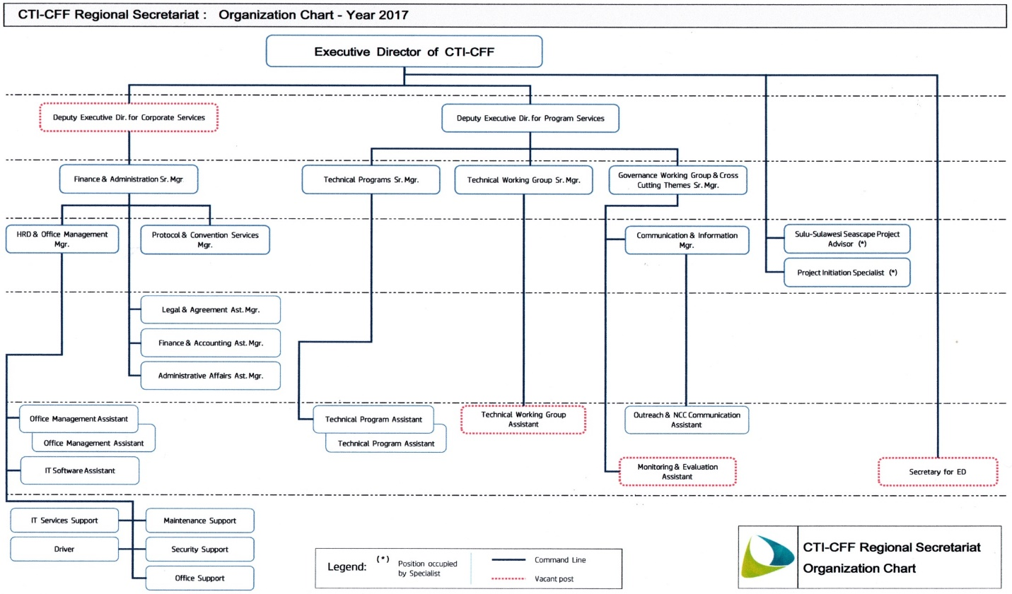
Figure 1. The Organisational Structure of the CTI-CFF Regional Secretariat

The Financial and Administrative Systems
The Regional Secretariat has maintained the financial system through MYOB (Mind Your Own Business) accounting software and installation of hardware and software for administrative infrastructure (i.e. laptops, operating systems, microsoft office).

Both financial and administrative systems are under the Corporate Division. The division had established operating policies to regulate the operations and code of conduct of the Regional Secretariat office. Particularly, policies for travel, budgeting, and cost allocation are being observed. Administrative policies had been established such as working time, remuneration and benefits as well as utilization of office’s properties

Part II. REGIONAL ACTIVITIES

The RPOA captures the joint priorities and commitments of the Coral Triangle member countries. In 2017, the CT6 member countries continuously take multilateral action along with its partners – funding agencies, international NGOs, and private sector– operating at the regional scale.

The Regional Secretariat, for its part, has continued its efforts to provide technical support and coordination through its Technical Working Groups, Governance Working Groups, and Cross-Cutting Themes to realize the goals of the RPOA.

- Technical Working Groups (TWGs)
The RPOA are supported by clear sets of actions and timelines to specifically address regional marine resource conservation and sustainability priorities. The CTI-CFF created five (5) TWGs that correspond to each of the 5 goals. The creation of technical working groups is to facilitate progress in achieving these goals. To achieve the goals of the RPOA, the five working groups continue to meet, build capacity, exchange insights, and plan activities in order to attain the targets identified in each goal. Each TWG has a Chair and Co-chair coming from CT6 member countries to oversee the work and development of identified plans and activities. Table 1 shows the Chair and Co-Chair of the five Working Groups.

Table 1. Chair and Co-Chair of the Technical Working Groups

Working Group | Chair | Co-Chair
Seascapes | Indonesia | Philippines
Ecosystem Approach to Fisheries Management (EAFM) | Solomon Islands | Timor-Leste
Marine Protected Areas (MPAs) | Philippines | Indonesia
Climate Change Adaptation (CCA) | Malaysia | Philippines
Threatened Species (TS) | Malaysia | Philippines

In 2017, the thematic TWGs organized and conducted activities were fully supported either by development partners or the CTI-CFF Regional Secretariat, while others were partially supported by funding agencies in collaboration with host countries and the CTI-CFF Regional Secretariat.

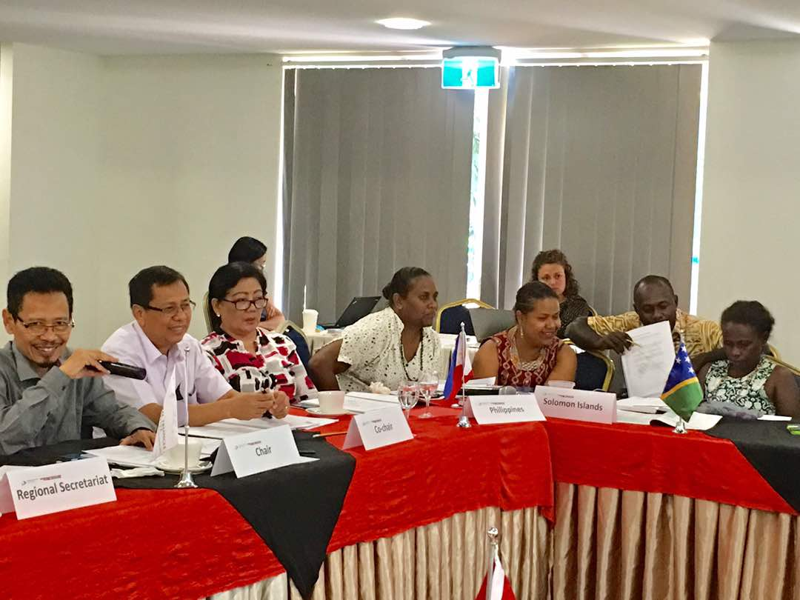
A.1. Seascape Working Group (SWG)
In 2017, the Working Group nominated two priority seascapes for investments namely, the Lesser Sunda Seas (LSS) and Bismarck Solomon Seas Ecoregion (BSSE). Although the investment plans for the two identified priority seascapes are yet to be devised, talks begun to further mobilise financial resources necessary to support the priority seascapes.

In this year, the 4th CTI-CFF Seascape Working Group meeting was held on 15-16 May in Honiara, Solomon Islands. The meeting was a follow-up to the Seascape Writeshop held in Manila last April 2016 and in Bali last December 2016. The meeting was intended to review, finalize and endorse the CTI-CFF Seascapes Model and Regional Framework for Priority Seascapes in preparation for the SOM-13.

Further, the 2nd Regional Exchange (REX) on Seascape was held last 17-19 May 2017 in Honiara, Solomon Islands. The objectives of the REX were as follow: 1) to socialize the CTI-CFF Seascapes Model and Regional Framework for Priority Seascapes amongst the broader CTI-CFF community; and 2) to develop a set of key messages around communicating the CTI-CFF Seascapes Model and Regional Framework for Priority Seascapes.

The Working Group also conducted a capacity building on seascape appreciation and establishment in the same year. The activities of the Working Group in 2017 are shown in Table 2.

Table 2. Activities of the Seascapes Working Group

Activities | Venue | Date | Technical Support | Funding Support
2nd CTI Seascapes Writeshop | Bali, Indonesia | 29 November -1 December 2016 | Conservation International (CI) and German Corporation for International Cooperation GmbH (GIZ) | Government of Australia and GIZ
Update CTI Seascapes document and disseminate to CT6 NCCs | - | December - January 2017 | - | -
Country level consultations | - | January - March 2017 | - | -
2nd Regional Exchange on Seascapes | Honiara, Solomon Islands | 18-19 May 2017 | CI and GIZ | Government of Australia and GIZ
4th Seascapes WG Meeting | Honiara, Solomon Islands | 15-17 May 2017 | CI and GIZ | Government of Australia and GIZ
Submission of CTI Seascapes Document and General Model to SOM-13 | Manila, Philippines | 29-30 November 2017 | - | -

During the SOM-13 last November 2017, the senior officials adopted the CTI-CFF Seascapes General Model and Regional Framework for Priority Seascapes which contains the Seascapes Monitoring and Evaluation Indicators. Further, the senior officials tasked the SWG to facilitate the socialization of the General Model and Regional Framework in each member state for adoption and implementation.

Further, the senior officials supported the recommendation for each member state to begin talks that will lead towards the establishment of national and transboundary seascapes. They also supported the continued progress of the Lesser Sunda Seascape and the Bismarck Solomon Sea Seascape towards “priority seascape” nomination.

The SWG has been efficiently managed by the focal points of the CT6 member countries as shown in Table 3 through the generous support of CTI-CFF development partners namely, Conservation International (Technical Lead and Coordination Support) as well as the Government of Australia and GIZ (Technical and Funding Support).
Table 3. Focal points of the Seascapes Working Group from CT6 member countries.

Member Country | Focal Points
Indonesia (Chair) | Director of Marine Spatial Planning  Ministry of Marine Affairs and Fisheries (MMAF)
Philippines (Co-Chair) | Dr. Theresa Mundita Lim  Director of Biodiversity Management Bureau  Department of Environment and Natural Resources (DENR)
Indonesia | Mr. Okto Irianto  Deputy Assistant for Marine Service  Coordinating Ministry of Maritime Affairs
Malaysia | Ms. Norasma Dacho  Assistant Director for Conservation and International Office Department of Fisheries (DOF)-Sabah
Papua New Guinea | Ms. Yvonne Tio  Executive Manager  Conservation and Environment Protection Authority (CEPA)
Philippines | Ms. Nilda Baling  Chief, Integrated Coastal and Marine Partnership Section  Biodiversity Management Bureau - DENR
Solomon Islands | Ms. Agnetha Vave-Karamui  Chief Conservation Officer  Ministry of Environment, Climate Change, Disaster Management and Meteorology(MECDM)
Timor-Leste | Mr. Antonio de Jesus  Program Officer  Ministry of Agriculture and Fisheries (MAF)

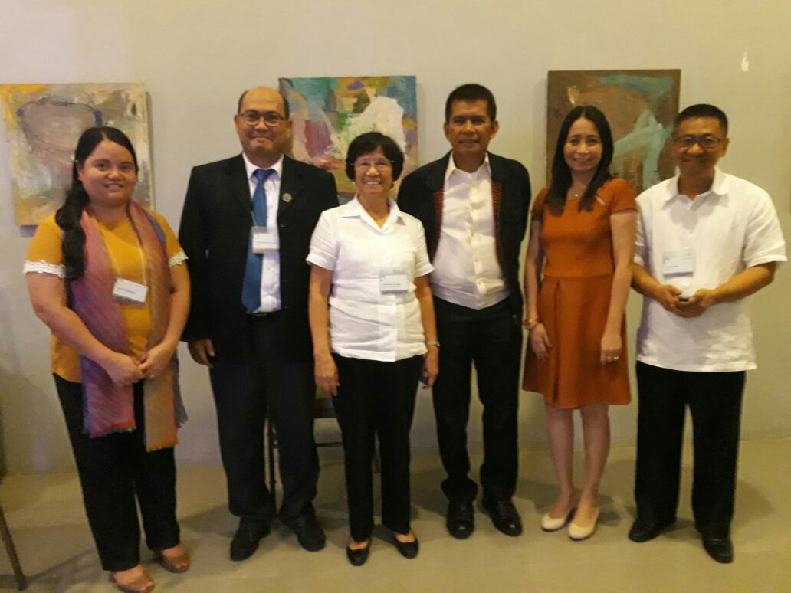
A.2 Ecosystems Approach to Fisheries Management (EAFM) Working Group
The year 2017 had been a busy and productive year for the EAFM Working Group with three (3) major regional activities and a TWG meeting conducted. On 4-7 July 2017, the EAFM Working Group held the 3rd Fishers Forum in Iloilo City, the Philippines. The event was hosted by the Government of the Philippines through its Bureau of Fisheries and Aquatic Resources (BFAR) and the Philippine CTI-CFF NCC with support from WWF and the CTI-CFF Regional Secretariat. The theme of the 3rd Fishers Forum was “Sustainable Coastal Fisheries through Local Innovation: Scaling Up Effective Models for Illegal, unreported and unregulated fishing (IUU) Reduction, Catch Documentation and Traceability in Support of Sustainable Local Fisheries” with a variety of sub-themes. One significant output of the activity was the CT 3rd Fishers Forum Communique which was adopted by the senior officials during the SOM-13.
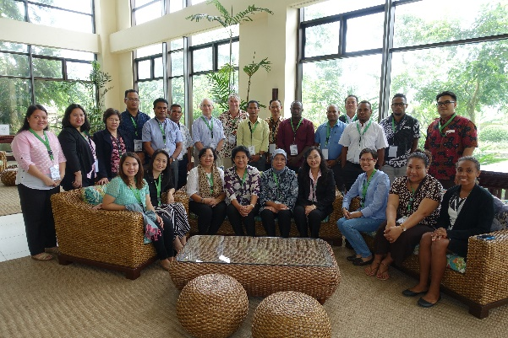
Further, the Working Group conducted the Tuna Governance Workshop on 7 July 2017 at the same venue of the Fishers Forum. The theme of the event was “Regional Workshop on the Sustainable Management of Shared, Straddling and Highly Migratory Fish in the Coral Triangle Region.” In said workshop, the EAFM Working Group came up with the Terms of Reference (TOR) for the Informal Tuna Forum. The forum was part of the EAFM WG’s efforts to put effective measures to ensure sustainable exploitation of shared tuna stocks. Apart from the forum, research work and the protection of spawning grounds and juvenile growth areas had been carried out and spearheaded by various development partners in the region. The projects were in support of the programs of the respective governments.

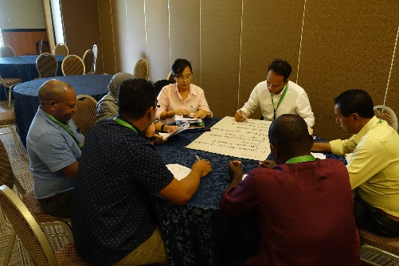
For a sustainable coastal fisheries and poverty reduction (COASTFISH), a COASTFISH Workshop was held last 1-2 August 2017 in Tagaytay City, Philippines. The workshop was hosted by the Government of the Philippines through the Philippine CTI-CFF NCC with the support of SMART Seas Philippines Project and the CTI-CFF Regional Secretariat. The workshop gathered participants from the government and NGOs working on livelihood activities to design a region-wide CTI COASTFISH Initiative Framework with focus on livelihoods linked to EAFM. The forum served as a venue for sharing experiences and lessons learned on livelihood programs related to EAFM and ‘scaling up’ successful models. One of the outputs of the workshop was a draft roadmap to develop the CTI COASTFISH Initiative Regional Framework. The framework was presented to and adopted by the senior officials during its 13th meeting in November 2017. The framework is ready for implementation pending funding. Collaborative mobilization of new financial investments to support COASTFISH has yet to be undertaken because countries have livelihood programs linked to EAFM. For the same reason, collaborative technology and information-sharing, as well as joint marketing of common products have not started. The experiences, lessons learned, and models, however, were shared during regional exchanges, meetings, and the like.

After the workshop, the 6th EAFM WG meeting was held on 3 August 2017 in Tagaytay, Philippines. The meeting reviewed the recommendations, follow-up actions and the way forward for the EAFM programs and activities. The meeting also reviewed the goal and targets of goal 2 of the RPOA and EAFM framework. The group agreed on the handover of Chairmanship from Solomon Islands to Timor-Leste and the turnover of the Co-Chairmanship from Timor-Leste to Malaysia based on the provisions stipulated in EAFM WG’s terms of reference. The summary of activities undertaken by the EAFM WG are shown in Table 4.

Table 4. Activities of the EAFM Working Group

Activities | Venue | Date | Technical Support | Funding Support
3rd Fisheries Forum | Iloilo Convention Center, Iloilo City, Philippines | 4-6 July 2017 | WWF | WWF
Tuna Governance Workshop | Smallville 21 Hotel, Iloilo City, Philippines | 7 July 2017 | WWF | WWF
Coastal fisheries and poverty reduction (COASTFISH) Workshop | Hotel Kimberly, Tagaytay City, Philippines | 1-2 August 2017 | Dr. Robert Pomery | Regional Secretariat
6th EAFM TWG Meeting | Hotel Kimberly, Tagaytay City, Philippines | 3 August 2017 | - | Regional Secretariat

The above activities were efficiently implemented due to cooperation and support of the EAFM Working Group which is shown in Table 5.

Table 5. Focal points of the EAFM Working Group from CT6 member countries.

Member Country | Focal Points
Solomon Islands (Chair) | Ms. Rosalie Masu  Deputy Director for Inshore Fisheries Division  Ministry of Fisheries and Marine Resources
Timor-Leste (Co-Chair) | Mr. Lino de Jesus Martins  Ministry of Agriculture and Fisheries (MAF)
Indonesia | Director of Fisheries Resources, MMAF
Malaysia | Dr. Norasma Dacho  Assistant Director  DOF-Sabah
Papua New Guinea | Mr. Leban Gisawa  Executive Manager for Inshore Fisheries  National Fisheries Authority
Philippines | Ms. Drusila Bayate  Assistant Director for Technical Services  BFAR
The senior officials during the SOM-13 acknowledged the activities, particularly, the full support and contribution of the WWF during the 3rd CT Fisheries Forum and the Tuna Governance Workshop. They also called on partners to continue to provide technical assistance to the different EAFM learning events and activities. Further, the senior officials approved the recommendation for the turnover of Chairmanship from Solomon Islands to Timor-Leste and Co-Chairmanship to Malaysia based on EFM Working Group TOR as well as the Workplan for 2018.

4.3 Marine Protected Areas (MPAs) Working Group
The activities of the MPA Working Group, particularly capacity building activities were mostly at the national/country level. Further, on establishing MPA networks, only one network of MPA was established for the green turtles in the Philippines. Malaysia and Indonesia planned to develop their network, and this would be the first transboundary network of MPAs. Moreover, public-private partnership or working group for engaging relevant industries in supporting Coral Triangle Marine Protected Area System (CTMPAS) was done at the country level. Also, updating of the CT Atlas MPA Database has been ongoing.

Most of the activities identified in the Workplan for 2017 were not carried out due to numerous hosting commitments to both regional and international events and conferences. At the same time, with the Philippines as the current CT COM Chair, the Philippine MPA Working group was tasked to focus on the organizational development of the CTI-CFF Regional Secretariat and other CTI-CFF administrative concerns and issues.

In the SOM-13, senior officials recognized the efforts and progress of the countries on their MPA programs and activities, which are contributing to the regional and global targets. They directed the MPA Working Group to accomplish all the tasks and decisions made during the SOM-12 in Papua New Guinea and called on all partners to assist the MPA Working Group in accomplishing all the tasks and targets activities in the 2017 Workplan. On a different matter, the senior officials supported the recommendation of the MPA Working Group to turnover the Chairmanship from Philippines to Indonesia and Solomon Islands as the next Co-Chair based on the provisions stipulated in the MPA Working Group Terms of References. The focal points of the MPA Working Group in the CT6 countries are shown in Table 6.

Table 6. Focal points of the MPA Working Group from CT6 member countries.

Member Country | Focal Points
Philippines (Chair) | Dr. Theresa Mundita S. Lim  Director Biodiversity Management Bureau, DENR
Indonesia (Co-Chair) | Dir. Andi Rusandi  Director for Marine Conservation and Biodiversity  MMAF
Malaysia | Dr. Jamili Nais  Director for Sabah Park, Ministry of Tourism, Culture and Environment
Papua New Guinea | Dir. Kay Kalim  Director of Environment and Conservation
Solomon Islands | Ms. Agnetha Vave-Karamui  Chief Conservation Officer  Ministry of Environment, Climate Change, Disaster Management and Meteorology (MECDM)  (Supported by Mr. Paul Jay Tua of Ministry of Fisheries and Marine Resources)
Timor-Leste | Mr. Jose Monteiro  Ministry of Agriculture and Fisheries

A.4 Climate Change Adaptation (CCA) Working Group
Identification of the most important and immediate climate change adaptation measures for the near-shore marine and coastal environment and small island ecosystems was completed with the publication of the Region-wide Early Action Plan (REAP) document. All immediate regional and national adaptation measures were listed in the document. While the identification was completed a few years back, the implementation of such adaptation measures is still ongoing. For this reason, capacity needs assessment and capacity building program on climate change adaptation measures were carried out as ongoing activities at country and regional level. This was also the case with financial resources mobilization for REAP implementation.

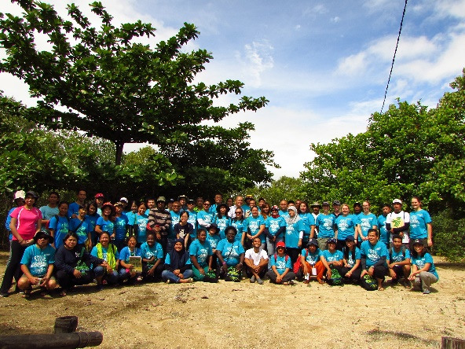
One of the activities carried out by the CCA Working Group was the Blue Carbon Workshop held on 29-31 August 2017 in Batangas, Philippines. The workshop was participated by representatives of Indonesia, Malaysia, Papua New Guinea, Philippines and Solomon Islands, development partners and related government agencies. The workshop included presentations on blue carbon and the CTI from Ryan Whisnant of Partnerships in Environmental Management for the Seas of East Asia (PEMSEA); international partnership for blue carbon from Lucy Wallington of the Australia Government; and Region-wide Early Action Plan (REAP) for Climate Change Adaptation and CCA TWG Update from Jackie Thomas of WWF and Astrid Lim of CTI-CFF Regional Secretariat respectively.

The Chair of the CCA TWG shared insights on the current blue carbon situation, the connectivity with Goal number 3 of RPOA and other ecosystem services. The workshop also had presentations from CT6 countries which focused on country condition, priority programs, gaps and challenges as well as future
direction related to the blue carbon within its variables (mangrove, seagrass and tidal marshes). Participants had a field trip to relate the knowledge experienced in the workshop and compare it with the field for observation and as a lesson learned.

As a follow-up activity to the Blue Carbon Workshop, a two-day Climate Change Working Group meeting hosted by the Philippine government, was held on 12-13 October 2017 at the Hotel Kimberly in Manila. NCC representatives of Indonesia, Malaysia, Philippines, Papua New Guinea and Solomon Islands attended the meeting. Commissioner Noel Antonio Gaerlan of the Philippine Climate Change Commission (PCCC) highlighted the importance of the meeting as well as the value of individual’s input not just to each country but to the CT region as well.

Apart from the activities conducted, discussions about the establishment of National Centers of Excellence (COE) on Climate Change Adaptation for marine and coastal environments at the regional and national levels are still ongoing. During the SOM-13, senior officials tasked the working group to further develop the TOR for the establishment of the CT COE on climate change adaptation. In the same meeting, the senior officials adopted the regional work plan on Blue Carbon Initiative for carbon storage as a means to maintain healthy marine and coastal ecosystem. The WWF, Government of Australia, the Nature Conservancy and Conservation International have been providing technical support to the Working Group. The focal points of the CCA Working Group in the CT6 countries are shown in Table 7.

Table 7. Focal points of the MPA Working Group from CT6 member countries.

Member Country | Focal Points
Malaysia (Chair) | Mr. Kepten Zaharuddin Mohd Maideen  Deputy Undersecretary  Ministry of Science, Technology and Innovation (MOSTI)  Supported by: Dr. Ejria Saleh
Indonesia | Mr. Sri Tantri Arundhati  Ministry of Environment and Forestry  Supported by Nuraieni
Papua New Guinea | Dir. Kay Kumaras Kalim  Director  Conservation and Environment Protection Agency  Supported by: Iki Peter
Philippines | USec. Noel Antonio Gaerlan  Undersecretary  Climate Change Commission  Supported by: Alexis Lapiz
Solomon Islands | Ms. Agnetha Vave-Karamui  Chief Conservation Officer, MECDM  Supported by: Nancy Diamana and Nelly Kere
Timor-Leste | Mr. Rui dos Reis Pires  Ministry of Commerce, Industry and the Environment

4.5 Threatened Species (TS) Working Group
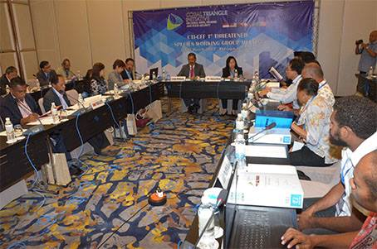
The 1st CTI-CFF Threatened Species Working Group (TSWG) Meeting was held on 22-23 March 2017 in Putrajaya, Malaysia. The two-day meeting gathered CTI-CFF NCCs, TSWG focal points and partners from CTI-CFF member states (Indonesia, Malaysia, PNG, Philippines, Solomon Islands, and Timor-Leste) and formally agreed to develop the region-wide conservation plan for marine turtles, marine mammals and sharks and rays. They also agreed to formulate a Threatened Species Assessment Report based on the current studies, researches and assessments made in the CT Region by the member states and partners to profile the status of the threatened species in the region. Another output of the workshop was the regional roadmap for Goal 5.

To improve the status of sharks, sea turtles, seabirds, marine mammals, corals, seagrass, mangroves and other identified threatened species, various development partners and collaborators were noted to be conducting threatened species assessment in various parts of the region and for certain species. A region-wide conservation action plan for sharks, turtles and marine mammals was also developed.

Further, adoption and strengthening of local and national legislative, policy and regulatory frameworks as well as regional and international agreements on threatened species are ongoing. At the national level, countries developed various national laws, ordinances and policies to protect the spawning grounds, growth areas, migratory routes and habitats of various threatened species. Most countries are also members or signatories to various international agreements and treaties for the protection of endangered and threatened marine animals.

At the national level, countries had their own capacity building activities supported by their respective governments and, in some cases, by partners such as the Secretariat of the Pacific Regional Environment Programme (SPREP) and SEAFDEC.

Another positive development is the Sulu-Sulawesi Seascape Project with the establishment of a network of MPAs on the Philippine side of the transboundary Marine Turtle Protected Area Network (MTPAN) as safe havens for the green turtles (Chelonia mydas) in Sulu-Sulawesi Seascape. The network was launched during a a side vent at the CMS-COP12 last 24 October 2017 in Manila, Philippines. This was facilitated by GIZ in collaboration with CI Philippines with support from the German Federal Ministry for the Environment, Nature Conservation, Building and Nuclear Safety.

During the SOM-13, senior officials noted that the MTPAN should be included in the regional conservation plan for the marine turtles and for the project. Further, the working group was tasked to develop a regional profile/report based on the national reports on the status of the TS in the Coral Triangle Region. Apart from the regional profile, the working group was tasked to finalize the proposed TOR for the creation of a pool of experts on threatened species.

In the same meeting, the senior officials agreed to endorse the recommendation of the working group to turnover the TWG Chairmanship from Malaysia to Papua New Guinea and for Indonesia to be the next Co-Chair based on TSWG’s TOR. The WWF, GIZ, CI Philippines and SEAFDEC are the development partners that are providing technical support to the working group.

Table 8. Focal points of the MPA Working Group from CT6 member countries.
Member Country | Focal Points
Malaysia (Chair) | Mr. Tan Geik Hong  Deputy Director General  Department of Fisheries Malaysia  Supported by: Mr. Bohari Hj. Leng
Philippines (Co-Chair) | Dr. Theresa Mundita Lim  Director  Biodiversity Management Bureau
Indonesia | Dir. Andi Rusandi  Director for Conservation and Marine Biodiversity, MMAF  Supported by: Setiono
Papua New Guinea | Dir. Kumaras Kay Kalim  Director, CEPA  Supported by: Vagi Rei
Solomon Islands | Ms. Ivory Akao  Ministry of Fisheries and Marine Resources  Supported by: Agnetha Vave-Karamui, Chief Conservation Officer, MECDM
Timor-Leste | Mr. Jose Monteiro  Ministry of Agriculture and Fisheries  Supported by: Junior Pascoal de Carvalho
The CTI-CFF Regional Secretariat through its TWG Senior Manager Astrid Lim, has ensured communication and discussions between and among the focal points of each of the working groups are smoothly progressing and working towards the achievement of the goals and targets outlined in the RPOA.

The annual deliverables to achieve the five goals are dependent on the approved work plan of each working group. The work plan is formulated by each working group and endorsed to SOM for approval. The implementation of the work plan is largely dependent on the availability of the budget and to some extent technical capacity and leadership.

The Regional Secretariat encourages the CT6 member countries to host activities of the working groups. This is intended to increase sense of ownership toward CTI-CFF and at the same time, strengthen NCC work and coordination.

- Governance Working Groups

The success of the CTI-CFF towards full implementation of the goals and objectives of the RPOA is very much dependent on a well-structured and effective coordination mechanism across multiple level of organization. It requires a large and diverse pool of implementation partners from within and outside the CT region, including local governments, local communities, non-governmental organizations, major funding institutions, multi-lateral and bilateral organizations, private sector entities, and others.

In addition to having a well-structured coordination mechanism, the CTI-CFF requires a well-planned and practical financial management system. In short, this entails collaboration around two (2) main activities: (1) mobilization of funds and (2) development of a financial architecture to manage funding flows towards supporting priority activities and programs.

To measure the success of programs and projects, a monitoring and evaluation system needs to be put in place to ensure that the goals and objectives of the programs and projects are maintained. A set of measurable indicators has been proposed for each of the RPOA goals. As of October 2017, only indicators for seascapes and threatened species have not been finalized and endorsed.

The three (3) governance elements are managed by the Coordination Mechanism Working Group (CMWG); Financial Resources Working Group (FRWG); and Monitoring & Evaluation Working Group (MEWG) respectively. The Governance Working Group (GWG) Division is formed within the Regional Secretariat to undertake a coordination role with the guidance of the respective Chairs of the Governance Working Group towards meeting the objectives of CTI-CFF governance matters as set out in the RPOA.

B.1.Coordination Mechanism Working Group (CMWG)
As described in the RPOA, levels are critical and require a range of mechanisms to ensure all CTI-CFF components are well-coordinated. At the regional and sub-regional level, coordination mechanisms such as the use of the most practical mode of communications; development and implementation of institutional structures; outreach programs / activities and regular meeting needs to be established and applied to all CT6 member countries.

At the national level, each CT6 member countries need to lead multi-stakeholder processes to coordinate and promote country-level implementation of the Regional and National Plan of Action (NPOA). The formation of NCCs in each CT6 member countries is paramount to achieve the goals and objectives of the RPOA and NPOA. However, the nature of the NCCs varies in accordance to the institutional framework of the countries itself and each is led by a National Secretariat based on a lead government ministry. The NCC Secretariat is led by the following ministry in the CT6 member countries:
- Indonesia: Ministry of Marine Affairs and Fisheries (MMAF)
- Malaysia: Ministry of Science, Technology and Innovation (MOSTI)
- Papua New Guinea: Conservation and Environment Protection Authority (CEPA)
- Philippines: Department of Environment and Natural Resources (DENR)
- Solomon Islands: Ministry of Environment, Climate, Disaster Management and Meteorology (MECDM)
- Timor-Leste: Ministry of Agriculture and Fisheries (MAF)

In matters related to coordination, a fully functional Coordination Mechanism Working Group was achieved with its Terms of Reference, as mandated by the SOM-13.

In 2017, significant milestones were achieved by the CMWG. One development was the fully functional CTI-CFF website in compliance with RPOA Section IV and decisions made in the SOMs-11 and 12. During the SOM-13, senior officials acknowledged the progress made for the website and encouraged relevant entities to provide latest data and information to populate the website to be ready for its official launch in 2018 during the 7th MM. Similarly, the development of e-library (depository of publications and meeting materials) and CTI-CFF Coffee table book were acknowledged and proposed to be launched on during the MM-7.

Further, senior officials approved and endorsed the use of the CTI-CFF Communication Strategy (including Work Plan and Branding Guidelines) for the period of 2017-2020. The document provides more operational detail on the proposed objectives, target audiences, and key messages to be conveyed to various CTI-CFF audiences; identifies outreach products and tools that have been developed and can be incorporated into a broader CTI communications programs; presents a Staffing and Management Plan for implementation; presents a proposed CTI-CFF communications protocol and guidelines to encourage the branding of CTI-CFF; and a Work Plan document that lays out relevant communication activities throughout the years 2017-2020.

Further, efforts to develop the draft Guidelines/Recommendations on the Use of a CTI-CFF Project Development Pursuits and Other Related Fund-Raising Initiatives are ongoing and is planned to be ready for the SOM-14. In summary, Table 9 shows update on the deliverables of the CMWG.

Table 9. Status of the Deliverables of CMWG

Activities / Deliverable | Rationale / Mandate | Timeline | Status
Fully functional CMWG with Terms of Reference | To implement mandate from SOM | By SOM-13 | Draft TOR to be finalized in pre-SOM and SOM-13
Fully functional CTI-CFF Website | In compliance with RPOA Section IV & Decisions made in SOM-11 and SOM-12 | Official launch at MM-7 | Ongoing
Fully functional e-library (depository of publications / meeting materials) | In compliance with RPOA Section IV & Decisions made in SOM-12 | - Soft launch SOM-13  - Official launch at MM-7 | Ongoing
Socialization of the CTI-CFF Communication Strategy (publication approved in SOM-12) | To familiarize all CTI-CFF stakeholders of the guidelines and branding measures in the Communication Strategy | Mid-2018 | Planned 2018 activity / ongoing online presence
Completion of CTI-CFF Coffee Table Book | In compliance with Decisions made in SOM-11 and SOM-12 | - Draft version deadline 31 October 2017  - Official book launch at MM-7 | Ongoing
Development of a Guideline for Proposal Development & Management (Toolkit) | In compliance with RPOA Section IV & Decisions made in SOM-10 | - To be approved in CMWG meeting mid-2018;  - Official launch at MM-7. | Ongoing; Draft Guideline to be revised
Development & operationalization of Proposal Management system (e.g. e-portal for CTI Proposals) | In compliance with RPOA Section IV & Decisions made in SOM-10 | Mid-2018 to 2019 | Planned 2018-2019 activity

B.2 Financial Resources Working Group (FRWG)
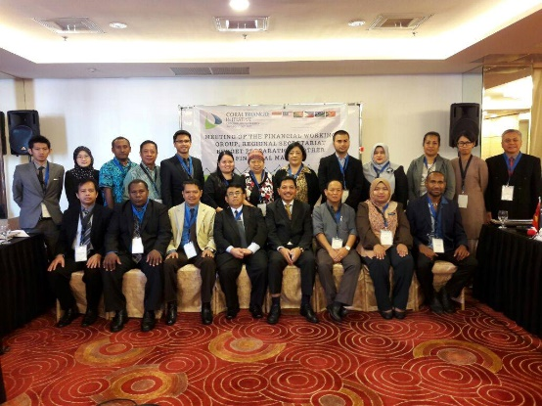
The FRWG’s main task is to analyze relevant information, conduct preliminary assessments and feasibility studies, and develop financial management tools. This working group is led by Indonesia and has been so since then. The FRWG is guided by the RPOA in Section V on Financial Resources for CTI-CFF to establish a realistic, workable and sustainable financial architecture.

In 2017, the Regional Secretariat supported the FRWG Meeting which was held on 29 March 2017 at ACE Hotel and Suites in Pasig City, Philippines. During this meeting, the delegates discussed, among others, the ToR of FRWG, the finalization of Project Initiation Specialist (PIS) and possible supports to funding activities under CTI-CFF. Subsequently, following the decisions from SOM-12 and with the guidance from the Chair of the CTI-CFF Council of Senior Officers, the meeting on budget and other financial matters were held on 30-31 March 2017. The meeting adopted the 2017 budget, provided guidelines for the audit process and produced several recommendations for the revision of Financial Rules and Procedures. The meeting was hosted by the Philippines’ NCC. On the same day, a Memorandum of Understanding (MoU) between Regional Secretariat and PRIMEX, an implementer agency of AAB was signed on 31 March 2017. The MoU provided ADB’s support for CTI-CFF through PRIMEX, among others, in the scope of MPA trilateral meeting, youth forum and support for Pacific countries.
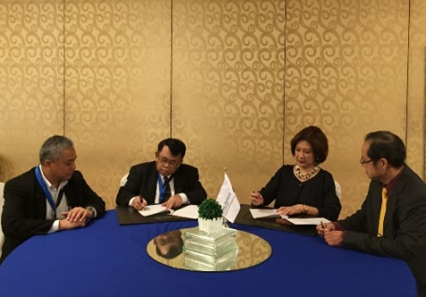
Since the FRWG meeting, with the support of ADB, the Regional Secretariat engaged a Project Initiation Specialist (PIS) for three (3) months starting from 1 May and extended for another three (3) months which ended on October 2017. The deliverables included drafts of:
- Grant Opportunities 2017-2020 document;
- Logical Framework Analysis document;
- Sample proposal for Climate Change Adaptation;
- Programme Manual; and
- Cost-Benefit Analysis (CBA).

These drafts\which would still need further revision, provided the fundamental basis towards the establishment of the Project Preparation Facility (PPF) and the subsequent set-up of the CTI-CFF Trust Fund. Upon full revision and assessment of the deliverables, it will be circulated to all NCCs before the next FRWG meeting scheduled for April 2018 in Indonesia.

During the SOM-13, the senior officials acknowledged the importance of a Financial Management Advisor position within the Regional Secretariat to oversee the establishment of the PPF and implement the proposed initial activities set out in the CTI-CFF Financial Architecture Report. Further, the Regional Secretariat was urged to continue seeking funding support for the said position.

Further, the senior officials agreed that together with ADB-GEF Focal Point, the group should design briefing session with regards to GEF Funding application procedures and similarly through accredited bodies of other funding organizations on its respective funding application to be organized in April 2018; endorsement of the final TOR of the FRWG to SOM-14; and the period reporting of the Regional Secretariat to FRWG every one (1) month. In summary, Table 10 shows the status of the deliverables of the FRWG.

Table 10. Status of the deliverables of the FRWG

Activities / Deliverable | Rationale / Mandate | Timeline | Status
Finalization of FRWG Terms of Reference | RPOA Section V | end-2017 | Draft completed to be endorsed in SOM-13
Appointment of Project Initiation Specialist (PIS) | SOM-12 Decisions & FRWG Meeting Decision 2017 | April – October 2017 | Completed
Continue Project Initiation Specialist (PIS) / Financial Management Advisor | SOM-12 & FRWG meeting in 2017 | 2018 onwards | Not started
Completion of National Plan of Action (NPOA) Costing for all CT6 | SOM-10 to SOM-12 Decisions | end of 2018 | - NPOA Costing for CT3 SEA countries completed;  - NPOA Costing for CT3 Pacific Countries ongoing
Identification of Showcase Sites upon completion of NPOA Costing process | SOM-10 to SOM-12 Decisions | end of 2018 | Pending confirmation from NCC Indonesia and NCC Philippines for showcase sites at Wakatobi National Park and Palawan & Davao respectively.
Establishment of Project Preparation Facility (PPF) in Regional Secretariat | SOM-10 to SOM-12 Decisions | 2018-2019 | Not started
Establishment of CTI-CFF Trust Fund | SOM-10 to SOM-12 Decisions | 2018-2019 | Not started
Seek potential financial resources (i.e. GEF) | SOM-10 to SOM-12 Decisions | 2018-2019 | Ongoing

B.3 Monitoring and Evaluation Working Group (MEWG)
As the RPOA is implemented, it is expected to see tangible and measurable improvements in marine and ecosystems, fisheries, and food security as well as well-being of the communities which depend on them. The MEWG was instrumental in ensuring that it is achieved through the development of a CTI-CFF Monitoring and Evaluation System (M&E) as guide for the Regional Secretariat’s M&E System.

In 23-24 May 2017, a Partners’ Meeting was convened in Manila, Philippines in response to SOM-12 call for more transparency and communication between Partners and the Regional Secretariat. In said meeting, the offer of support from the Government of Australia to review the CTI-CFF RPOA was discussed. Guidance was sought from the Chair of CSO, with the response of offering to draft both the ToR for a Consultancy and for the establishment of the Technical Advisory Group.

GIZ, one of the partners of the CTI-CFF, also finalized and presented the results of the Capacity Needs Assessment Report to the senior officials during the 13th SOM. The Report was aimed at analyzing the existing capacity assets and gaps of CTI-CFF and relevant government institutions of the Sulu-Sulawesi Seascape. In summary, Table 11 shows the status of the deliverables of the MEWG, which is chaired by Dr. Theresita Mundita, Director of Philippines’ Biodiversity Management Bureau.

Table 11. Status of the Deliverables of the MEWG

Activities / Deliverable | Rationale / Mandate | Timeline | Status
Development of M&E System Operation Manual | RPOA Section VI & SOM-9 | 2013 | Completed
Seek sustained measures for CT Atlas maintenance and operation | RPOA Section VI & SOM-10 to SOM-12 | 2018 | Ongoing
Development and finalization of M&E indicators – submission of agreed indicators for seascape and threatened species | RPOA Section VI & SOM-9 to SOM-12 & 2nd Regional Priority Workshop | 2018 | Ongoing
Implementation of M&E System | RPOA Section VI & SOM-12 | 2018-2019 | Not started
Hire M&E Coordinator in Regional Secretariat | SOM-10 to SOM-12 | 2018 | Not started
Review of Regional Plan of Action | Partners Meeting 2017 | 2017-2018 | Ongoing

Other activities under the GWG framework were as follows:
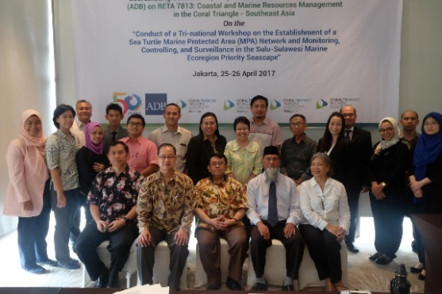
- The ADB under the RETA 7813 program, in coordination with the CTI-CFF Regional Secretariat organized a consultative meeting with the NCCs from Indonesia, Malaysia and the Philippines) on 25-26 April 2017 in Jakarta. The meeting was to prepare for the Tri-national Regional Workshop on “The Establishment of a Sea Turtle Marine Protected Area (MPA) Network and Monitoring, Controlling, and Surveillance (MCS) in the Sulu-Sulawesi Marine Ecoregion Priority Seascape” that would be held in Manado next June. The objectives of the meeting were to plan and develop the agenda, program materials and identify both national and international resource persons for the workshop. One of the major performance targets of RETA 7813 according to the Design and Monitoring Framework (DMF) of ADB was “MPA management plan with a monitoring, control, and surveillance system for a transboundary network of MPAs pilot-tested”. Together with other CTI Development Partners through their own programs, the identified sites could be pilot-tested soon.

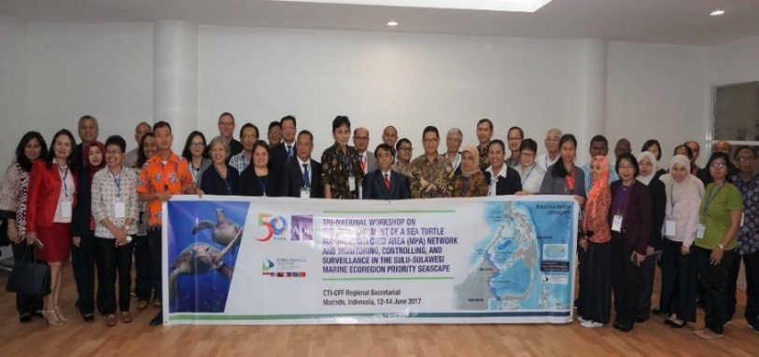
- The Tri-National Workshop on the Establishment of a Sea Turtle MPA Network and MCS in the Sulu-Sulawesi Marine Ecoregion Priority Seascape was conducted in Manado, Indonesia last 12-14 June 2017. The workshop was conducted in collaboration with ADB, under the Coastal and Marine Resources Management in the Coral Triangle - Southeast Asia Project (ADB RETA 7813). The activity aimed to bring together representatives of the CTI thematic technical working groups (i.e. Seascapes, EAFM, MPA, Climate Change Adaptation and Threatened Species), particularly those involved in the establishing and managing of marine protected areas and addressing IUU fishing, especially on sea turtles in the Sulu-Sulawesi Marine Ecoregion (SSME) Priority Seascape.

- The Maritime Environmental Security Workshop was held last 12 – 15 September 2017 in Kota Kinabalu, Sabah, Malaysia. Ms. Jasmin M. Saad, GWG Senior Manager of the CTI-CFF Regional Secretariat attended the workshop. The workshop sought to foster enduring relationships by bringing together participants from Asia/Pacific nations to address common environmental security concern through responsible civil and military action. Workshop topics emphasized the following: 1) Marine Resource and Wildlife Protection; 2) Sustainable Maritime Economic Development; 3) Water Security and Pollution Prevention; and 4) The military’s role in Maritime Environmental Security.

Moreover, in terms of empowering the work of GWG, the Regional Secretariat works together with the ADB to provide support on Project Initiation Specialist (PIS) to develop project tools for seeking potential funds from funding entities. This post is important for Regional Secretariat in exploring possible support of funding to implement RPOA. However, the function of PIS has not been fully optimized due to short-term assignment and limited funding resources to support PIS’ benefits and works. The Regional Secretariat is looking for other possible supports to sustain the function of PIS in the near future. On a different note, the Regional Secretariat is also in close coordination with ADB-RETA 7753 for supporting the CTI Pacific countries, including the supports on NPOA costing through the ADB-RETA 7753.

C. Cross-cutting Themes (CCT)
Throughout the lifespan of the Coral Triangle Initiative, several cross-cutting themes were established to address elements or issues not identified in the RPOA but are critical towards the fulfilment of the goals and objectives of the RPOA. Elements and issues on gender equality, private sector involvement, local communities, promotion of scientific research and findings, and identification of capacity building needs are addressed in the following: establishment of the Women Leaders’ Forum (WLF); Regional Business Forum & Business Advisory Council (RBF/BAC); Local Government Network (LGN); Scientific Advisory Group (SAG); and Capacity Building. These cross-cutting themes are mainly led and supported by the CTI-CFF Development Partners in the early years of the CTI-CFF establishment.

The Regional Secretariat through its GWG and CCT Division works with development partners to ensure continued support for the cross-cutting themes and at the same time to ensure CT6 member parties’ interests are taken into consideration when designing programs/projects.

The Regional Secretariat seeks ways and means to implement agreed workplans with partners. It also seeks potential collaboration with other relevant organizations for its cross-cutting themes. Often, the Regional Secretariat and NCC representatives attend and participate in conferences and workshops organized by other organizations with subject matters that are relevant to the cross-cutting themes either through the support of the organizers, development partners and the Regional Secretariat. The GWG and CCT Division also facilitates the development of annual reports to SOM and organize pre-SOM meetings to review and finalize SOM reports for CCTs.

Deliverables are in response to the decisions and recommendations made at SOMs and Ministerial Meetings. Although it is not stipulated in the RPOA, the cross cutting themes are crucial towards the implementation of the RPOA goals.

C.1. Capacity Building
The Council of Senior Officers recognizes the need for improvement in institutional and human capacity. As such, the CTI-CFF Regional Secretariat has been closely collaborating with its partners to continue work on building human capacity for beneficiaries at various level.

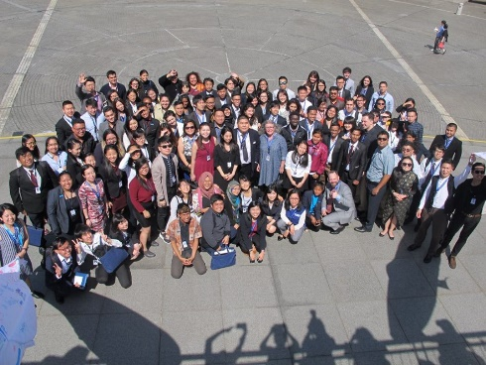
Through the support of ADB-RETA 7813 and NGO and Civil Society Center (NGOC) of ADB, youth representative of the CTI-CFF from Regional Secretariat, the officers from the Indonesia and Malaysia NCCs (Ministry of Marine Affairs of Indonesia, Ministry of Science Technology and Innovation of Malaysia) as well as representative of Universiti of Malaysia Terengganu attended the 5th Asian Youth Forum (AYF-5) in conjunction with the 50th ADB Annual Meeting from 1-7 May 2017 in Yokohama, Japan. Through the facilitation of ADB (Youth for Asia), Plan International, and AIESEC, the forum shared lesson learned in mechanism of ADB operations with youth elements in achieving Sustainable Development Goals through plenaries and knowledge sessions. The activity was also an opportunity for youth to involve and interact with stakeholders and leaders in various development sectors. About 150 delegates gathered at the event venue in Yokohama, Japan.

In 2017, the identification of capacity support gaps across all CTI-CFF goals as well as identification of existing capacity building mechanism were done for MPA Technical Working Group only. Both identifications for other technical working groups are yet to start. Consequently, utilization of existing capacity building mechanism to a wider audience in order to promote capacity building opportunities is yet to start. An information system to enable countries to inform capacity providers of their capacity building needs also has yet to start.

C.2. Local Government Network (LGN)
The Maritime Local Government Network (LGN) is a product of regional planning meetings among local government peers in the region. The RPOA of the CTI-CFF recognizes the importance of local governments and communities in coastal and marine management and protection. As such, from the outset, there has been an ongoing effort to engage local governments in the CTI-CFF process. These local governments share the common challenge of facing the front lines of marine and coastal management with local constituents. They play a critical role in the CTI-CFF process for they conduct community level planning, adopt and implement fisheries management strategy, establish and manage marine protected area(s), and implement climate change adaptation measures. The CTI-CFF LGN is the only medium to encourage local authorities within CT6 member countries to directly implement the CTI-CFF program at grass root level.

In 2017, to further establish the LGN Secretariat, the Coral Triangle Center with funding from the USAID –Department of Interior (DOI) hired a Program Development Specialist and Secretariat Coordinator. Further, there is an ongoing effort to implement the LGN Roadmap as endorsed in the SOM-11.

C.3 Regional Business Forum (RBF) and Business Advisory Council (BAC)
The Regional Business Forum was created by CTI-CFF and other development partners to engage with the private sector in creating innovative business solutions that are both economically profitable and environmentally sustainable. In the 4th CTI-CFF RBF, it was successful in influencing member states and private entities implementing sustainable management tourism measures in its operation. The introduction of the Global Sustainable Tourism Council (GSTC) Criteria as the baseline standard for sustainability in travel and tourism in marine protected areas have had successes in Indonesia and it is hoped the same will be achieved in the other CT6 Member States. In 2017, RBF had the following activities shown in Table 12.

Table 12. 2017 Activities of the RBF

Activity | Date | Venue | Support
Global Tourism Conference | 19-22 July 2017 | Kuala Terengganu, Terengganu, Malaysia | Regional Secretariat & Universiti of Malaysia Terengganu
Courtesy visit to Ministry of Tourism and Culture Malaysia (MOTAC) | 18 July 2017 | Kuala Lumpur, Malaysia | MOTAC and Regional Secretariat

Moreover, ongoing implementation continues for the following: bi-annual organization of CTI-CFF Regional Business Forum on sustainable marine tourism; adoption of the Global Sustainable Tourism Council (GSTC) Criteria across CT6 as baseline standard for sustainability in travel and tourism in MPAs; and establishment of the Business Advisory Council. On the other hand, the official launch of the formation of the task force under MPA TWG has yet to start.

C.4. Scientific Advisory Group (SAG)
The Council of Senior Officers acknowledged the critical need for process of decision-making to be back-up by good and best available science. Further, NCCs agreed that the SAG shall be a crucial scientific arm of the CTI. As such, the CTI-CFF Regional Secretariat has been relentless in its efforts to help establish the SAG. Particularly, discussions in relation to the establishment and financing of the SAG took place in the CTI-CFF University Partnership Meetings.

On 19-20 October 2017, a preparatory meeting for SOM-13 with Malaysia’s CTI-CFF NCC which included discussion on the establishment of the SAG was discussed during the 2nd University Partnership Meeting in Putrajaya, Malaysia. Discussions on the establishment of SAG along with the development of criteria and mechanism for SAG are still ongoing.

In 2017, a proposed TOR for the establishment of the SAG based on the developed mechanism of the utilization of experts was presented to and recognized by the senior officials during the SOM-13. Particularly, the TOR include the following information, among others:

- Definition of SAG: The Regional SAG of CTI is a multidisciplinary team working under the coordination of the CTI Regional Secretariat to provide scientific advice and input towards meeting the overarching goals of the CTICFF stated in the RPOA. This group shall work closely with other existing bodies such as the Technical Working Groups, University Partnerships, and other relevant parties.
- Mission: Provision of scientific advice and input towards meeting the overarching goals of the CTI-CFF as stated in the RPOA.
- Objectives: to provide scientific advice/input & assessment to the planning and implementation of CTI-CFF programs under the coordination of the Regional Secretariat scientific; support and advice to all bodies under regional and national platform of the CTI-CFF; technical expertise for the accomplishment of the CTICFF goals and targets stated in the RPOA; and evaluation on scientific relevance of project proposed under the umbrella of CTI-CFF.
- Deliverables: (1) provide ongoing written, concise scientific input to any relevant ongoing CTI-CFF activities; (2) Provide detailed reports based on specific tasks or requested by SOM (coordinated with the Regional Secretariat; (3) Alert all the relevant parties (with short scientific statement) for any emerging and crucial issues related to CTI-CFF; and (4) Assist in disseminating and promoting CTI-CFF goals, progress, and challenges to broader scientific and management communities (e.g. through seminars, symposium, workshops

C.6. Women Leaders’ Forum (WLF)
The CTI-CFF Women Leaders' Forum is a peer-learning network for women who are playing key leadership roles in sustaining the marine resources of the Coral Triangle region. It recognizes the achievement of grassroots women leaders who are championing marine conservation in the six Coral Triangle countries, and serves as a platform to build the capacity of women from the Coral Triangle to take leadership roles in preserving and sustaining the regions' unique marine and coastal resources.

The forum also aims to support the CTI-CFF in integrating gender principles in its activities under its Regional and National Plans of Action and thus, becoming a world leader in integrated, gender sensitive conservation and development. This will be done by collecting and sharing tools as well as good practices that integrate gender principles in marine conservation and sustainability projects and weaving it into existing CTI-CFF structures and activities outlined by the CTI-CFF Regional and National Plans of Action.

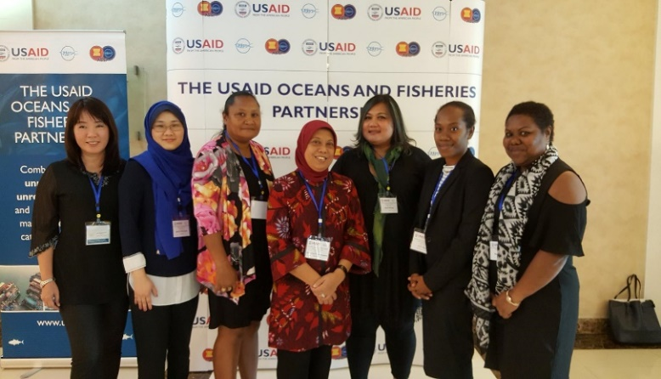
The CTI-CFF Regional Secretariat was invited by SEAFDEC/USAID Oceans and Fisheries Partnership to participate in the second Technical Working Group Planning Workshop in Bangkok, Thailand on 12-14 July 2017 for the USAID Oceans Partnership Regional Workshop – Gender and Human Welfare TWG meeting. The workshop reviewed the progress made over the past year and served as a venue to plan and discuss activities to be conducted in the program's third year-fiscal year 2017- in both the learning and expansion sites related to the gender and human welfare. In addition, the activity presented findings from extensive research conducted over the past year in the Philippines and Indonesia to inform the program's approach and catch documentation and traceability system design. Updates on the U.S. Seafood Importation Monitoring Program were also presented.

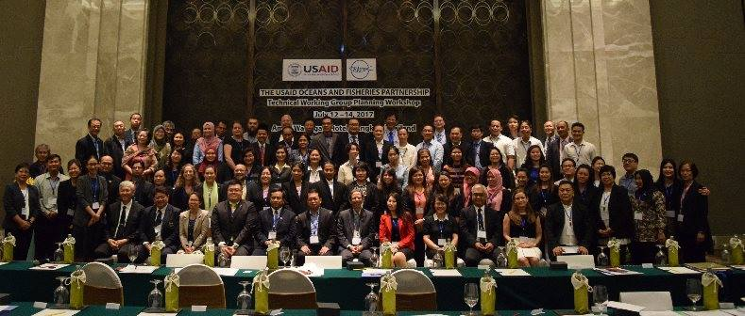
In another activity, the CTI-CFF, as a partner to the Oceans and Fisheries Partnership (Oceans Partnership) shared its WLF Intergenerational Learning (IL) program at the Oceans Partnership Regional Gender Workshop held on 20-22 August 2017 in Bangkok, Thailand. The workshop was part of its Gender Strategies Implementation in the Oceans and Fisheries Partnership activity. CTI-CFF participation includes women representatives from Indonesia, Malaysia, Papua New Guinea, Solomon Islands and Timor-Leste. The participants shared their respective experiences, local and national programs and thoughts on capacity building. They were exposed to the approaches towards developing gender sensitive indicators. In general, the participants acknowledged the need for further capacity building to ensure inclusion of gender issues in all aspects of strategic planning. CTI-CFF, in coordination with the Coral Triangle Centre (CTC) have developed an IL program that shall span over 18 months and is expected to cover one pair of mentor-mentee for each CT country selected through an open call / submission of proposals. This program was supported through the USAID / Department of Interior (DOI) grant.

Mutual collaboration with the Oceans and Fisheries Partnership has empowered the CTI-CFF Women Leaders’ Forum in terms of capacity building and more importantly on the approaches towards developing gender sensitive indicators. Close cooperation with ADB has produced supports for potential establishment of CTI Youth Forum as well as close engagement with CTC also has provided modality for WLF, Capacity Building and LGN.

Through Women Leaders Forum, women’s participation in Technical Working Group events or meetings and their engagements at national, regional and international forums had become the norms. These participations and engagement are expected to endure throughout the life of CTI-CFF. The development of gender measures or indicators to be embedded in the M&E Operations Manual, however, has yet to start.

Other activities, such as network with women ministries across CT6 countries, development of long-term plan for Women Leaders Forum, and development of mechanism or framework for sustainable financing for Women Leaders Forum programs, have yet to start too. The summary of the activities of WLF for 2017 is shown in Table 13.

Table 13. 2017 Activities of the WLF

Activity | Date | Venue | Support
ADB’s 50th Annual Meeting | 1-7 May 2017 | Yokohama, Japan | ADB; The Nature Conservancy
USAID Oceans Partnership Regional Workshop – Gender and Human Welfare TWG meeting | 12-14 July 2017 | Bangkok, Thailand | USAID Oceans Partnership & Regional Secretariat
Preliminary discussion for potential collaboration with the Women for Organizing Change in Agriculture and Natural Resources (WOCAN) | 20 August 2017 | Bangkok, Thailand | Regional Secretariat
USAID Gender Workshop | 21-22 August 2017 | Bangkok, Thailand | CTC & Regional Secretariat

The CTI-CFF Regional Secretariat has continued its efforts in empowering the works of Technical Working Groups (TWGs) and Technical Program under the EAFM. Cooperation arrangement and collaborative efforts with U.S. Department of Interior – International Technical Assistance Program (USDOI-ITAP), U.S. Agency for International Development/Regional Development Mission for Asia (USAID/RDMA), USAID Oceans and Fisheries Partnership (USAID Oceans) are on the pipeline.

This support from USAID will be from 2017-2019 comprising seven activities, including Public-Private Partnership engagement. The activities are dedicated to CTI-CFF Member States in the form of support for airfare, accommodation, and meeting packages. The objective of this collaborative effort is to strengthen regional cooperation to combat IUU fishing, promote sustainable fisheries, and conserve marine biodiversity in the Asia-Pacific region.

D. Technical Program
The Technical Program division supports the implementation of CTI-CFF RPOA; develops regional plans, programs and project activities; foster networking with other organizations and donors; facilitates technical/expert assistance; and performs other duties and functions assigned to it by CSO and COM.

For FY 2017 and following the SOM-12 decisions related to the technical program, the division has the following five (5) main focus activities:
- Consultative meeting for Program Initiation: University Partnerships for Capacity Building, Research Collaboration, and Community Outreach
- Capacity building for the Secretariat Staff in program management and/or technical related matter according to the mandate of SOM-12 (related to RPOA goals)
- Support for program initiation and potential collaboration with other international / regional organization
- Development of Partners Consultative Meeting (USD 10,000)
- Support for other matters related to the SOM-12 decisions on the Regional Business Forum, the Business Advisory Council, and the Scientific Advisory Group

D.1. The CTI-CFF University Partnership
The University Partnerships is a non-legally binding, voluntarily, and mutual cooperation among/between all parties involved, which respect to each University’s own rules and regulations, as well as member country’s laws and regulations. The partnership is aimed at promoting marine conservation, sustainable fisheries, and food security through educational and professional accredited capacity building, research, and outreach activities within CT6 member countries under the CTI framework (i.e. goals, targets, and regional activities).
The Partnership was acknowledged during the 12th SOM in Port Moresby, Papua New Guinea on 1-2 November 2016, in Decision Nos. 14.2.2 and 14.2.3 as follows:
- “Initiated and signed MoUs with four of Indonesian universities in October 2016 namely Bogor Agricultural University, Institut Teknologi Sepuluh Nopember, Hasanuddin University and Sam Ratulangi University as for strengthening CTI-CFF to achieve its goals in terms of research supports, education, and outreach program for capacity building and scientific advisory group.” (Decision No. 14.2.2)

- “Acknowledged the initiation of CTI-CFF Regional Secretariat for upcoming MOU with University Malaysia Terengganu from Malaysia, James Cook University from Australia; as well as the upcoming potential signing of MOU to extent cooperation arrangements with PEMSEA, University of Queensland from Australia and Solomon Islands National University from Solomon Islands in the frame of the proposed CTI-CFF University Partnership and other potential cooperation arrangements to be established and pursued by the CTI-CFF Regional Secretariat in the near future.” (Decision No. 14.2.3)

The partnership with universities has increased significantly after SOM-12. As of December 2017, the CTI-CFF Regional Secretariat had entered into partnership with 13 universities, with two more upcoming MoUs with universities. The 13 universities are:
- Bogor Agricultural University/ Institut Pertanian Bogo (IPB)
- Institut Teknologi Sepuluh Nopember (ITS)
- Hasanuddin University/ Universitas Hasanuddin (UNHAS)
- Sam Ratulangi University/ Universitas Sam Ratulangi (UNSRAT)
- Universiti Malaysia Terengganu (UMT)
- University of Papua New Guinea
- James Cook University (JCU)
- The University of Queensland
- Universidade Oriental de Timor Lorosa’e
- Padjajaran University
- Solomon Islands National University
- Universiti Malaysia Sabah

The CTI-CFF Regional Secretariat is still working out possible collaboration with other leading universities in the US and Europe.

Initial outcomes from the partnership were agreed principles and mechanism of the partnership among and between Universities and the CTI-CFF, proposed capacity building, research as well as community outreach activities to support the implementation of the CTI-CFF goals and identified funding sources.

The workshop on program development became a venue to identify eight (8) priority actions with indicative budget for 2017 and 2018. The eight priority actions focus on capacity building, research, and community outreach with a total indicative budget of USD 3 million.

Further, partners from the universities had met up with CTI-CFF NCCs during the CTI-CFF/USAID Inception Workshop: Building-Up A Regional Catch Documentation and Traceability (CDT) System and Advancing Fisheries Management for Strengthening Food Security in Coral Triangle Region held last 25-26 September 2017 in Manado, Indonesia.

Through the University Partnership, the Technical Program Division taps expert’s assistance in supporting the USAID-support activity of the SOACAP IFM; establishing of Scientific Advisory Group and its mechanism; and developing regional concept note for capacity building, research, and community outreach.

D.2. Program initiation and potential collaboration with other international / regional organization

USAID/US Department of Interior (DOI)-support CTI Work Plan on Strengthening Organization and Administrative Capacity for Improved Fisheries Management (SOACAP-IFM)
The SOACAP-IFM was introduced to and recognized by the senior officials during the SOM-12 in Papua New Guinea. Its work plan is implemented through the US DOI assistance. The MoU between the CTI-CFF Regional Secretariat and the US DOI was signed last 15 June 2017 with funding support amounting to USD 250,000. Through this activity, the CTI-CFF Regional Secretariat achieved the USAID classification of Public International Organization (PIO), which means that the Regional Secretariat is eligible to receive direct support from the USAID.

The work plan aims at strengthening the CTI-CFF in EAFM through sharing the existing Catch and Documentation Traceability (CDT) system as well as USAID Oceans’ CDT system to combat illegal, unreported and unregulated fishing and promote sustainable fisheries for livelihoods and food security in the Asia and Pacific Region by the middle of 2019.

Operationally, the work plan is designed to meet two (2) objectives, and each objective will be achieved through several activities as summarized in the figure below:
Objective 1. Improve Application of the Ecosystem Approach to Fisheries Management (EAFM)
Objective 2. Strengthen Collaboration among Key CTI-CFF Organizations and Partners through a Series of Cross-Cutting Activities Designed to Promote County-to-Country Engagement, Build Professional Networks, and Leverage Private Sector Funding;

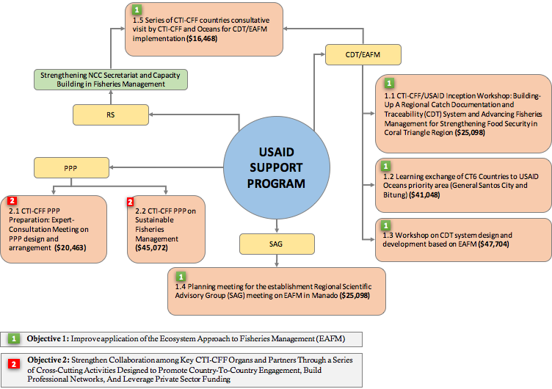
Figure 2. USAID Support Program Objectives and Activities
The work plan exhibits large activity collaboration between CTI-CFF and other organizations i.e. Southeast Asian Fisheries Development Center (SEAFDEC), the USAID Oceans and Fisheries Partnership, National Oceanic and Atmospheric Administration (NOAA), and other potential private sectors.

The activity 1.1. which is the CTI-CFF/USAID Inception Workshop: Building-Up A Regional CDT System and Advancing Fisheries Management for Strengthening Food Security in Coral Triangle Region was successfully undertaken last 25-26 September 2017 in Manado, Indonesia. The meeting was aimed at (1) introducing the USAID/RDMA support program to CTI-CFF on development of traceability system; (2) exchanging information on existing traceability system among member countries, and (3) building better understanding on the benefit of introduced traceability system in EAFM and in international market.

Key Achievements of the Activity 1.a were as follows:
- full participation of the CT6 member countries;
- full participation of main resource persons (partners): USAID/RDMA, NOAA, the Ocean and Fisheries Partnerships, and the SEAFDEC;
- The workshop produced the following outputs:
      - Draft country gap analysis for identification of country existing traceability system and the need of the country on traceability system development;
      - Recommendation on development of countries-specific CDT systems;
      - Draft TOR for establishing the task force for CDT development and EAFM integration.
- alignment USAID-CTI CFF activity or Work Plan with the CTI-CFF EAFM Working Group; and
- commitment of the participant to attend in the remaining activities through the establishment of the task force for CDT development and EAFM integration.

Collaboration with SEAFDEC
SEAFDEC’s support to CTI activities is related to the USAID-CTI CFF Work Plan where it provides resource persons to activities, including Activity 1.1. Discussion on possible project collaboration through external funding source was explored during the SEAFDEC/Oceans and Fisheries Partnership Technical Working Group Planning Workshop held on 11 - 15 July 2017 in Bangkok, Thailand.

Collaboration with PRIMEX - ADB RETA 7813
On 31 March 2017, the CTI-CFF Regional Secretariat signed an MOU with PRIMEX-ADB RETA 7813. Collaboration with PRIMEX was on the following activities:
      - The organization of Program Consultative Meeting on the Establishment of a Sea Turtle MPA Network and MCS in the SSME which was held on 25-26 April 2017 in Jakarta, Indonesia. The outputs of the meeting were as follows:
- Bringing together representatives of the Technical Working Groups of Marine Protected Area, Threatened Species, Seascape, Ecosystem Approach to Fisheries Management (particularly those responsible in addressing IUUF and Climate Change from the three countries in the SSME to discuss turtle conservation status, current issues, and national programs to promote the protection of habitats for marine turtles.
- Identification of common threats of marine turtle populations in the SSME.
- Identification of solutions and practical options such as the establishment of a turtle MPA network in the three countries.
- Discussion on possible joint efforts to address common concerns such as predation on turtle eggs and hatchlings and shore erosion that are affecting turtle nesting and hatchery management.
- Sharing best practices and practical learning experiences among the three countries.
- Discussion on the framework of a monitoring, control, and surveillance system, and the mechanism for implementation of a reporting/coordination system.

      - The three-day National Workshop on the Establishment of Sea Turtle MPA was conducted on 12-14 June 2017 in Manado, Indonesia. The outputs of the workshop were as follows:
- A brief summary of discussions that can be used for advancing the conservation of sea turtles in the SSME Priority Seascape.
- An outline of the design for an NMPA for sea turtles with a management framework to provide monitoring, controlling, and surveillance system, and coordination and reporting system on the performance (based on indicators) of the NPMA.
- Hiring of a Project Initiation Specialist that will develop draft framework for initiating and raising the possibilities of financial and technical assistance from funding entities.

D.3. CTI-CFF and International Community
The CTI-CFF Regional Secretariat has received increased international attention particularly from high profile international organizations such as the UN and Indian Ocean Rim Association (IORA). In 2017, the CTI-CFF Regional Secretariat was invited to several international events. Among these events were:
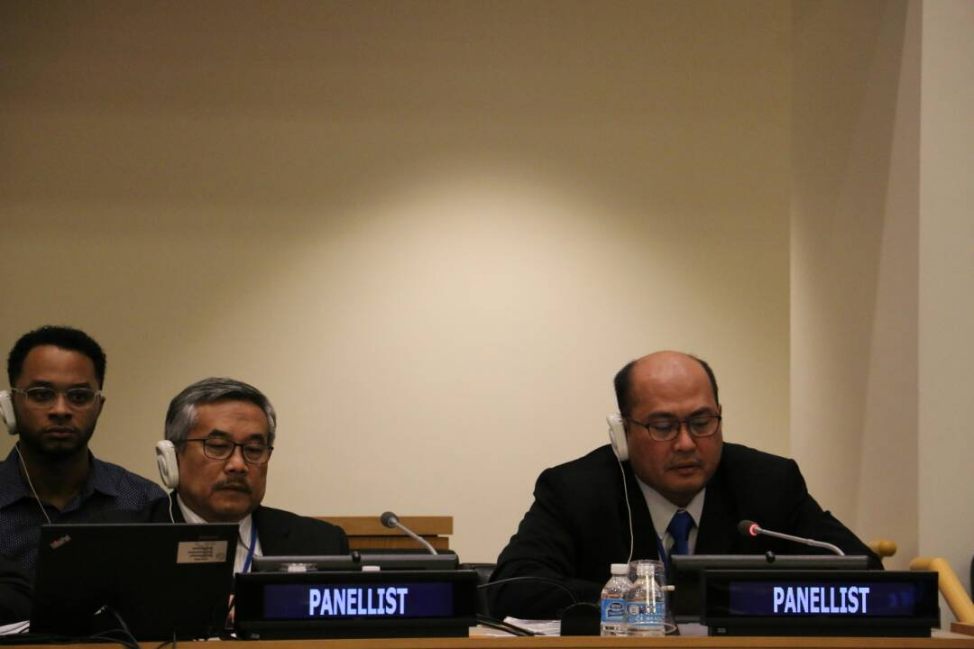
- The 18th UN-Informal Consultative Process (ICP-18). The invitation came from the UN Division on Ocean Affairs and the Law of the Sea to attend as a panelist as proposed by Government of Indonesia. The ICP-18 focused on the effects of climate change on oceans. The presentation of the RS was included in the session of cooperation and coordination in addressing the effects of climate change on oceans: current action and opportunities. The meeting was held at the United Nations Headquarter in New York from 15 – 19 May 2017. The Consultation Process brought together representatives from the governments, NGOs, intergovernmental organizations, and academic institutions. Effects of climate change on oceans, as well as environmental, social and economic aspects were discussed during the meeting. This meeting was a strategic multinational forum under the UNCLOS. It allowed CTI-CFF to interact with UN and promote what CTI-CFF had done so far to maintain the sustainability of the CT marine resources, particularly under the challenges of the climate change. The meeting was also strategic for the CTI-CFF to engage with other international organizations. By attending this meeting, it implied that the international community recognizes CTI-CFF as a potential initiative for better resource management by the international community. The CTI-CFF Regional Secretariat delivered the message that efforts made by CTI member countries and partners are geared towards assuring the sustainability of the CT resources.

Participation in the meeting led to:
- Sharing information and promoting the goals of the CTI-CFF in UN, particularly in the Division of Ocean Affairs and the Law of the Sea (DOALOS).
- CTI-CFF is considered as a potential initiative for regional marine resource management by UN.
- Further, communication with FAO and GEF on any CTI initiation of climate-change projects is encouraged. GEF noted the average time of two (2) years between the application for financing and implementation of a project.

- National Conference IORA: “Financing Blue Economy.” The Coordination Ministry of Maritime Affairs invited CTI-CFF RS to attend the conference. The conference was held on 20 April 2017 in Bandung, Indonesia. Participation in the conference allowed RS to promote the objective of CTI-CFF and deliver views of CTI-CFF on Blue Economy.

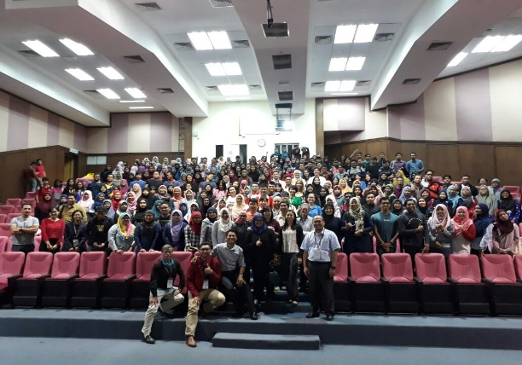
- 11th International Conference on Artificial Reef and Related Aquatic Habitats 2017 (MYCARAH2017). This conference was held on 11-13 September 2017 at the Universiti Malaysia Terengganu in Malaysia. The conference, which was supported by the CTI-CFF Regional Secretariat, was a platform for sharing of knowledge, information, experiences, ideas, which contributes to improving the benefits of artificial reefs in the global aquatic system. Participation in this event allowed the CTI-CFF Regional Secretariat to share information and promote the objective of the CTI-CFF to the MyCARAH scientific community and foster network through the role of UMT.

D.4. Other Activities of Technical Program
Collective effort in supporting and pursuing the implementation of RPOA through the function of Technical Program in 2017 has modestly emerged. This was another step to move forward in strengthening the involvement of CTI-CFF in engaging programmatic efforts. In 2017, the Technical Program supported and participated in the following activities:
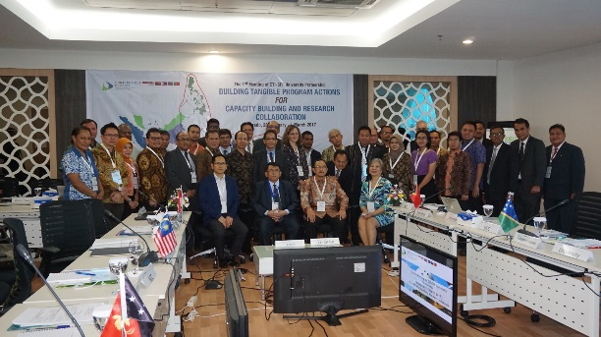
- The 1st CTI-CFF University Partnership Meeting. The meeting was held on 28 February - 1 March 2017 at the CTI-CFF Headquarters in Manado. Universities from six (6) CTI-CFF member states particularly focusing on fisheries and marine resources attended the event. Representatives from universities namely, IPB, ITS, UNHAS, and UNSRAT, University Malaysia Terengganu, University Of Papua New Guinea, University of the Philippines Diliman (UPD), Solomon Islands National University (SINU), Universidade Nacional Timor Lorosa'e (UNTL), and James Cook University (JCU) were present in the meeting. Also, representatives from CT6 NCCs were in attendance. The meeting was a venue for participants to share their insights and provide inputs on conceptual framework and mechanism of the CTI-CFF University Partnership; to build tangible and collaborative programs on capacity building, research and outreach; as well as to identify possible support and mechanism to strengthen capacity of Regional Secretariat, Technical Working Groups and NCCs.

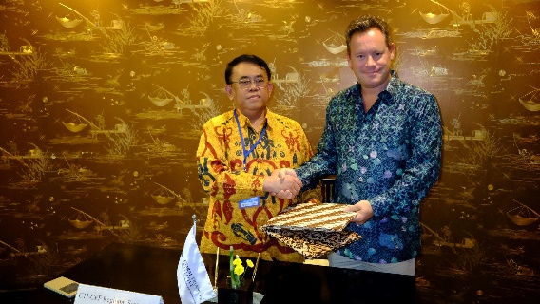
- Signing of MoU with the University of Queensland (UQ). On 8 May 2017, the CTI-CFF Regional Secretariat signed an MOU with UQ, one of Australia's leading research and teaching institutions, at the Sari Pan Pacific Hotel in Jakarta. The MoU signing provides a platform for both parties to strengthen, promote and develop cooperation and exchanges in areas of capacity-building, technical assistance, and research collaboration throughout the CTI regions in the area of marine and coastal resource management. This also marked UQ’s involvement in CTI-CFF University Partnership.
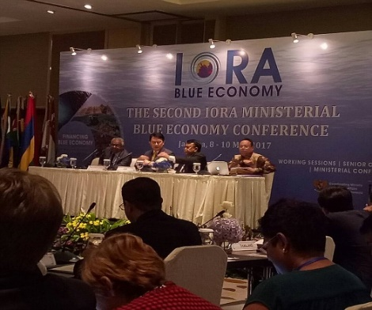
- IORA Ministerial Blue Economy Conference: “Financing Blue Economy. Dr. Widi A. Pratikto, Executive Director of the CTI-CFF Regional Secretariat was invited as a speaker in this conference. This conference was held on 8 - 10 May 2017 in Jakarta and attended by relevant Ministries/Agencies of 21 IORA member states, seven (7) IORA dialogue partners and observers. The main aim of this conference was to strengthen current cooperation in the maritime sector, in particular, the Blue Economy, among IORA Member States and Dialogue Partners. Areas of focus of the conference were fisheries and aquaculture, marine tourism, network and marine plastic debris.

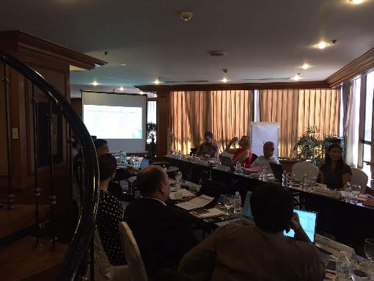
- The CTI-CFF Partners’ Meeting. The meeting was held on 23-24 May 2017 in Manila, the Philippines. It was opened by the Undersecretary for International Affairs and Foreign-Assisted Programs, Department of Environment and Natural Resources of the Philippines, H.E. Atty. Jonas R. Leones as the Chair of CTI-CFF Committee of Senior Officials followed by a speech from the Executive Director Widi A. Pratikto. The CTI-CFF Partners-Regional Secretariat Coordination Meeting specifically sought to accomplish the following objectives: 1) Coordinate and communicate with Development Partners the key programs/actions, acknowledge support extended to NCCs / CT6 Member Countries based on SOM-12, Decision No. 9.4 and 14.5, as well as engagement strategy to facilitate nations to achieve the RPOA’s higher outcomes; 2) Discuss the strategy for the review of the RPOA (SOM-12; Decision 14.6); and 3) Discuss other matters related to revitalizing the important role of CTI-CFF in conserving the coral reefs, sustaining the fisheries, and securing food from the ocean. Further, the group agreed on the following:
  - A Development Partners’ meeting (with the Regional Secretariat and Chair CSO) be scheduled for at least once a year;
  - The scope outline of the evaluation could follow that of the RPOA document itself, and examine each of the program mechanisms established therein without turning into a full examination of the degree to which the CTI goals and targets have been reached (that to be left to a later full M&E review;
  - The review should be implemented as soon as possible to ensure sufficient time for substantive draft findings to be presented at SOM-13 in November 2017; and
  - Partners can assist in the drafting of the TOR pending guidance from the Chair of the CSO.

Participants also reviewed the content of a letter on the RPOA review sent to the CSO Chair in March 2017 and endorsed its content as regards its independence, scope, purpose, timeline and suggested governance arrangements. Also, the meeting formally recommended that the partners write to the Chair of the CSO via the Philippines NCC, requesting the Chair indicate how the partners may assist in supporting next steps.

- Coral Triangle Fishers Forum (FF) III - Sustainable Coastal Fisheries through Local Innovation: Scaling Up Effective Models for IUU Reduction, Catch Documentation and Traceability (CDT) in Support of Sustainable Local Fisheries Production. The forum was held on 3-6 July 2017 in Iloilo City, Philippines and was organized by the EAFM Working Group and WWF. As for the results, the participants agreed that the outputs of the forum could become a basic reference for the member countries to further discuss the development of the CDT, including how to secure financial support for its implementation. In addition, involvement of private sectors in the development of CDT technology and application in the 3rd FF was likely to be extended to any potential PPP program developed by member countries.

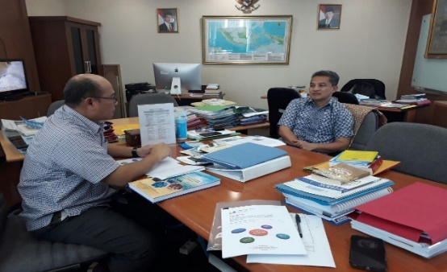
- Meeting with Chair of Financial Resources Working Group (FRWG). The CTI-CFF Regional Secretariat met with Anang Noegroho, Director of Investments of National Planning Bureau of Indonesia as well as Chair of the FRWG on 7 July 2017 in Jakarta. Among the key discussions were the following: 1) Proposal for PPP arrangement to the USAID in the area of fisheries management, in particular for CDT system should be elucidated as soon as possible, whether the proposal was accepted and necessary steps can be taken; 2) Extensive discussion and talk with FRWG member, Indonesia, should be undertaken to prepare the PPP arrangement including identifying potential private sectors to be involved, in what sectors the PPP should be focused, and how the arrangement can be made.

At the same time, the CTI-CFF Regional Secretariat met with, Mr. Syarial, Director of Investment Unit of the Ministry of Marine Affairs of Fisheries of Indonesia, as part of seeking support from the NCC. At this meeting, the discussion was more about on a consultation process to support PPP activity under CTI-CFF within the framework of the SOACAP-IFM.

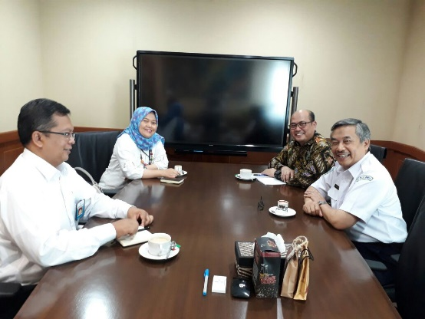
- Meeting with Indonesian Agency for Meteorology, Climatology and Geophysics (red. BMKG). On 10 July 2017, CTI-CFF RS represented by Dr. Muhammad Lukman, Technical Program Senior Manager held a meeting with Dr. Andi E Sakya, Head of BKMG. Dr. Lukman explored the potential of Global Climate Fund (GCF) scheme to initiate regional programs to support the implementation of the CTI RPOA, particularly in Climate Change Adaptation. Since the proposal should be country-based proposal, the CTI-CFF RS could propose to the CTI-CFF Climate Change Working Group to put on their agenda to consider GCF schemes. BMKG could be a channel or partner with regards to approach to WMO as GCF-AE. Exploring potential collaborative programs between CTI-CFF and BMKF-involved international organization (for Asia Pacific) in addressing the climate change challenges in the CT region was also raised and the BMKG expressed their interest and support accordingly.

- Participation in the Oceans and Fisheries Partnership Technical Working Group Planning Workshop. The CTI-CFF Regional Secretariat participated in the workshop which was held on 12 – 14 July 2017 in Bangkok, Thailand. The workshop, organized by SEAFDEC and the USAID Oceans and Fisheries Partnership, was important for the CTI-CFF RS to align its program with the Oceans, and come up with a concrete plan with SEAFDEC related to follow-up collaborative program initiation for implementation, especially related to SOACAP-IFM funded by USAID fund.

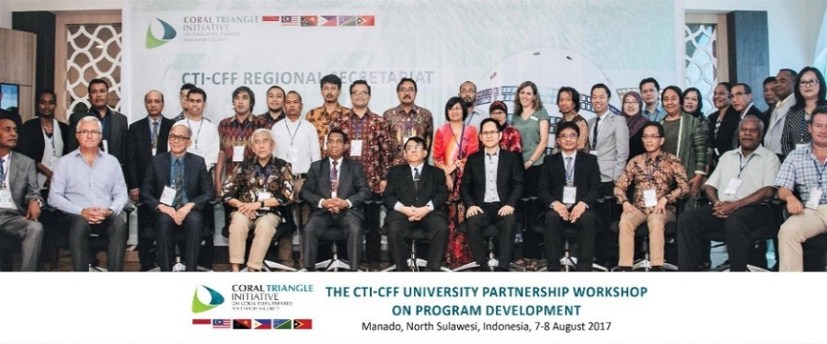
- The CTI-CFF University Partnership on Program Development. The activity was held at the CTI-CFF Headquarters in Manado in Indonesia on 7 – 8 August 2017. The meeting aimed at: (1) developing collaborative program actions for the Financial Years 2017 and 2018 as the continuation of the results of the 1st CTI-CFF University Partnership held last 28 February – 1 March 2017; (2) identifying mechanism in developing a joint-program and proposals on capacity building, research and outreach; and (3) securing financial supports. The program sessions included among others introduction to CTI-CFF University Partnership Workshop on Program Development, Capacity Building, and on Research for 2017-2018; and discussion on program priority of CTI-CFF University Partnership 2017-2018 for the community outreach. The meeting concluded with the MoU Signing ceremony between CTI-CFF and UNTL as well as between CTI-CFF and University of Papua New Guinea.

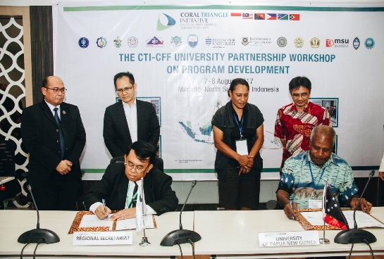
- Signing of MOU between CTI-CFF RS and University of Papua New Guinea. On the occasion of the University Partnership Workshop, the CTI-CFF Regional Secretariat and University of Papua New Guinea signed the MoU on 8 August 2017. Executive Director Widi Praktikto and Prof. Samuel Saulei of University Papua New Guinea signed the MOU, witnessed by the Chair of the Meeting, Assoc. Prof. Dr. Ramzah Dambul, Chair of the University Partnership, and Prof. Grevo Gerung, NCC of Papua New Guinea Focal Points and Technical Program Senior Manager.
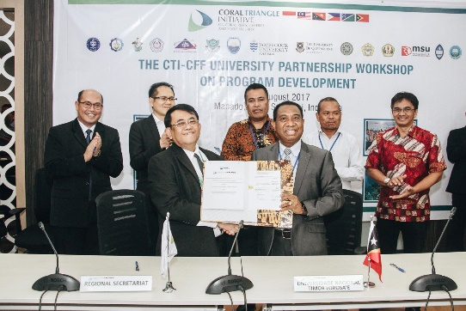
- Signing of MoU between CTI-CFF RS and UNTL. The CTI-CFF Regional Secretariat and UNTL formalized their cooperation through signing the MoU on 8 August 2017. The MoU provided the collaboration on research, capacity building and in the provision of the technical assistance in support of the sustainable management of the marine and coastal resources in the Coral Triangle region. Dr. Francisco Miguel Martins, Rector of UNTL and Dr. Widi A. Pratikto signed the MoU witnessed by Deputy Secretary General Office (Science, Technology & Innovation) of Ministry of Science, Technology & Innovation of Malaysia.
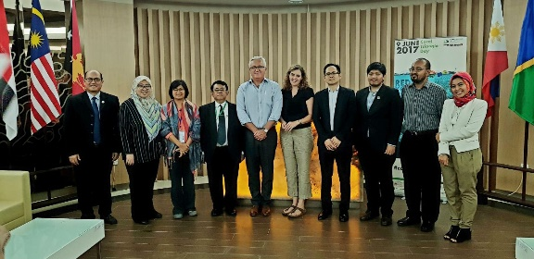
- Side Meeting with University Partners. During the occasion of the University Partnership Workshop on 7-8 August 2017 in Manado, Indonesia, NCCs of Malaysia, represented by Dr. Ramzah Dambul, Universiti Malaysia Sabah and James Cook University held a side meeting with CTI-CFF Regional Secretariat team as a follow up discussion on collaboration as well as capacity building of CTI-CFF member countries.
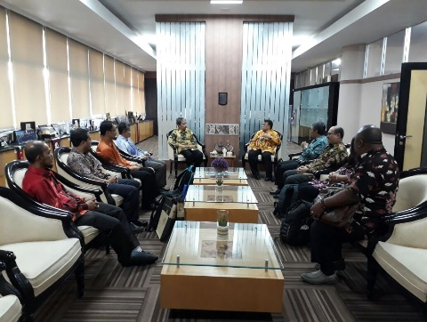
- Signing of MOU between CTI-CFF Regional Secretariat and Institute Teknologi Sepuluh Nopember (ITS) and Universiti Malaysia Trengganu. The CTI-CFF Regional Secretariat Executive Director Widi A. Pratikto together with CTI-CFF Head of Program and Project Initiation Specialist of ADB witnessed the MoU signing ceremony on 11 August 2017 in Surabaya, Indonesia. Apart from the MoU Signing ceremonial, CTI-CFF also had a thematic discussion with ITS to improve Climate Change Mitigation and Adaptation efforts in CTI-CFF member countries.

- Signing of MOU between CTI-CFF Rgional Secretariat and University of Padjajaran. Under the University Partnership framework, the CTI-CFF Regional Secretariat sealed a cooperation with University of Padjajaran-Bandung last 18 August 2017 to reach the preservation of the marine environment, sustainable fisheries and food security through a framework of cooperation to strengthen, promote and develop exchange of cooperation in the field of science and marine research. Through the MoU, research activities as well as skills capacity of human resources will increase in the field of marine and fisheries through the exchange and visitation of researcher among the CT6 countries. It will also result to the development of capacity through education and training where the purposes are intended to achieve the extended of technology development and social development, promotion and social economic welfare by means of the regional training, seminar and symposium. Further, the MoU allows both parties to change technical expertise and cooperative research.

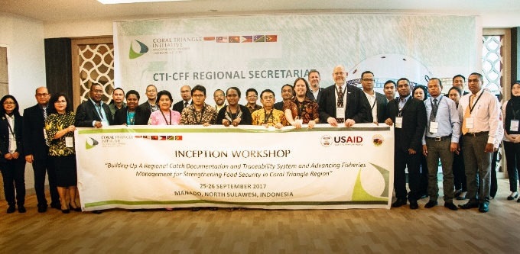
- The USAID/RDMA and CTI-CFF Regional Secretariat held the CTI-CFF/USAID Inception Workshop: Building-Up a Regional Catch Documentation and Traceability (CDT) System and Advancing Fisheries Management for Strengthening Food Security in Coral Triangle Region held on 25-26 September 2017 at the CTI-CFF Headquarters in Manado. For the period of 2017 – 2019, the USAID/RDMA through the US DOI supports CTI to introduce and develop fisheries related activities that can promote sustainable fisheries practices in the CTI region, in order to combat IUUF, promote sustainable fisheries, and conserve marine biodiversity. Attendees came from the NCC CTI-CFF member states and the resource persons were from NOAA, the Oceans Partnerships, SEAFDEC, USDOI-ITAP, Universities, and some private sectors related to the CDT. The outcomes of the workshop were the following: 1) Country analysis on the existing traceability system and the need of the country on traceability system development; 2) Recommendation on the development of countries-specific CDT System; and 3) TOR of EAFM task force on CDT System.

Part III. National Activities

- Indonesia
The implementation of the CTI-CFF program in Indonesia has been completed in 2014 in accordance with the first National Plan of Action (NPOA) 2009-2014. The objectives and targets were developed in accordance with the Medium Term Development (RPJM) and Long Term Plans (RPJP) related to coral reefs, fisheries, and food security.

In order to continue the program, NPOAs need to be reviewed and developed thoroughly to produce better outcomes in the future. The challenges, lessons learned, and recommendations that were generated from the achievements of the previous NPOA will guide the framework for developing new NPOA.

There are 5 (five) goals in NPOA:
Goal 1. Priority seascapes designated and effectively managed.
Goal 2. Ecosystem approach to fisheries management and other marine resources fully applied.
Goal 3. Marine protected areas established and effectively managed.
Goal 4. Climate change adaptation measures achieved.
Goal 5. Threatened Species status improving.

National Focal Points
Each technical working group has assigned focal points, which are as follows:
- Seascape TWG: Deputy Assistant of Maritime Services, Coordinating Ministry of Maritime Affairs and Director of Marine Spatial Planning – Ministry of Marine Affairs and Fisheries (MMAF)
- EAFM TWG: Director of Fish Resources Management, Directorate General of Capture Fisheries – MMA;
- MPA TWG: Director of Marine Conservation and Biodiversity, Directorate General of Marine Spatial Management – MMAF
- CCCA TWG: Director of Climate Change Adaptation – Ministry of Environment and Forestry
- TS TWG: Director of Marine Conservation and Biodiversity, Directorate General of Marine Spatial Management – MMAF

Further, there are also focal points assigned to technical working groups under the Governance Division. The focal points are as follows:
- Financial Resources TWG: Director of Marine Fisheries – Ministry of National Development Planning
- Coordination Mechanism TWG: Director of Asia-Pacific and African Intra-regional Cooperation, Ministry of Foreign Affairs
- Monitoring and Evaluation TWG: Director for Oceanographic Research Center, Indonesia Institute of Science.

The focal points for each technical working group also represent Indonesia in their respective technical working group at the regional level.

Progress towards NPOA
The Indonesia CTI-CFF NCC through its technical working groups continued in its efforts in ensuring the goals identified in the NPOA will be achieved. The following highlights the achievements, challenges, lessons learned in 2017 as well as identified next steps for each goal.

Goal 1. Priority seascape designated and effectively managed.
Achievements
The Office of the Marine Spatial Planning is focused on coming up with planning and management tools for Indonesia’s Seascapes. In 2017, significant achievements had been attained which were as follows:
- National Marine Spatial Planning (MSP) on legislation process.
- Five (5) zoning of the coastal areas and small islands had been established - North Sulawesi, West Sulawesi, East Nusa Tenggara, West Nusa Tenggara, and Central Sulawesi.
- MSP of Lesser Sunda national seascape was finalized.

Challenges
Harmonizing regulations and authorities among sectors and government levels as well as allocating marine space for social-economic objectives with considering ecological sustainability remain a challenge.

Lesson Learnt and Next Steps
Despite the challenges met, there were also lesson learnt such as the importance of collaboration among stakeholders, cross-sectoral coordination as well as an updated and integrated data.

As next steps, the following activities will be undertaken:
- develop National Seascapes Management Guidelines, adopted from seascapes document;
- initiate and coordinate with Timor Leste, Papua New Guinea, and Solomon Islands to establish trans-boundary seascapes (Lesser Sunda & BSS); and
- coordinate with TWG MPA, EAFM and TS in Sulu-Sulawesi Seascape Management.

Goal 2. EAFM is fully applied.
Achievements
In 2017, some of the notable achievements for the EAFM were reducing IUUF through development of community based IUU fishing reporting system in collaboration with NGOs and CSOs; deployment of observers on board in 11 Fisheries Management Areas; and implementation of the Fisherman ID Card program all over 34 Provinces with about 1,109,313 ID Card (2009-2017) and 500,000 insurance distributed.

However, it is to be noted that coordination among implementing agencies, multi species and multi gear fisheries as well as the large number of small-scale fishermen over vast geographical area remain a challenge for EAFM to be fully implemented.

Lesson Learnt and Next Steps
Critical to the full achievement of EAFM is coming up with indicators that can be adopted in Fisheries Management Plan and establishing a mechanism/guideline for coordination among stakeholder.

In the year to come, operationalization of Fisheries Management Council to promote co-management on fisheries and development of a harvest strategy for specific fisheries will be the focus.

Goal 3. MPAs established and effectively managed.
Achievements
Indonesia has a total of 169 MPAs (92% out of the total target 20 million ha by 2020), with 18.4 million ha in total number. Its MPAs covered 940,707 hectares or 37% of coral reefs ecosystem. Another significant achievement is providing access and partnership to local community for fishing.

Challenges
Ensuring that MPA contributes to support fisheries/fisheries management areas and ensuring sustainable financing system contributes to effective MPA management remain a challenge. Further, there is also the need to optimize MPA utilization for economic benefits of local communities (ecotourism, mari-culture and capture fisheries).

Lesson Learnt and Next Steps
The valuable lessons learnt from the implementation of activities are strong collaboration among stakeholders is important to support and improve MPA management as well as coming up with community-based income generating activities is important.

Among the next steps to be undertaken will be the development of zoning and management plans; strengthening partnership program in supporting MPA management; and development of sustainable marine tourism in MPA.

Goal 4. Climate change adaptation measures achieved.
Achievements
In 2017, the TWG identified and nominated an existing institution as Center of Excellence on CCA. Further, vulnerable areas and ecosystems to climate change were identified and mapped. Policy and guideline development as well as capacity building were also pursued.

Challenges
Mainstreaming CCA development along with ensuring a sustainable and innovative funding scheme for climate change adaptation remain a challenge. Extra effort is also required to attracting potential funding from private and development partners.

Lessons Learnt and Next steps
Regular financial support for activities is important to sustain CC programs. And in order to cope with limited resources, there is a need to build a strong network and cooperation with non-state actors and pursue other mechanism.

Therefore, in future activities, potential development partners will be involved to support CC/CCA actions. An inventory of CC activities being proposed or carried out by NGOs will also be conducted. Mainstreaming ocean issue in UNFCCC will be pursued.

Goal 5. Threatened Species status improving.
Achievements
The government together with partners continues to undertake actions to realize Goal 5. In 2017, compilation of documents particularly the National Conservation and National Assessment Reports for sharks, mantas, marine mammals and turtles was done. Genetic study for green turtle (Chelonia mydas), olive ridley turtle (Lepidochelys olivacea) and leatherback turtle (Dermochelys coriacea) were also undertaken. Further, migration study for whale shark in West Papua was carried out. Development of network for stranded marine mammals in certain locations as well as utilization of fishing gear using green LED that can reduce 38% sea turtle by-catch as a pilot project were also pursued.

Challenges
However, quick response on stranded mammals, monitoring and surveillance threatened species in remote area; lack of resources to conduct species data collection and analysis; and ways to minimize the frequency of shark by-catch remain a challenge.

Lessons Learnt
In the implementation of the above-mentioned activities, lessons learnt are as follows:
- Social media contributes in reporting incident (stranded, hunted, consumed, by-catch, etc).
- Joint management between agencies and communities helps in combating illegal activities.
- Genetic study on sea turtles should focus on specific species.
- Universities should be involved in the study of threatened species population and the development of fishing gear technology to reduce by-catch.

As of December 2017, Indonesia has considerably implemented activities that will achieve NPOA’s goals as shown in Table 14. Indonesia further hopes for other member states and partners’ support to accelerate the achievement of the NPOA’s goals that will contributed to the RPOA.

Table 14. Status of Indonesia’s NPOA

Working Group | Total Actions | Complete | Ongoing | Not started
Seascape | 8 | 0 | 7 | 1
Ecosystems Approach to Fisheries Management | 21 | 8 | 9 | 4
Marine Protected Area | 7 | 5 | 2 | 0
Climate Change Adaptation | 7 | 0 | 7 | 0
Threatened Species | 4 | 0 | 4 | 0
Total | 47 | 13 | 29 | 5

Development Partners
The Indonesia CTI-CFF NCC has 12 active partners in various projects to realize the goals of the NPOA. These are the Environment Facility (GEF), USAID, Australian Government Department of Environment, ADB, CI, TNC, CTC, Wildlife Conservation Society (WCS), WWF, RARE, ReefCheck and GIZ.

Other Activities
Indonesia NCC celebrated Coral Triangle Day on June 9 and the theme was “Reduce Your Plastic Waste.” Indonesia NCC also launched the Dugong Ambassador, Mr. Arifin Putra to spread campaign on Dugong and Seagrass Conservation. Another activity was the Ocean Care Movement or GITA LAUT to encourage people to love our ocean through various activities such as coastal school, coastal jamboree, school champaign, beach clean up and underwater photography contest.

- Malaysia
For 2017, Malaysia CTI-CFF NCC through the efforts of the different working groups and support of development partners were able to carry out various activities towards meeting the targets of the NPOA.

National Focal Points
Each technical working group has assigned focal points, which are as follows:
- Seascape TWG: Department of Fisheries Sabah, Ministry of Agriculture & Food Industry Sabah
- EAFM TWG: Department of Fisheries Sabah, Ministry of Agriculture & Food Industry Sabah
- MPA TWG: Sabah Parks, Ministry of Tourism, Culture & Environment Sabah
- CCCA TWG: Strategic Technology and S&T Application Division, Ministry of Science, Technology & Innovation (MOSTI)
- TS TWG: Department of Fisheries, Ministry of Agriculture & Agro-based Industry Malaysia (MOA)

Development Partners
Malaysia’s activities in relation to CTI are being supported by various development partners. Table 15 shows the status of the projects being implemented through the support of development partners for 2017.

Table 15. Malaysia’s Partners and Status of Partnership

Partner | Project/Program | Status
GIZ | Project: CTI-GIZ Sulu Sulawesi Seascape Programs: Seascape and EAFM, MPA and CCA Planning | Ongoing
Conservation International, Australian Government, GIZ | Program: CTI-CFF Seascapes General Model and Framework Document | Ongoing
WWF | Application of Climate Change Coastal Adaptation Toolkits | Ongoing
WWF | Project: Support the implementation of TMP Integrated Management Plan | Ongoing
ADB | Project : Capacity building for MPA managers & stakeholders Program : Cross visit to WAKATOBI (6 MPA managers & 3 stakeholders, August 2017) | Completed as of August 2017
ADB | Network of Marine Protected Area (NMPA) National Activities in Malaysia under the ADB-funded Coastal and Marine Resources Management in the Coral Triangle-Southeast Asia Project | RETA activity is ongoing; MOA ended on September 2017
Wildaid | Project : Conduct study & design a cost-effective compliance strategy for the TMP to design and recommend a practical control and vigilance system for the park. Outcome: TMP Compliance strategy plan prepared | Completed as of January 2017
SEAFDEC | 1. Published waterproof field guide book entitled : Identification guide to sharks, rays and skates of the Southeast Asian Region in 2017 2. “SOP Sharks and Rays Data Collection in the Southeast Asian Waters in 2017” | Completed
SEAFDEC | ASEAN Sharks and Rays Data Collection Program Towards Sharks NDF, 2013 – 2017 | Ongoing

Activities conducted in support of CTI
In 2017, Malaysia had series of activities to support initiative of the CTI. These were focus on raising awareness, building capacity and sharing/exchanging of ideas and insights. Table 16 shows the 2017 CTI—related activities of Malaysia.

Table 16. Malaysia’s 2017 Activities
Activity | Date | Implementor and Partner
Awareness Program
World Ocean and Coral Triangle Month | 19 April 217 – 6 May 2017  15 June 17– 15 July 2017 | MOSTI, UMT  MOSTI, UMS
Ocean Conservation For All (OC4A) | 9 September 2017 | MOSTI, UMS
Climate Change Impacts towards Marine and Fisheries | 15-17 November 2017 | MOSTI, UMS
Ecosystem Discovery Journey | 16 November 2017 | MOSTI, UKM
“No Shark Fin” Campaign | 13 December 2016; 28 September 2017 – 1 October 2017; 12-14 October 2017 | Department of Fisheries
Workshop Training
Tun Mustapha Park (TMP) regulation based on conservation zoning plan | 23 – 26 January 2017 | Sabah Park, WWF-Malaysia, State AG
EAFM Cross Visit | 17 – 22 April 2017 | DoF Sabah, GIZ, CI Philippine)
Sabah Honorary Park Ranger | 21– 25 August 2017 (training as Honorary Park Manager (HPM))  28 – 30 November 2017 (refresher course HPM) | Sabah Park, WWF-Malaysia, GIZ  Sabah Park, GIZ
Climate Change Impacts Workshop (Phase 1) | 25-27 October 2017 | MOSTI, ASEAN COST, CTI RS
Seminar/Symposium
TMP Scientific Expedition 2017 & Seminar on Expedition | 10 April -19 May 2017 and 20-21 November 2017 | Sabah Park, Universities , NGOs, WWF-Malaysia, Dewan Bahasa dan Pustaka  ( DBP)
Sabah Anti Fish Bombing Symposium | 3 – 5 May 2017 | Sabah Park, MMEA, WWF-Malaysia, Scubazoo, Reefcheck Malaysia
Assess Management Effectiveness of Sabah MPAs | 11 – 13 July and 4 – 7 September 2017 | Sabah Park, WWF-Malaysia, GIZ
Others
TMP Collaborative Enforcement Program | 13 June and 20-21 July 2017 | Sabah Park, WWF-Malaysia, GIZ
TMP Sustainable Financing program | 17 April – October 2017 | Sabah Park, WWF-Malaysia, State Attorney General (AG)
Co-management of Tun Mustapha Park | 18 September 2017 | Sabah Park, WWF-Malaysia, State AG

Progress towards NPOA
Goal 1: Priority seascapes designated and effectively managed.
Achievements
The final draft of CTI-CFF Seascapes General Model and Regional Framework for Priority Seascapes as well as final draft of Monitoring and Evaluation Indicators were completed.

Challenges
Developing and finalizing the Seascapes document and M & E Indicators remain a challenge. Further, funding and technical assistance are needed for socializing the Seascapes document at national level.
Lesson Learnt and Next Steps
In the implementation of NPOA, continuity in leadership provided clear ways forward. Malaysia will be focusing on the establishment of Seascapes technical team at national level and socializing the Seascapes document as part of its next steps.

Goal 2: Ecosystems approach to management of fisheries and other marine resources is fully applied.
Achievements
Among the key achievements were as follows:
- Developed draft of CTI-CFF COASTFISH (Sustainable Coastal Fisheries and Poverty Reduction Initiative) Initiative Regional Framework designed to apply EAFM.
- Participated at the 3rd CT Fishers Forum (produced more EAFM champions and successors).
- Attended the CTI-CFF/USAID Inception Workshop Building up a Regional Documentation and Traceability Scheme (CDT) advancing fisheries management for food security in the CT region. Draft TOR of the Task Force for CDT development is available for the next step.
- Implemented four (4) EAFM replication sites (benefitted 150 stakeholders).
- Conducted four (4) EAFM capacity development programs (produced 58 EAFM champions).

Challenges
The challenge in realizing the targets in Goal 2 is the limited funding for the following activities: training more EAFM champions, strengthening national EAFM technical team, and conducting M & E on all EAFM projects.

Lesson Learnt and Next Steps
Lesson learnt in the implementation of EAFM-related activities are: the continuity in leadership and clear ways forward is necessary to ensure the success of EAFM implementation; and existing cooperation at national and regional level is crucial. EAFM TWG will be strengthening EAFM technical team, establishing more EAFM replication sites and conducting M & E as part of its next steps.

Goal 3: Marine protected areas established and effectively managed.
Achievements
The notable achievements in 2017 were the operationalization of TMP started (staff deployment, assets purchasing & routine patrolling); co-management of TMP based on Integrated Management Plan is demonstrated through community involvement (HPR); collaborative Enforcement Committee & MOU with WWF-Malaysia fostered; and knowledge of MPA management effectiveness assessment tool imparted to Sabah Parks & stakeholders.

Challenges
Among the challenges are: limited and need for sufficient resources (knowledge, human, financial) to manage large MPA; tight schedule for implementation programs to operationalize TMP and activities supported by partners; and travel advisory to some areas for activity implementation affected progress.

Lesson learnt and Next Steps
In the implementation of MPA-related activities, understanding of legal basis for all program is crucial. Further, it is important to ensure close coordination among partners and stakeholders as well as to be time flexible and adaptive in the implementation of activities.

As next steps, Malaysia’s MPA lead group will conduct MEAT assessment of other Sabah MPAs; implement strategies under TMP Integrated Management Plan; and come up with Gazette TMP regulation and implement zoning plan.

Goal 4: Climate change adaptation measures achieved.
Achievements
In 2017, the CCA Working group were able to: develop the draft Terms of Reference (TOR) for Regional COE on CCA; organize the Workshop on Climate Change Impacts under ASEAN COST (SCMSAT) which was attended by non-CTI ASEAN member states; apply REAP and CCA toolkits at five (5) locations; and participate in CTI Blue Carbon Workshop.

Challenges
MPA implementation requires inter disciplinary activities/program between CTI goals. Further, there is a need to improve communication within CCA lead agencies, stakeholders and focal points. Another challenge is the difficulty in synchronization of research directions and activities, priorities, evidence-based and cross-cutting knowledge between all CT6. The absence of Blue Carbon element in national climate change policy will also be a hindrance in the full realization of the goal.

Lesson Learnt and Next Steps
One notable lesson learnt is that CCA toolkits could be shared and applied with non-CTI countries which has similar geographical features.

As next steps, the working group will: embark on national blue carbon initiative by engaging relevant ministries; identify pool of experts to support the establishment of regional COE CCA; and create networking in terms of human resources and infrastructure required for CoE on CCA.

Goal 5: Threatened Species status improving.
Achievements
Installation of Turtle Excluder Devices in all vessels that operate the monsoon season trawlers started 1 November 2017.

Challenges:
More technical assistance and funding needed to support threatened species activities i. Baseline data especially marine mammals is needed to conserve threatened species.

Lesson Learnt and Next Steps
It is worthy to note the importance of threatened species in marine ecosystem. As next steps, the Working Group will develop baseline data on target species - sharks & rays, turtles & marine mammals; strengthen Threatened Species Working Group cooperation among members; publish six (6) more threatened species (4 sharks and 2 rays).

As a summary, out of the 133 identified actions needed to achieve the NPOA, 37 or 28% has been completed while 67 or 50% are ongoing. On the other hand, 29 or 22% of the actions have yet to start. The status of Malaysia’s NPOA is shown in Table 17.

Table 17. Status of Malaysia’s NPOA

Working Group | Total Actions | Complete | Ongoing | Not started
Seascape | 20 | 8 | 11 | 1
Ecosystems Approach to Fisheries Management | 55 | 18 | 25 | 12
Marine Protected Area | 19 | 1 | 8 | 10
Climate Change Adaptation | 18 | 1 | 12 | 5
Threatened Species | 21 | 9 | 11 | 1
Total | 133 | 37 | 67 | 29

In 2017, Malaysia was entrusted as Interim Chair of CMWG. Further, University of Malaysia Sabah (UMS) is the 2nd university in Malaysia (after UMT) to sign MOU with the CTI-CFF Regional Secretariat under CTI-CFF University Partnership.

For 2018, Malaysia CTI-CFF NCC has set its sight on the following activities:
- Hosting of the 5th RBF 2018 with the continued thematic focus on sustainable marine tourism
- 2nd phase of CCA workshop to be organized tentatively in mid-2018
- Handover of the Chairmanship of TSWG

- Papua New Guinea
Papua New Guinea implemented various CTI-related activities with support from different government agencies and development partners. The national focal points of the working groups were also active in representing Malaysia at the regional level to help plan and implement activities.

National Focal Points
Each technical working group has assigned focal points, which are as follows:
- Seascape TWG: Conservation and Environment Protection Authority (CEPA); Co-Chair is TNC
- EAFM TWG: National Fisheries Authority (NFA)
- MPA TWG: CEPA
- CCCA TWG: Climate Change and Development Authority(CCDA)
- TS TWG: CEPA

Under the Governance Working Group, the focal points are:
- FRWG: CEPA
- CMWG: CEPA; Co-Chaired by NCC,TNC
- MEWG: CEPA Co-Chaired by NCC, NFA

Development Partners
The budgetary support and technical assistance provided by development partners of Papua New Guinea have been significant in ensuring the projects will be carried out according to its objectives and thus, contribute to the NPOA. Table 18 shows PNG’s partners and their supported projects.

Table 18. Papua New Guinea’s Partners and Status of Partnership

Partners | Project | Status
The Nature Conservancy | Support the NCC on the Ridge to Reef Sustainable Natural Resources management planning for New Britain Island | Ongoing
Wildlife Conservation Society | Marine Program in Manus | Ongoing
Rainforest, Reef Conservation | Building Resilience on Developing a National Ranger Program Ranger program | Ongoing
WWF | Research and distribution of Hawksbill Turtles, in Milne Bay | Ongoing
Live and Learn | Capacity Building on Education and Awareness programs | Ongoing
Centre for Locally Marine Areas | Mangrove Rehabilitation and capacity building and enhancement program | Ongoing
Centre for Community Law Rights | Paralegal training for local coastal community on Laws for protected areas | Ongoing
Department of Environment Australia & Commonwealth Scientific and Industrial Research Organisation (CSIRO) | Database development on Marine Values for New Britain Island pilot study | Ongoing
Partners with Melanesia | Mangrove restoration project, Marsh | Ongoing
UNDP GEF 5 | National Protected Areas Program for PNG Coastal Resource Management | Ongoing
14 Maritime Provincial Governments | Technical capacity and local community support | Ongoing
Private Sector | Enhancement projects and support to local community projects in designated locations only | Ongoing
ADB RETA | Support the Papua New Guinea (PNG) Marine Program and the PNG NCC | Extended until 2018

Activities conducted in support of CTI
PNG conducted and supported activities that will further contribute and promote the goals of the CTI-CFF. These activities were the following:
- Maritime Governor Roundtable Conference.
- Signing of the CTI MoU by the 14 Maritime Province Governors as a pledge of support to promote CTI CFF under the PNG Marine Program 2017 – 2021.
- Conducted 1st Ranger Training program in support of Threatened Species in the Southfly District.
- Conducted the CT Day and released three (3) green marine turtles.
- Made a voluntary commitment of Bootless Bay on the Coral Triangle Day during the Ocean Conference.
- Conducted NPA consultation on MPAs, Reserves, Parks.
- Protected Areas Bill to be endorsed by parliament for Protected Area conservation.
- Developed a Protected Areas Implementation Plan for PNG aligned with the CTI Marine Programs.
- Conducted the Marine Value Database pilot project in East New Britain Province.
- Attended the Blue Carbon Research hosted by Philippines government.

Progress towards NPOA

Goal 1. Priority seascapes designated and effectively managed.
Achievements
PNG had built capacity for sustainable and responsible Bismarck Sea, particularly on the following areas:
      - Ridges to reef planning (TNC as lead)
    - Mapping where resources are
    - Assessing the value of the resources
      - Values database (CSIRO lead)
    - Framework to collate and illustrate the EGS values
    - Interactive interface is in development to aid in decision-making
      - Decision Making process (CSIRO lead)
- Research and assessment of decision making processes to guide Ridges to Reef Planning, application of values database, and to target key capacity gaps

PNG is continuously working in collaboration with CEPA, United Nations Development Program (UNDP) and East and West New Britain Provincial Governments for seascape activities. Other stakeholders involve are communities across New Britain, community-based organizations (CBOs), industry (primary engagement has been with oil palm and tourism) and all levels of government in PNG. Funding was provided by the Australian Government through the Department of Environment and Energy.

Lesson learnt
In the implementation of the activities, one is guided by the questions/challenges “Where to draw the “seascape” line? and concern on technical capacity and communications. The solutions lie to listening to the people and including the full island and the marine areas they depend on. Further, reaching out to all communities and providing them a variety of tools should also be taken into account.

For the project “Building Capacity for Responsible and Sustainable Development in the Bismarck Sea,” CEPA, TNC & CSIRO realized the benefits of working in collaboration with a wide range of stakeholders to address the pressing needs of New Britain, the Bismarck Sea, and the south coast shores of the Solomon Sea.

Goal 2. Ecosystem approach to fisheries management and other marine resources fully applied.
Achievements
Among the key achievements under Goal 2 were the following:
- 2016 National Beche-de-mer Fishery Management Plan
- Implementation of CBRM through the support of WWF, TNC, WCS.
- Vessel Monitoring Scheme and Observer Program in place; EU Yellow Card lifted
- Inshore FADs; Seaweed Trapnet; Deep water snapper
- EAFM Training
- Information system under the creel market surveys

Challenges
Capacity to maintain the implementation of key projects i.e. CBRM, FMA, Special Spawning area; Enforcement on IUU Fisheries; and political support to meet international obligation remain a challenge to fully achieve targets.

Lessons Learnt and Next Steps
Cross-cutting agencies, legislation gaps, duplication of activities, need for consultants and contractors, as well as sustainable financing were some of the considerations in the implementation of the activities.

As next steps, PNG will focus on the establishment of Fisheries TWG; support coastal fisheries management plans; support the Provincial Fisheries Heads forum; and link Fisheries activities with the Western Pacific Regional Fishery Management Council (WPRFC) aligned with EAFM activities.

Goal 3. Marine protected areas established and effectively managed.
Achievements
PNG were able to successfully implement the following activities:
- Conduct inventory of the Protected areas in PNG
- Conduct public consultation of the PA Policy where an implementation plan was developed and will be costed through support from ADB TA
- Protected area new bill was endorsed by Department of Justice & Attorney General (DJAG) and has gone from the first reading to 2nd reading and ready for parliament endorsement by 2017
- Continuously working on demonstration site on Bootless Bay with funding support from JICA to develop a national MPA process for the country

Challenges
Full realization of goals for MPA is hindered by the lack of political support for endorsement of the new PA Bill; lack of support and awareness with cross-cutting government and NGO collaboration; and lack of sustainable funding to support provincial and national agencies to perform other duties under the PA policy.

Lessons Learnt and Next Steps
In the implementation of MPA-related efforts, creating partnerships with all stakeholders in development of the PA work plan is important. Further, it is worthwhile to do joint submission for funding through government or other donor agencies. Linkages with NGOs must be very strong to promote coastal community livelihood projects as well as strong local-level government (LLG) support to develop PAs/MPAs is crucial to attract good partnership and strong financial commitments are valuable lesson learnt.

Next Steps
Papua New Guinea will work on the following activities: Parliament’s endorsement for the PA Bill to become a law; provide financial justification for the PA Work plan so that sustainable funding can be secured through PNG government and through donor agencies including UNDP and ADB; ensure action on voluntary commitment for two (2) protected areas and five (5) fisheries sites during the Global Oceans Conference under the SDG; and ensure demonstration of MPA of Bootless Bay (research to commence on January 2018) to become 1st MPA model.

Goal 4. Climate change adaptation measures achieved

Achievements
Among the noteworthy achievements were:
- Able to achieve most of the policy targets set in the country Roadmap;
- Adopted seven (7) other additional policies and strategies related to CCA but not targeted in the roadmap;
- Built the profile of the Blue Carbon in PNG;
- Capacities built through knowledge and skills gained especially in the area of Blue Carbon;
- Established network and strengthened partnerships with experts and resources persons from CT6 member countries in the area of CCA;
- Improved networking and participation among CCA stake holders in PNG; and
- Able to identify policy gaps on BC and initial discussion taken place.

Challenges
There are still many challenges that need to be look into and these are the: lack of up to date data on profile of BC ecosystems and other relevant data for CCA; lack of capacity in equipment and resources; complication in coordination with local governments; lack of sustainable funding; presence of policy gaps and legislation; and cross-cutting activities by other government agencies.

Lesson learnt and Next Steps
In the implementation of the CCA activities, it is important to know the types of CCA (BC activities and projects being implemented by CT members countries; the protocols and guidelines on mangroves restoration; and CCA policies and strategies of the other CT6 member countries. One must also have a readily available and up to date CCA and have identified funding options for CCA activities internally.

Further, there are benefits to gain from networking and establishing partnership with experts, resources persons and other member countries. It is important also to have proper coordination with local government and national agencies.

As next steps, PNG will strengthen partnership and network with national, regional, and international partners to implement effectively Blue Carbon activities; improve coordination with local government and national stakeholders; do a Blue Carbon ecosystems profile of the country; identify gaps on CCA (Mangroves); and take a stock take of all CCA and BC activities in the country.

Goal 5. Threatened Species status improving.
Achievements
In 2017, Ranger training was conducted which concentrated on building resilience in PNG and Protected Areas Bill submitted before parliament for endorsement.

Challenges
Inadequate funding and political support are hindering the full implementation of activities.

Lessons Learnt and Next Step
Building membership with cross-cutting agencies is important to realize the goals of the NPOA. Therefore, as a next step, coordination through inter-agencies collaboration will be pursued by PNG CTI-CFF NCC.

In summary, PNG has completed 40 out of the 63 actions identified in the NPOA. There are still 23 ongoing activities; 16 activities have yet to start. Table 19 shows the summary of the PNG’s NPOA.

Table 19. Status of Papua New Guinea’s NPOA
Working Group | Total Actions | Complete | Ongoing | Not started
Seascape | 4 | 2 | 2 | 2
Ecosystems Approach to Fisheries Management | 23 | 15 | 7 | 1
Marine Protected Area | 15 | 10 | 7 | 5
Climate Change Adaptation | 12 | 8 | 4 | 4
Threatened Species | 9 | 5 | 3 | 4
Total | 63 | 40 | 23 | 16

Other Activities
In 2017, PNG conducted, supported and implemented the following activities:
- Attended the World Oceans Conference in New York and made seven (7) voluntary commitments to promoting Coral Reef, Fisheries and Food Security
- Working very closely with WCS on the new Marine program in support to the PNG Marine Program
- Submitted ADB Technical Assistance to support PNG NCC 2018 particularly on the drafting of the Dugong and Marine Turtle plan for selected maritime province for 2018; NCC enhancement
- Review and amend the PNG Marine Program 2017 -2020
- Support of Pas through the UNDP GEF 5/6.

- Philippines

In 2017, the Philippines implemented various CTI-related activities with its NNC at the helm and through the assistance of different government agencies and development partners. The national focal points of the working groups actively participated in various national and regional activities to help carry out identified activities in support of NPOA, and RPOA in general.

National Focal Points
The focal points for the following technical working group are as follows:
- Seascape TWG: Dir. Theresa Mundita S. Lim DENR-Biodiversity Management Bureau
- EAFM TWG: USec. Eduardo Gongona DA-Bureau of Fisheries and Aquatic Resources
- MPA TWG: Dir. Theresa Mundita S. Lim DENR-Biodiversity Management Bureau
- CCCA TWG: Comm. Noel Antonio V. Gaerlan Climate Change Commission
- TS TWG: Dir. Theresa Mundita S. Lim DENR-Biodiversity Management Bureau

Under the Governance Working Group, the focal points are:
- FRWG: Dir. Angelito Fontanilla DENR
- CMWG: Department of Foreign Affairs (DFA)
- MEWG: Dir. Theresa Mundita S. Lim DENR-Biodiversity Management Bureau

Development Partners
The Philippines has about 20 development partners and nature of engagement are focused on MPAs, fisheries, biodiversity, social networking, resource valuation, conservation and masteral program. Table 20 shows the list of the Philippines’ partners as well as the status of projects being worked on.

Table 20. Philippines’ Partners and Status of Partnership

Partner | Projects | Status
GIZ | Sulu- Sulawesi Seascape Project | Ongoing
UNDP | • Strengthening Marine Protected Area to Conserve Marine Key Biodiversity Areas | Completed as of June 2017
 | • SmartSeas | Ongoing
 | • Strategic Action Plan for the Sustainable Fisheries Management of the Sulu Celebes (Sulawesi) Large Marine Ecosystems
ADB | RETA 7813: CTI Support for Southeast Asia | Completed
UP-Marine Science Institute (UPMSI) | • MPA Support Network | Ongoing
 | • Coastal and Marine Ecosystems Management Project (CMEMP) | Ongoing
 | • Professional Masters in Tropical Marine Ecosystems Management (PMTMEM) | Ongoing
 | • CCA | Ongoing
US National Oceanic and Atmospheric Administration (NOAA) | MPA Capability Building Program | Ongoing
 | EcoFish Project | Completed
USAID | Protect Wildlife Project | Ongoing
 | Oceans Partnership | Ongoing
Conservation International | Seascapes, MPA, EAFM, CCA and Threatened Species | Ongoing
UN Environment | Green Fins Code of Conduct (Reef World Foundation) | Ongoing
 | The Economics of Ecosystems and Biodiversity (TEEB) | Completed as of June 2017
WWF | Marine Key Biodiversity Area (MKBA), EAFM (Tuna), Threatened Species, CCA | Ongoing
World Fish | COASTFISH | Ongoing
BFAR-NFRDI | Tuna Genetics, Threatened Species, CCA | Ongoing
PEMSEA | SDS-SEA | Ongoing
COBSEA | South China Sea Project | Ongoing
SEAN | Coastal and Marine Environment Nature Conservation and Biodiversity | Ongoing
World Bank | Philippine Wealth Accounting and Valuation of Ecosystems (PhilWAVES) | Completed as June 2017
International Fund for Agricultural Development (IFAD)
Marine Wildlife Watch of the Philippines | Sharks and Marine Turtle Conservation | Ongoing
LAMAVE | Large Marine Vertebrates (Sharks) Conservation | Ongoing
Coastal Conservation and Education Foundation | MPAs | Ongoing

Activities conducted in support of CTI
To support efforts of the CTI, the Philippines CTI-CFF NCC conducted and supported the following activities:
- Launching of the Coastal and Marine Ecosystems Management Program
- Coral Triangle Day
- UP Marine Science Institute –MPA Support Network (UPMSI-MSN) Para el Mar Awards
- Conference of the Parties to the Convention on the Conservation of Migratory Species of Wild Animals (CMS COP12) – Approval of COP Resolutions
- Sulu Sulawesi Seascape
- West and North Philippine Seas
- Philippine Rise – designated as proposed MPA
- Marine Debris
- Leader’s Breakfast
- NPOA Review
- RPOA Review - initiated discussions within NCC

Progress towards in NPOA

Goal 1. Priority seascapes designated and effectively managed
Achievements
In 2017, the Philippines were able to carry out the following activities:
- Sulu-Sulawesi Seascape Implementation continued: Lessons learned and best practices documented in Seascape model and Regional Framework of CTI-CFF
- West Philippine Sea Expedition
- North Philippine Sea Expedition (including Philippine Rise
- Ongoing implementation of Executive Order No. 533: Integrated Coastal Management Policy

However, the absence of a policy framework to designate an in country seascape under CTI definition remain a challenge.

Lesson Learnt and Next Steps
The Sulu Sulawesi Priority Conservation Areas are mainstreamed in the Philippine Key Biodiversity Areas where conservation programs and investments are focused. As next steps, the Philippines will conduct research and exploration of new seascapes and link with other regional cooperation mechanisms (e.g. BIMP-EAGA, ASEAN, PEMSEA, COBSEA, etc.)

Goal 2. Ecosystem approach to fisheries management and other marine resources fully applied
Achievements
The Philippines were able to accomplish numerous EAFM-related activities that contributed to realizing the NPOA goals. These activities were:
• Adopting EAFM in BFAR Programs and activities (as stipulated in RA 10654)
• Development/Customization of EAFM Modules in Philippine Setting
• Identification of Pilot Sites for Fisheries Management Areas
• Continued Municipal Fisherfolk Registration and Boat Registration
• Vessel Monitoring System/Vessel Monitoring Measures and Fisheries Observers Programs
• Collaboration with the Department of Social Welfare and Development (DSWD0 in the implementation of Sustainable Livelihood Program
• Consultation of and adoption of Reference Points and Harvest Control Rules
• Continued Mangrove Reforestation activities through Philippine National Aquasilviculture Program
• Conducted Essential EAFM Trainings and Training of Trainers
- National Stock Assessment Program
- Implementation of Seasonal Closures in several Major Phil Fishing Grounds
- Adoption and publication of the Philippine Status Reports and NPOA of Napoleon Wrasse, Sharks and Rays 2017-2022
- Napoleon Wrasse Non-Detrimental Findings Study
- Formulation of policy and regulation on capture and transport of live reef fish trade • Produce quad media (TV, print, radio and social media) materials to promote fisheries management and conservation e.g. MMK, Capture Fisheries Atlas of the Philippines, FishBOOK, etc.

Challenges
There are limitations/challenges that hinder or delay realization of identified targets in the NPOA. These are:
destructive and illegal fishing practices; limited institutional capacity (assets and resources); complexity of multiple stakeholders (overlapping governance responsibilities); high disaster risk areas.

Lessons Learnt and Next Steps
In carrying out the activities, it was noted that forging strong linkage with concerned Civil Society Organizations (CSOs) and other academic and research institutions helped in maximizing efforts and resources. As next steps, Philippine will carry the following activities:
- Implement mainstreaming EAFM nationwide
- Update the NPOA costing and determine budget allocations for this goal
- Pilot various modalities for sustainable finance and ensure policy support for sustainable financing
- Develop and finalize the EAFM M&E for the NPOA
- Ensure the alignment of the NPOA to the Philippine Development Plan

Goal 3. Marine protected areas established and effectively managed.
Achievements
Among the significant achievements in 2017 were as follows:
- Establishment of Marine Turtle Protected Area Network (MTPAN)
- SmartSEAS: establishment of locally managed MPAs and MPA networks within mKBAs
- Recognition of best managed MPAs (national and local) and MPA networks (Para El Mar; regular METT/MEAT)
- Updating of MPA database system
- Nomination of Ecologically or Biologically Significant Marine Areas (EBSA) (Benham Rise)
- Tubbataha designated as a Particularly Sensitive Sea Area
- Resumption of bilateral discussions with Malaysia on Turtle Islands Heritage Protected Area (TIHPA)
- Seagrass and intertidal flats protection and management are mainstreamed in national policies (CMEMP, Blue Carbon Initiative)
- Valuation of Coastal Ecosystems (Asanza et.al., 2017)
- Declared 1M hectares of MPA (Cagayancillo, Palawan)

Challenges and Next Steps
Among the challenges delaying the accomplishment of Goal 3 are incomplete technical description of MPAs; many locally managed MPA have no management plan; inadequate management plan implementation, monitoring, and evaluation; sustainable financing for some MPAs.

Lesson Learnt and Next Steps
Multi-sectoral partnership will aid in completing identified activities. As a next step, the Philippines will focus on climate-smarting MPA management plans.

Goal 4. Climate change adaptation measures achieved.
Achievements
The Philippine were able to carry out CCA activities that are align with NPOA and RPOA. These activities were the following:
- Coastal Vulnerability Assessment in El Nido
- People Survival Fund allocated for qualified municipalities (Lanuza, Surigao Del Norte and Del Carmen, Surigao Del Sur)
- Green-gray solutions project in Iloilo: awareness raising of local governments and communities, and capacity building on Ecosystem-based Adaptation/Eco-DRR, climate change adaptation and vulnerabilities, and DRRCCA planning in preparation for pilot-testing of nature and engineering solutions to CCA
- Blue Carbon Initiative
- Mangrove and Beach Forest Development
- Tool: Climate and Disaster Risk Assessment (CDRA)
- ADB TA 8493 “Climate Resilience and Green Growth in Critical Watersheds: Davao Or, CamSur and Lower Marikina” (With ADB and JFPR)
- Conduct of ENRA, PES, CCVA and GHG
- Demonstration of the Ecotown Framework in the Provinces of Romblon and Bohol
- Conduct of Natural Resources Assessment (NRA) and Vulnerability Assessment (VA) in Provinces of Romblon and Bohol
- Conduct of Training-Workshop on Planning for Climate Change in the Coastal and Marine Environment
- Youth Camps and Inset training for Science teachers (Palawan, Zambo del Sur and Zambo Sibugay) on Climate Change and Adaptation and Coastal Resource management

Challenges
Delay or limitation in the implementation of CCA activities are due to the following reasons: development the Local Climate Change Action Plan (LCCAP); institutional arrangements; mobilization of CSOs and private sector in the implementation of adaptation measures; and standardization of VA methodology.

Lessons Learnt and Next Steps
Instrumental to the success of the implementation of CCA activities is due to linkage with other institutions (i.e. IRRI for climate smart rice). As next steps, the Philippines will work on the official creation of the Blue Carbon National Steering Committee and National Blue Carbon Technical Working Group and mainstream Blue Carbon into national policies.

Goal 5. Threatened Species status improving.
Achievements
For 2017, among the activities accomplished by the TS Working Group were the following:
- Creation of pool of experts
- Hosting of CMS COP 12 and promotion of CMS in the region
- Elevation of the protection status of species under the following: a.) Convention on International Trade in Endangered Species (CITES) b.) CMS (resolutions)
- Manado statement on the establishment of Marine Turtle MPA Network
- International Union for Conservation of Nature (IUCN) Red Listing Workshop for Aquatic Wildlife Species
- Development of In-Country Status Report for Sharks and Napoleon Wrasse with attached National Plan of Actions
- Capacity Building on Aquatic Wildlife and Fishery Law Enforcement

Challenges
Status of threatened species may not improve if the following issues persist: trade-related issues; mobilization of aquatic wildlife funds; and trans-boundary enforcement.

Lessons Learnt and Next Steps
The status of threatened species in the Philippines will improve with the following: multi-sectoral cooperation; linking of wildlife protection with habitat management and social benefits and provision of alternative livelihood for communities. As next steps, the Philippines will roll out and implement sharks and rays and napoleon wrasse NPOAs on the national and regional levels; and conduct habitat assessment of areas for potential expansion of MTPAN.

Other activities implemented and supported by the Philippines are shown in Table 21.

Table 21. Other Activities Implemented and Supported by the Philippines

Activity | Date | Venue
CTI-CFF 1st Threatened Species Working Meeting | March 22-23, 2017 | Putrajaya, Malaysia
FRWG, Proposed Budget for 2017 and Other Financial Matters Meeting | March 29-31, 2017 | Pasig City, Philippines
Seascapes Technical Working Group Meeting | May 15-19, 2017 | Honiara, Solomon Islands
Partner’s Meeting | May 22-23, 2017 | Pasig City, Philippines
Tri-National Workshop on the Establishment of a Sea Turtle MPA Network and MCS in the Sulu-Sulawesi Marine Ecoregion Priority Seascapes | June 12-14, 2017 | Manado, Indonesia
Fisher’s Forum back to back with Tuna Governance Workshop | July 4-67, 2017 | Iloilo City, Philippines
COASTFISH Workshop and EAFM TWG Meeting | August 1-4, 2017 | Tagaytay, Philippines
Blue Carbon Workshop | August 28-30, 2017 | Tagaytay City
CCA TWG Meeting | October 12-13, 2017 | Manila, Philippines
University Partnership Meeting | August 7-8, 2017 | Manado, Indonesia
SEAFDEC/USAID Regional Fisheries Management Planning Workshop (August 2017)
ASEAN Working Group on Coastal and Marine Environment (AWGCME) – DENR-BMB as the host | May 2017 | Conrad Hotel, Pasay City
CTI-CFF Side Event at the UN Ocean Conference | June 6, 2017 | UN Headquarters, New York
Inception Workshop: Building-Up a Regional Catch Documentation and Traceability (CDT) System and Advancing Fisheries Management for Strengthening Food Security in Coral Triangle Region | September 25-26, 2017 | Manado Indonesia
12th Meeting of the Conference of Parties to the Convention on the Conservation of Migratory Species of Wild Animals | October 23‐28, 2017 | Manila, Philippines

Apart from the activities mentioned, during the CMS-COP12, the Philippine Resolution adopted the following: Manila Declaration on Sustainable Development and Migratory species; Sustainable Tourism and Migratory Species; Promoting Marine Protected Area Networks in the ASEAN Region; Promoting conservation of critical intertidal and other coastal habitats for migratory species; and CMS COP12 Presidency.

As presented during the SOM-13, out of the 60 actions to be undertaken, the Philippines has completed 14 while 42 are ongoing. Two (2) actions/activities that have yet to be started. The status of the Philippines’ NPOA is shown in Table 22.

Table 22. Status of Philippines’ NPOA

Working Group | Total Actions | Complete | Ongoing | Not started
Seascape | 9 | 3 | 4 | 2
Ecosystems Approach to Fisheries Management | 24 | 6 | 18 | 0
Marine Protected Area | 8 | 0 | 8 | 0
Climate Change Adaptation | 11 | 3 | 8 | 0
Threatened Species | 8 | 2 | 6 | 0
Total | 60 | 14 | 42 | 2

- Solomon Islands (SI)

The SI National Work Program is guided by the NPOA framework and its implementation plan. It is premised on implementing a Community-based Resource Management (CBRM) framework supported by policy and legislation, capacity building, knowledge management and enhanced awareness, outreach and education. The regional themes seascapes, ecosystems-approach to fisheries management, marine protected areas, climate change adaptation and threatened species are embedded within the CBRM framework. In 2017, the SINPOA was in its 8th year of implementation.

The NCC provides an oversight and coordination of various activities, projects and programs related to the NPOA and RPOA goals. It also monitors progress and initiates partnerships and collaborations through complimentary programs/events to enhance national and local actions. NCC members included government agencies, NGOs, universities and other technical stakeholders. The NCC is co-chaired by the Permanent Secretaries for MECDM and MFMR (SOM representatives) supported by two national coordinators from the two agencies.

Below is a list of county focal points aligned with the regional TWGs and governance working groups. This provides the link to regional implementation of priority activities and coordination between Regional Secretariat and other partners. The leads are supported by a team of technical officers, assigned by the NCC, forming national working groups.

National Focal Points
- Technical Working Groups
- Seascape TWG: MECDM (Environment & Conservation Division) and MFMR (ERSI Project)
- EAFM TWG: MFMR (Inshore Fisheries and Policy/Projects Divisions)
- MPA TWG: MECDM (Environment and Conservation Division) and MFMR (Inshore Fisheries)
- CCA TWG: MECDM (Environment & Conservation Division, Policy Monitoring Unit and Climate Change Division)
- TS TWG: MFMR (Inshore Fisheries) and MECDM (Environment & Conservation Division)

- Governance Working Groups
- Financial Resources TWG: MFMR and Ministry of Development Planning
- Coordination Mechanism TWG: MECDM and MFMR
- Monitoring and Evaluation TWG: MECDM and MFMR

- Cross-cutting themes
- University Partnership: SINU supported by MECDM/MFMR Local
- Local Government Network: MECDM/MFMR supported by MPGIS
- Regional Business Forum: MFMR and MECDM supported by Ministry of Culture and Tourism
- Women Leaders Forum: MECDM/MFMR supported by Ministry of Women

NPOA implementation is supported (funded) by key development partners – Australia, ADB/GEF and USAID; and non-governmental organizations such as WorldFish, The Nature Conservancy, Conservation International and WWF –Solomon Islands, Solomon Islands Community Conservation Partnership (SICCP). Other national partners and projects are also contributing to achieving the goals of the NPOA and RPOA. Table 23 shows the list of related projects and programs supported by development partners.

Table 23. Solomon Island’s Partners and Status of Partnership

Partners | Projects | Status
Regional & National (CTI-aligned)
Australia CTI Support Program - through Conservation International | Expanding Reach of CBRM in SI and Sea Turtles Project (Data and Knowledge, Capacity Building, CBRM and TS | Ongoing
Australia CTI Support Program - through CSIRO | Enhancing Pacific Ocean Governance (Data and Knowledge Management) | Completed
ADB RETA 7753 - Through WorldFish Solomon Islands | Malaita Province ICM (EFM, CBRM) | Ongoing
ADB RETA 7753 | SI NPOA and Costing Exercise | Initiation
WWF | Regional Study: CTI-CFF Sustainable Nature-based Tourism | Completed
MFMR – SIG | Inshore Fisheries Division (CBRM Program) | Ongoing
MECDM – SIG | Division (CTI National Work Program and Climate Change Division (CCA) | Ongoing
NGOs/Projects supporting implementation with non-CTI funding (Site or Sector based)
WWF Solomon Islands | EAFM, MPAs | Ongoing
TNC Solomon Islands | MPAs, CBRM, EAFM, TS | Ongoing
Solomon Islands Community Conservation Partnership | CBRM, TS | Ongoing
Wildlife Conservation Society | Protected Areas – MPA, CBRM and Seascapes (proposed) | Ongoing
MSSIF Project (NZ funded) | MFMR Institutional Strengthening – EAFM, CBRM | Ongoing
PROP Project (World Bank and GEF) | CBRM | Ongoing
MACBIO Project (SPREP, GIZ and IUCN) | Marine Spatial Planning (Ocean governance, Locally Managed Marine Areas and Ecosystem serves valuation) | Ongoing

The Solomon Island also conducted activities in support of Regional efforts. It hosted the 2nd Regional Exchange on Seascapes (Honiara) to finalize the Seascapes Regional Framework. CT6 representatives attended along with other technical experts from Wildlife Conservation Society, CSIRO and CI Philippines. The Australia government and Conservation International supported this event.

In partnership with other government agencies, private sector, schools, NGOs and schools, Solomon Islands celebrated World Environment Day, World Ocean Day and Coral Triangle Day. Activities were held in Honiara and also in Western Province (led by WWF and Western-based partners and the Provincial government). Special follow-up events in the year including hosting of the first ever National Resources Management Symposium and conducting a highlight event of Miss Nature Pageant Show for Schools.

In collaboration with the CTI-CFF Regional Secretariat and WWF, the Solomon Islands hosted the CTI –Side event during the UNOC in New York last June 2017. Both CTI national coordinators attended the event. Further, it co-facilitated the participation of the Solomon Islands Minister of Foreign Affairs to co-host the side event in partnership with CTC, WWF, Solomon Islands Mission Office to UN and the CTI-CFF Regional Secretariat.

Solomon Islands was also present during the ADB 50th Annual Meeting in Japan 2017. SI- WLF representative, Agnetha Vave-Karamui attended the side session as panelist through the support of TNC and CTC.

Progress towards NPOA
National progress is also reported as national actions aligned with the five CTI-CFF goals. Achievements, challenges and the next steps are outlined under each thematic area

Goal 1. Priority seascapes designated and effectively managed.
Achievements
With guidance from the Seascapes WG and CI, the Seascapes NCC TWG developed a national seascapes roadmap as guide towards establishment of a potential ‘priority seascape’ within its national waters. A proposal was drafted to explore options for a seascape area between Isabel Province and Choiseul Province. Moreover, with collaboration from the MACBIO Project, the government initiated a national Marine Spatial Planning process.

Challenges
One of the challenges is the limited technical and institutional capacity for large scale marine planning and management. Solomon Islands still in the process of learning. Also, there is a concern on jurisdictional matters – communities’ vs provinces vs national government. There is a need for clarity on issues of ownership, benefit sharing including boundaries for inshore and offshore priorities. There is also a challenges in engaging private sector into national discussions.

Next Steps
As next steps, the Solomon Islands government will socialize Seascapes General Model and Regional Framework for national implementation. It will also pilot test the General Model on a selected national seascape and seek support towards seascapes implementation from development partners (national/regional and international).

Goal 2. Ecosystem approach to fisheries management and other marine resources fully applied.
Achievements
Key achievements for the year 2018 in the area of EAFM were as follows:
- Developed the MFMR Strategy 20172019 and Corporate Plan 2014-2018
- Completed Finfish market surveys in Honiara and Western Province
- Completed Invertebrates survey in Honiara
- Provided support to establish Constituency Fisheries Centers in Provinces = 16 target sites
- Established the and capacity building for new CBRM Unit within MFMR
- Expanded and supported FAD Program (livelihoods and food security)
- Supported partners’ projects – Ridge to Reef Initiatives, provincial networking and exchanges, research and women empowerment through micro-financing schemes
- Expanded Seaweed Farming
- Completed Phase 1- Pilot research of sea-cucumber (peanut fish) breeding and hatchery in Guadalcanal Province

Challenges
Remoteness – limited access to EAFM information and support by communities; limited finance, technical capacity and human resources; limited research expansion and support; and price fluctuations of the world market are concerns that need to be addressed to fully realize EAFM application.

Next Steps
The Solomon Islands government will focus its efforts on the following activities:
- Complete market surveys and analysis for Malaita Province with WorldFish/HapiFish. This to be replicated for Lata, Temotu Province.
- Develop MFMR CBRM policies
- Finalize fisheries inshore regulations for gazettal
- Develop Aquatic Biosecurity Guidelines (Aquaculture)
- Expand Sea-cucumber research sites. Proposal to be in Central Islands Province (Sandfly area)
- Hand-over of Constituency Fisheries Centre (CFCs) in provinces

Goal 3. Marine protected areas established and effectively managed.
Achievements
The Solomon Islands government made its first officially declared first National Marine Park in SI under the Protected Areas Act 2010, the Arnavon Community Marine Park (in collaboration with Choiseul and Isabel Provincial Governments, TNC and Arnavon Community Marine Conservation Area (ACMCA)). Also, MPAs/MMAs national data and information (use of CT Atlas) were submitted into SPREP Protected Areas Portal, World Database of Protected Areas and SOLGEO platforms.

Challenges
Irregular and inconsistent updating of MPAs, MMAs and taboos data into the national and regional M&E and information sharing platforms because of time and capacity issues is still a concern. Further, data sharing and feedback from implementing partners and communities is often challenging.

Next steps
The Solomon Islands government will be taking undertaking the following activities as a continuing effort for MPAs:
- Update status of MPAs or MMAs in CT Atlas and other relevant platforms (Biodiversity and Protected Areas Management (BIOPAMA) & World Database on Protected Areas (WDPA))
- Finalize SI MPA Management Effectiveness Tool (SI MAME tool)
- Progress official designations and declarations of other managed marine areas (submissions or Expression of Interests (EOIs) made) under the Fisheries Management Act or Protected Areas Act
- Continue training and awareness on MPAs and related topics for communities, provinces and other enforcement agencies and stakeholders

Goal 4. Climate change adaptation measures achieved.
Achievements
For 2017, the Solomon Islands government were able to undertake the following activities:
- Initiation of the development of Climate Change Legislation – now in its drafting stage
- Rolling out and adoption of the REAP and LEAP as guide for implementation by CCA partners and projects for community-based activities
- Completed the Vulnerability and Adaptation (V&A) assessment profile for Choiseul Province
- Re-vitalized the National Climate Change Working Group as a multi-stakeholder group for monitoring of the National Climate Change Policy implementation
- Establishment of the Geospatial Unit within the Climate Change Division. This will be useful for climate change data and analysis functions
- Introduction of the Blue Carbon Initiative through the CCATWG
Challenges
One challenge is the competing priorities - the marine sector has low support vs. land-based CCA activities which mostly cover the land/agriculture adaptation programs. Further, there is also limited capacity – technical and financial. Also, most projects concentrate or occur in Western parts of SI and there is needed attention for eastern parts vulnerable to impacts of climate change.

Next steps
As part of its next steps, the Solomon government will
- finalize drafting of Climate Change Bill for submission to Cabinet for endorsement;
- review National Climate Change Policy. This will be an opportunity to include blue carbon concepts and objectives and integrating an ocean focus); and
- initiate the second provincial-wide V&A assessment (target - Malaita Province).
Goal 5. Threatened Species status improving.
Achievements
Key achievements of the Solomon Islands government were the Parliament adoption and gazettal of the Wildlife Protection and Management Amendment Act (WPMA Amendment) 2017 and in collaboration with James Cook University and Secretariat of the Pacific Community (SPC), an updated national Sharks check-list was finalized.

Challenges
The limited government budgets for threatened species programs is still a concern. There are existing national programs such as the Critical Ecosystem Partnership Funds support programs for prioritized endangered species including some NGO projects, however, these cover site-specific areas or communities and not at national scale. Majority of these focus are on marine turtle conservation. Only one national project addresses dugong and seagrass conservation implemented by WorldFish and SICCP.

Also, there is limited capacity in technical, financial and institutional for protection and management of threatened species. Data-sharing issues between ground implementation and leading government agencies leading to poor reporting on threatened species status continue to be a concern.

Next Steps
As next steps, the Solomon Islands government will finalize supporting regulations for the Fisheries Management Act 2015 and WPMA (Amendment) 2017; review and update the National Marine Turtles Action Plan; develop the National Dugong and Seagrass Management Strategy; develop a National Coral Management Plan; and develop the National Red List as per WPMA Regulations, Fisheries Regulations and with guidance from research findings and national surveys.

Annually, the SINPOA 25 prioritized actions are tracked and evaluated in terms of their ‘completed’, ‘ongoing’ or ‘not yet started’ status.

Goal 1: Seascapes
- Strengthen the regional BSSE Tri-national agreement between Indonesia, PNG and Solomon Islands to improve governance of sea turtles and potentially other trans-boundary resources and issues. (Ongoing)
Goal 2: EAFM
- Define policy and institutional commitments to a harmonized and collaborative work programme and outline implementation strategy. (Ongoing)
- Consolidate the enabling environment: Finalize review of Fisheries Act 1998 and adopt Coastal Community Strategy. Produce protected areas legislation (as committed to under Programme of Work on Protected Areas (PoWPA) which specifically complements Protected Areas and resource management to be achieved under Community Based Fisheries Management contemplated in the revised Fisheries Act. (Completed)
- Develop best practice, guidance and model for implementation of community based approaches to fisheries management and protected areas which includes ecosystem approaches and community strategies for adaptation to climate change and early warning of locally threatened species. (Completed)
- Develop and implement data sharing protocols and guidelines between government, NGO and community partners, collate available information on natural resources stocks and inventories, MPAs and traditional closed areas, threatened species, climate change, vulnerability, traditional knowledge and governance. Develop and manage simple and accessible joint database and Geographic Information System. (Ongoing)
- Incorporate feedback from trial strategy for joint implementation and harmonization of traditional and recent community management and protected areas under national, provincial and traditional governance/management (including ordinance, bylaws and customary processes). (Ongoing)
- Prepare appropriate materials and curriculum for community awareness and field staff training in line with the integrated community based approaches to fisheries management and protected areas. (Ongoing).
- Specific training and guidance for community managers, traditional leaders, local enforcement (empowered under acts), police or courts. Capacity building for data management and analysis. (Ongoing)
- Design and initiate programme of institutional strengthening of national and provincial bodies to ensure long-term capacity to sustain environmental management. (Ongoing)
- Prepare and deploy appropriate public awareness materials (size limit, restricted gear, community management plans, sale of undersize fish etc. (Ongoing)
- Expand and consolidate integrated community based approaches to fisheries management and protected areas in selected provinces and initiate staggered implementation in new provinces. (Ongoing)
- Explore synergies with CT governments through BSSE Tri-national agreement between Indonesia, PNG and Solomon Islands. (Ongoing)
- Finalize and disseminate management plans (for Live Reef fish and ornamental trade) in consultation with provincial and community stakeholders. (Not yet started)
Goal 3: MPA
- Preliminary gap analysis, cost-effective and useful to community and local field staff to define conservation targets, socio-economic and poverty gaps and inform research and monitoring strategies. In addition this will provide information to refine Protected Area models and strategies supplementary to the extended network of community driven fisheries MPAs. (Ongoing)
- Implement targeted and selected monitoring and research of biological and social parameters based on gap analysis and implementation plan for integrated community based approaches to fisheries management and protected areas. (Not yet started)
- Ensure support for the expansion and consolidation of integrated community based approaches to fisheries management and protected areas in selected provinces and initiate staggered implementation in new provinces. (Ongoing)
- Improve and support networking through national network (SILMMA) and provincial networks where appropriate for information sharing, capacity building, community involvement and ensuring linkages for ecosystem approach. (Ongoing)
- Seek funding for scholarships for professional training of Solomon Islanders and development of national curricula. (Ongoing)
Goal 4: CCA
- Rapid and preliminary assessment of information availability, priority adaptation issues and areas of particular vulnerability in conjunction with data collection and management under Goals #2 and #3. Includes assessment of coral reefs, fisheries and marine food security adaptation needs and priorities and mapping. (Ongoing)
- Integrate awareness and possible management option advice into integrated community based approaches to fisheries management and livelihoods. Includes promotion of mangrove/coastal forest planting programs. (Ongoing)
- Identification and implementation of priority adaptation/mitigation actions identified under Action 1 above. (Ongoing)
- Support Institutional Strengthening of the newly established Climate Change Office under MECM and priority research under Goal #3 Action #2. (Completed)
Goal 5: Threatened Species
- Support and implement surveys on priority threatened / target species and habitats as determined above. These may include turtles, dolphins, spawning aggregations and target species. (Ongoing)
- Integrate feedback from Community Fisheries Management plans on local knowledge of threatened or decreasing stocks of species as early warning on status of SI threatened species and critical stocks. (Not yet started)
- Ensure collation of local and national information on threatened species in the joint database and preliminary production of national list of threatened species (National Red List). (Not yet started)
For 2017, out of the total of 25 actions, 84% were either completed or ongoing and 16% of these have not yet started. Below is a list of projects that had been completed, still ongoing and has yet to start. Table 24 below outlines national progress of the five regional themes.

Table 24. Status of Solomon islands NPOA

Working Group | Total Actions | Complete | Ongoing | Not started
Seascape | 1 | - | 1 | -
Ecosystems Approach to Fisheries Management | 12 | 2 | 9 | 1
Marine Protected Area | 5 | - | 4 | 1
Climate Change Adaptation | 4 | 1 | 3 | -
Threatened Species | 3 | - | 1 | 2
Total | 25 | 3 | 18 | 4

Other Complimentary Efforts
As part of its overall goal to safeguarding the ocean, the marine and coastal resources and its services for its peoples and communities, Solomon Islands have used other various national, regional and international collaborations, partnerships and networks to gauge support for its national activities and programs. These were taken in 2017 and highlighted as complimentary to the efforts towards implementing the CTI-CFF RPOA and SINPOA objectives.

In partnership with MACBIO Project (SPREP, IUCN and GIZ), the government established the Ocean12 (including TWG), a body comprising of 12 Government Agencies that are responsible for ocean issues and functions. Key objectives for this is to develop an overarching SI National Ocean Policy and to develop a national marine spatial plan in which work has commenced for drafting of the country’s Special Unique Marine Areas and the Typology maps. The Solomon Islands Marine Ecosystem Services Valuation Report had been launched earlier in the year.
As part of its Voluntary Contributions for oceans, the Solomon Islands government submitted commitments to the United National Ocean Conference in New York last June 2017. These commitments included the national efforts to developing and implementing an integrated oceans policy and a marine spatial plan, supporting community-based resource management, reviewing the Environment Act for improved pollution control, improving fisheries management using Vessel-Day Scheme platform and finalizing its maritime boundaries and zones. Also, new collaborations were made with Wildlife Conservation Society and notably also with the SINU. Noting that SINU had also signed an MOU with the CTI-CFF Regional Secretariat.

2018 Prospects
Importantly, one of the key activities for 2018 is the NPOA Review and costing exercise work that will be conducted with the support of the ADB Coral Triangle Pacific Project. A consultant will be engaged to conduct national review on the work program and provide recommendations for an updated framework.

In 2018, work will be prioritized around the technical working groups and participation of members in focused thematic discussions and learning with the aim to build the country’s individual and institutional capacity for each of the regional goals especially Seascapes, EAFM and threatened species. Solomon Islands had assumed regional roles as the Regional WLF Chair and the Regional Vice-Chair of the Council of Ministers and Senior Officials Meeting, thus support will be to ensure the country’s participation and lead in these respective fora.

E.Timor-Leste

In 2017, the Timor-Leste government implemented and coordinated various CTI-related activities through the assistance of different government agencies and development partners. The national focal points of the working groups actively participated in various national and regional activities to help carry out identified activities in support of NPOA, and RPOA in general.

National Focal Points
Technical Working Groups
- Seascape TWG: Mr. Antonio de Jesus
- EAFM TWG: Mr. Lino de Jesus Martins (Chair)
- MPA and Threatened Species TWGs: Mr. Jose Monteiro (Supported By Junior Pascoal Carvalho)
- CCA TWG: Mr. Rui dos Reis Pires

Development Partners
Various development parts are supporting Timor-Leste in implementing its CTI-related projects. These partners are listed in Table 25.

Table 25. Projects with Timor-Leste’ Partners

Partners | Projects
CI | MPA(Conservation Area), EAFM(Fisheries Coastal Management Area), Threatened Species(Sea Mammals Conservation), Seascape, Livelihood (Partner with CI & WFC)
UNTL/CCCD | Research on climate change and biodiversity
FAO | CCA (Future Plan), LSME (Transboundary)
Haburas | Climate Change (Campaign of Marine Environment)
JICA | Capacity building (Over Sea Trainings)
CTC | Woman Leadership, Capacity Building (MPA Connectivity & Learning network), Fisheries Socio Economic Survey
ROMAN LUAN | MPA (Dissemination law and involving local awareness on coastal & marine resources)
PEMSEA | Capacity Building (ICM., Manatuto, Liquica)
Arafura and Timor Seas Expert Forum (ATSEF) (Phase2: 017-2020) | ICM, EAFM, MPA

Other activities conducted in support of CTI were Coast Cleaning (Funded by GoTL) which involved students and other stakeholders as well as Woman Leaders’ Forum.

Progress towards NPOA
Goal 1. Priority seascapes designated and effectively managed.
Achievements
In 2017, Timor-Leste established a Roadmap of Seascape Design.

Challenges
Limited funds, personnel and experts remain a challenge for Timor-Leste’s seascape initiatives.

Lessons Learnt and Next Steps
Learning new concepts and synchronizing many activities were part of the lesson learnt in the implementation of seascape activities. As part of next steps, the government of Timor-Leste is targeting by 2020 the following:
- presence of a resolution on the North Seascape;
- developed Seascape Strategy Plan;
- Resources Mapping & Data Gathering using EBM Tools Enabling legal framework, Ecosystem-Based Management (MPA); and
- Maintenance and restoration of critical habitats and ecosystems.

Goal 2. Ecosystem approach to fisheries management and other marine resources fully applied
Achievements
Among the significant accomplishments under the EAFM initiatives were the following:
- Fish-stock assessment
- Program integrated on crocodile management
- Environmental education in coastal areas
- Biological monitoring on MPAs areas
- Continuation mangrove replantation
- Social economic survey of fishermen and fish folks
- Constructing fresh water aquaculture/Brackishwater - Government and CTSP have concluded a comprehensive participatory mapping of Marine Spatial planning at Nino Konis Santana National Park
- Completed comprehensive participatory mapping exercise in priority areas
- Developed a Aquaculture Development plan as part of Timor Leste Strategic Plan
- National Ocean Policy
- National Legislation on marine resource conservation
- Provided alternative livelihood (FADs, Seaweed Farm)
- Costume Traditional law (Tara Bandu)

Goal 3. Marine protected areas established and effectively managed
Achievements
The Timor-Leste had undertaken various MPA-related activities, and these were as follows:
- Discussion with the Indonesian Government on the establishment of a trans-boundary protected area network; and
- Developed and implemented capacity building activities targeting mainly Environmental Managers in the Fisheries, Environment and Forestry Directorates (Central Government) and local government officers. 3. MPA effectiveness Management Tools.

Also, there were significant progress in the following MPAs in Timor-Leste: Nino Konis Santana National Park (NKSNP) in Lautem; MPA Atauro in Dili; MPA Batugade in Bobonaro; and MPA Kaitehu in Liquica (ongoing).

Goal 4. Climate change adaptation measures achieved.
Achievements
The following were the CCA activities accomplished in the year 2017:
- Adopted coral reef resilient to climate change principles in the MPA zoning/network design
- Developed and implemented early warning and response plan to climate adaptation
- Developed a coastal rehabilitation program to anticipate climate change impacts
- Started strictly implementing commitment to UNFCCC
- Established Center Climate Change and Biodiversity (CCCB-UNTL)
- Developed and operated national information network on climate changes
- Formed Global Climate Change Alliance (GCCA), MAF and GIZ, 4 years
- Coastal Resilience, MAF, Ministério do Comércio, Indústria e Ambiente (MCIA) and UNDP
- To’os ba Moris Diak (TOMAK), DFAT and MA
- AVANSA Project, MAF and USAID
- Dili-Ainaro Corridor
- Strengthening Agricultural Productivity (SAPIP), GAFSP
- Established a baseline for future monitoring activities of several climate change-related parameters in the nearshore ecosystem (NOAA, 2017)

Goal 5. Threatened Species status improving.
For 2017, Timor-Leste finalized the zoning of marine component of the NKSNP and completed identification of birds species by Forestry. Also, there are ongoing activities such as finalization of the cost-benefit analysis for the adhesion to CITES; assessment on threat status of species under different ecosystem categories to culminate the gaps identified by National Biodiversity Strategy and Action Plan (NBSAP); started discussion on the development of a threatened species act and have produced at least on draft management plan for the most threatened species and/or habitat identified by NBSAP; and care for marine mammals (dugong, whale, dolphin).

On the other hand, Timor-Leste Government has yet to start its priority site under Lesser Sunda protected area design. In summary, Timor-Leste completed 14 out of 32 actions in the NPOA; 14 are still ongoing while four (4) actions have yet start as shown in Table 25.

Table 26. Status of Timor Leste’s NPOA

Working Group | Total Actions | Complete | Ongoing | Not started
Seascape | 0 | 0 | 0 | 0
Ecosystems Approach to Fisheries Management | 9 | 6 | 3 | 0
Marine Protected Area | 8 | 0 | 5 | 3
Climate Change Adaptation | 8 | 6 | 2 | 0
Threatened Species | 7 | 2 | 4 | 1
Total | 32 | 14 | 14 | 4

Despite the notable accomplishments in the implementation of the NPOA, there are still challenges that need to be addressed. These are:
- lack of technical assistance and support of national level;
- lack of public awareness;
- law enforcement;
- limited human resources;
- limited of infrastructure and public facilities; and
- limited of financial support.

As a way forward, Timor-Leste will continue to improve public awareness and capacity building; improve law enforcement; improve capacity building for human resources (expert and technical); improve infrastructure and Public Facilities as well as financial support.

The progress made by the member countries in the implementation of their respective National Plan of Actions and the effort of some states to update their NPOA had been recognized during the SOM-13. Further, it was recognized that there is still the need for some member countries to review and finalize their financial structure to support the implementation of their respective NPOAs. Development partners’ assistance to complete this task and also to provide technical assistance to effectively implement programs and activities on the areas of seascapes, EAFM and threatened species are still crucial.

Part IV. Development and Government Partners

The CTI-CFF’s formal partners include governmental, inter-governmental and non-government organizations who support the CTI-CFF Regional Secretariat and the CTI National Coordinating Committees in achieving the goals specified by the CTI Regional Plan of Action.

The partners play an important role in sustaining the Coral Triangle by providing technical and scientific expertise; funding for priority conservation and sustainability projects; and activities at the regional, national and community level. Partners also support the CTI-CFF in the preparation of reports and
studies; and communications support to increase public awareness about the Coral Triangle and the CTI-CFF.
The CTI-CFF also engages individuals and other stakeholders such as academic and private sector institutions, in various projects at the regional and national level.

The CTI-CFF has maintained its linkage with its partners namely, ADB, Conservation International, Coral Triangle Center, Department of Environment and Energy of the Australian Government, GIZ, USAID Sea Project, USAID Oceans, USDOI, and USAID RDMA.

Further, during the SOM-13, the Wildlife Conservation Society (WCS) was considered to become a new partner of the CTI-CFF having met the CTI-CFF Partnership criteria. The senior officials further welcomed any potential support it can extend toward to CTI-CFF.

The WCS was founded in 1895 as the New York Zoological Society (NYZS). Its goal is to conserve the world's largest wild places in 16 priority regions, home to more than 50% of the world's biodiversity. Particularly, its mission is to save wildlife and wild places worldwide through science, conservation action, education, and inspiring people to value nature.
WCS has worked in the Coral Triangle for over 20 years. Its marine and terrestrial programs in Indonesia, Papua New Guinea, Malaysia and Fiji are nationally and internationally recognized. WCS programs in the region have grown across to include more seascapes, more local partners including new initiatives in Solomon Islands.
WCS have technical strength in protected areas designation and management, species conservation (with special expertise in sharks/rays, cetaceans and wildlife trade), small-scale fisheries management, ridge-to-reef management, integrated coastal management, community-based resource management, and climate change adaptation. (Source: “On the ground and in the water in the Coral Triangle: WCS in Indonesia, Papua New Guinea, Solomon islands and Fiji,” WCS publication, 2016)

Part V. The 13th Senior Officials’ Meeting (SOM-13)
The Senior Officials’ Meeting (SOM) is the annual meeting of the CTI-CFF Committee of Senior Officials (CTI-CSO) to review and give further guidance on the works of the Regional Secretariat, the NCCs and bodies under the umbrella of CTI-CFF (e.g. Technical Working Groups, Governance Working Groups, Cross-cutting themes, etc.). Since 2015, the SOM is preceded by the pre-meetings of the SOM (Pre-SOM). The pre-SOM is intended to give ample time for the Technical Working Groups, Governance Working Groups, Cross-cutting themes, Technical Programs, and CTI Partners to deliberate on their respective works and achievements during the year. They produce respectively a set of proposed recommendations to be considered and endorsed by the SOM.

At the SOM-12 and the 6th Ministerial Meeting (MM-6) held in Papua New Guinea in November 2016, both meetings endorsed the Philippines and the Solomon Islands as the new Chair and Vice-Chair of CTI-COM and CTI-CSO, respectively, from 2016 to 2018. This endorsement meant that the Philippines will host the SOM-13 in 2017 as well as the SOM-14 and the MM-7 in 2018. The NCC of the Philippines which is the DENR organized the pre-SOM on 27-28 November and the SOM-13 on 29 – 30 November 2017 in Makati City, Philippines. The meetings were attended by delegations from the CT6 member countries. In addition, representatives from CTI-CFF partners and observers also attended the meetings. The two-day session of Pre-SOM was dedicated for the meetings of Technical Working Groups, Governance Working Groups, Cross-cutting Themes as well as meeting on proposed Budget and financial matters. Each meeting was chaired by respective Chair/Vice-Chair of Working Groups and produced a set of draft recommendation to be reported to and endorsed by the SOM-13.

The sessions of pre-SOM along with its draft recommendation helped the SOM-13 to review their respective progress. The SOM-13 was chaired by the Chair of CTI-CSO, H.E. Atty. Jonas R. Leones, Undersecretary for Policy, Planning and International Affairs of Department of Environment and Natural Resources of the Philippines. He was also assisted by an alternate Co-Chair H.E. Engr. Nonita S. Caguioa, Assistant Secretary of Department of Environment and Natural Resources of the Philippines. The Chairs were further assisted by Co-Chairs from the CTI-CFF Member Parties delegation. The SOM-13 produced set of decisions and recommendations for the Regional Secretariat and other organs under CTI-CFF such as Technical Working Groups, Governance Working Groups, Cross-cutting Themes to implement accordingly.
Key decisions and recommendations of the SOM-13:
- Congratulated the Deputy Executive Director (DED) for Program Services for assuming her position in the CTI-CFF Regional Secretariat;
- Agreed to organize a workshop to discuss the amendment on the following, namely: 1) Financial Regulations; and 2) Staff Regulations and to finalize the draft 1) Financial Rules and Procedures and 2) Staff Rules and Procedures;
- Appointed PricewaterhouseCoopers (PwC) to conduct a special audit for all accounts relating to Regional Secretariat for years 2015 – 2016 and regular audit for 2017 referring to the due diligence process by Regional Secretariat in 2016
- Agreed to continue with current schedule of country contribution
- Agreed to give blanket approval on the proposed budget 2018 until March 2018 in accordance with the article 10 (2) of the Agreement on the Establishment of CTI-CFF Regional Secretariat based on actual spending of 2016
- Agreed to adopt the new texts of Article 6 (2) and (4) on Executive Director and article 7 (1) on Deputy Executive Directors of the
- Agreement on the Establishment of CTI-CFF Regional Secretariat as well as Regulation 7 (3) and (6) on Recruitment Policy for the
- Executive Director and Deputy Executive Directors of Staff Regulations
- Recommended the new texts to CTI-COM through its Ministerial Meeting for approval.
- Adopted and recommended the Wildlife Conservation Society (WCS) as member of CTI partners for CTI-COM approval in the next 7th Ministerial Meeting (MM-7)
- Recommended to Philippines, as the Chair of CTI-CFF for the period of 2016-2018, to host 14th Senior Officials’ Meeting (SOM-14) and the 7th Ministerial Meeting (MM-7) in the second week (i.e. 12 November onwards) of November 2018
Note: the full set of the Chairman's Summary of SOM-13 along with its annexes and attachments are available at the CTI-CFF website (http://coraltriangleinitiative.org/som-13-chairman-summary)

Part VI. Communication and Outreach Activities

The CTI-CFF Regional Secretariat conducts communication and outreach activities to promote the organization’s activities to all internal and external CTI-CFF stakeholders. The activities are spearheaded by the Communication Unit, which manages all communication-related activities of the Secretariat. The scope of activities include but not limited to the following: key messages development for internal and external stakeholders; Partners’ Call meeting coordination and management; media relations; social media management; and development of CTI-CFF communication materials. It uses different communication platforms such social and print media as well as conferences, workshops and other modes of face-to-face interactions to build awareness and appreciation about CTI-CFF and its activities among internal and external stakeholders. The Communication Unite is also in-charge of preparing the necessary communication materials in relation to Pre-and Actual SOM.

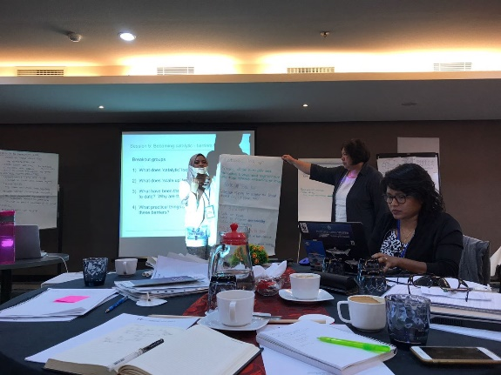
In 2017, the following were the communication and outreach activities managed and supported:
- The CTI-CFF Regional Secretariat participated in the Coral Triangle Futures Think Tank workshop held last 15-16 August 2017 in Bali, Indonesia. Supported by the Conservation International, the Regional Secretariat shared lesson learnt on the implementation of communication activities. The event was attended by representatives from 14 NGOs, regional and development organizations working across the Coral Triangle, as well as conservation organizations working in other countries. Key points from the visioning exercise were:
  - Raising the profile of sustainable fisheries in the food security arena
  - Internalizing the externalities
  - Listening more to communities
  - Bridging the divide between conservation and development
  - Communities of Practice
  - Sustainability of interventions (social, environmental, economic)
  - Demonstrating impact

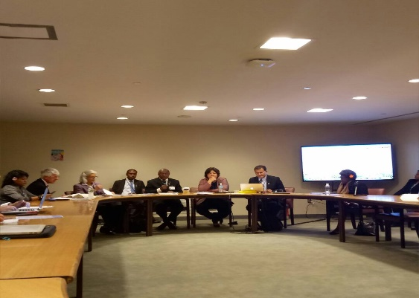
- The CTI-CFF Regional Secretariat together with, WWF, CTC, and the Solomon Islands Government as lead organizer, conducted a 2-hour side event entitled “The Coral Triangle – Partnerships to Achieve SDG 14 in the World’s Epicenter of Marine Biodiversity” on the sidelines of the UN Ocean Conference at UN Headquarters in New York, USA on 6 June 2017. Speakers were Honorable Milner Tozaka, MP. Minister of the Ministry of Foreign Affairs and External Trade, Solomon Islands Government; Gina Green, Senior Associate Tt. Project Manager of ECOFISH Programme; Luigi Cabrini, Chair of Global Sustainable Tourism Council (GSTC); Rindah Melsen, President of Nusatuva Women’s Savings Club, Solomon Islands; and Paul Holtus, CEO of World Ocean Council (WOC). They highlighted the existing challenges and great opportunities within the Coral Triangle region that need to be addressed together such as climate change adaptation issues, potential nature-based tourism, role of women in coastal areas, and sustainable fisheries.

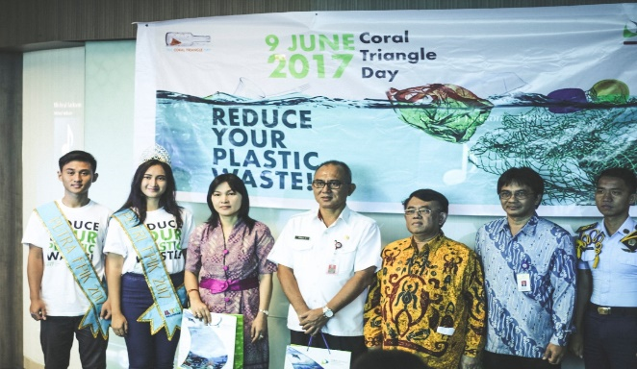
- To celebrate Coral Triangle Day, the CTI-CFF Regional Secretariat organized an event on June 7, 2017 at the CTI-CFF Regional Secretariat office in Manado. The concept of the event was to instill awareness to young people about the importance of marine conservation by means of reducing plastic waste. The Secretariat invited the Provincial Government and several schools and universities in Manado to become participants and take an active role in the celebration.

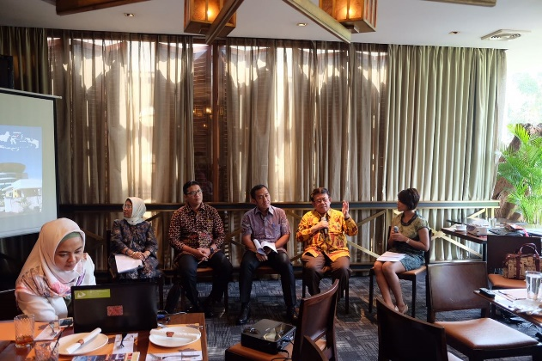
- A media luncheon was held in Jakarta on 9th September with the CTI-CFF Regional Secretariat Executive Director, Dr. Widi A. Pratikto. The event was attended by media representatives, NCC Indonesia team - Director General of Marine Spatial Planning of MMAF and Executive Secretary of NCC Indonesia, Mr. Brahmantya Satyamurti Poerwadi, ST; Head of the Agency of Research and Human Resources Development of MMAF, Mr. M. Zulficar Mochtar, and Director General of Climate Change of Ministry of Environment and Forestry, Dr. Nur Masripatin. It was also attended by CTI-CSO of Indonesia along with the Director General of Environment and Natural Resources and Head of Research and Human Development. Dr. Widi Pratikto emphasized that Media has a big role in educating the public as well as in disseminating information about strategic role of CTI-CFF in encouraging marine conservation, sustainable fisheries, food security and climate change at the regional level.

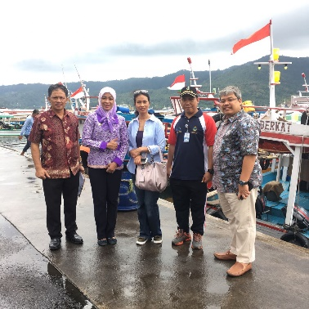
- The writer of CTI-CFF History Book, Ms. Juita Ramli, visited the Headquarters of CTI-CFF Regional Secretariat in Manado on 23-27 October 2017. During her visit, she interviewed the Executive Director and other staff as reference for the book. Additionally, Ms. Ramli visited Bitung Harbor to gain insights about Bitung Harbor and observe the impact of Bitung’s fisheries and align it with the progress and work of CTI-CFF as well as its impact in the local communities.

- Maintainance and updating of CTI-CFF Website and social media accounts are continuous to further promote the activities of the CTI-CFF to a larger public.

Part VII. Financial Performance

The CTI-CFF Regional Secretariat annually submits draft budget for the following year to all CTI-CFF member countries for consideration and approval. The draft budget comprises the estimates of receipts by the Secretariat from all sources and expenditures. The budget is formed by country contribution from CT6 member countries in accordance with the CTI-CFF Financial Regulations and Regulation on Provision of Funds, Article 1 (a) and its Schedule 1 stated as follows:
The funds of the Secretariat shall include:
- Assessed contributions made by Parties in accordance with Schedule 1 of these Regulations
Schedule 1 (Assessed Contribution Formulae)
- The total amount to be contributed will be determined by the CTI-COM based on the draft budget provided by the Secretariat;
- Sixty percent (60%) of the amount identified in paragraph (a) of the Schedule will be contributed by each of the Parties in equal shares; and
- The remainder of the total amount identified in paragraph (a) of the Schedule will be divided between the Parties based upon the relative size of their gross domestic product (GDP) as calculated by the most recent year for which GDP figures are available for all Parties.

The initial budget for FY 2015-2017 based on the Special SOM in May 2014 did not include budget for activities under Program Services. In the years mentioned, the activities under Program Services were supported by the CTI Partners. The activities were also on project-based mechanism from the funding institutions.

Following the transition process from an Interim Regional Secretariat to a Permanent Regional Secretariat from 2014-2015, the Regional Secretariat succeeded in implementing budget efficiency in terms of personnel/staffing cost, operational and capital expenditures. The savings generated were used to fund activities of the Program Services starting 2016. Budget allocation for Program Services (in line with the Special SOM recommendations) included logistical support for the members of the NCC of the CT6 member countries to participate and/or organize regional meetings and events.

The savings were also used to fund activities on strengthening partnerships and building new relationships with CT6 government agencies, partners, other regional organizations, and more importantly, with existing and new donors interested in supporting the implementation of the RPOA and in funding programmes which could be administered/managed through the Regional Secretariat. Particularly, funds were used to cover logistical expenses and organization of meetings and workshops. As a result, the Regional Secretariat successfully forged relationships through MoUs with SPREP, SEAFDEC, the Coral Triangle Centre and GIZ. Additionally, the Regional Secretariat had formalized relationships with various universities in the CT6 region and in Australia through the newly formed CTI-CFF University Partnership.

The 2017 budget and other financial matters were adopted during the budget meeting on 30-31 March 2017 in Manila, Philippines. Particularly, during the Special SOM, the amount of US$ 1,203,483 was adopted as the 2017 budget of the CTI-CFF Regional Secretariat. From the budget of US$ 1,203,483, a total amount of US$870,849 was utilized in 2017 (Note: This is still unaudited). Breakdown of fund utilization is shown in Table 27. Thus, it is to be noted that the annual contribution from CT6 member countries is imperative for the Regional Secretariat to administer its full operational function in coordinating and monitoring programs and activities in the region.

Table 27. 2017 Fund Utilization of CTI-CFF Regional Secretariat

Breakdown of Expenditure | Schedule | 2017 Fund Utilized (Unaudited)
A. CTI-CFF Regional Secretariat Core Operations
Operating Expenses |  | 83,546
-Insurance and Tax | A1 | 75
-Electricity & Water | A2 | 903
-Comm/Telp & internet Connect | A3 | 4,164
-Office Supplies | A4 | 3,787
- Publication and Printing | A5 | 16,753
-Website and Maintenance | A6 | 363
-Audit | A7 | 8,084
-Postage/Courier | A8 | 954
-vehicle rental |  | 14,456
-Copy Machine Rental | A10 | 299
-Vehicle Fuel | A11 | 2,710
-Hospitality | A12 | 651
-Miscellaneous (Visa, Permit etc) | A13 | 1,318
-Other Expenses ( Income) | A14 | 672
Capital expenditures ( Repair & Maintenance) | A15 | 19,338
Contract | A16 | 9,020
B. STAFFING |  | 482,130
1. ED and DED | B1 | 135,825
2. Expat &Professional staff | B1 | 305,275
3. Locally hired | B1 | 41,030
C. Recruitment Costs | C1
D. Travel and Meetings |  | 12,873
1. Staff Travel and Meetings | D1 | 98,097
2. SOM & MM Meeting | D2 | 30,876
Total Secretariat Core Operations |  | 694,649
E. Program Services |  | 176,200
1. Counterpart expenditures | E1
2. Program Activties | E2 | 60,616
3. Technical working groups | E3 | 94,488
4. Cross-cutting themes/GWG | E4 | 21,096
5. RPOA Review | E5
Total Expenditure before Contingency |  | 870,849
Contingency | 10%
Total expenditures |  | 870,849
Country Contribution |  | 1,203,483
Country Contribution Received: |  | 902203

Country Contribution
For FY 2017, the Regional Secretariat received a total amount of US$ 957,938 from CT member countries against the adopted/approved 2017 annual budget of US$ 1,203,483. Table 28 shows the contributions of each country from 2014 to 2017.

Table 28. Country Contribution from 2014-2017 (in USD)

Country | 2014 | 2015 | 2016 | 2017 | Total
Indonesia | 43,616 | 340,509 | 366,082 | 415,768 | 1,165,975
Malaysia | 23,212 | 181,212 | 194,821 | 221,263 | 620,508
Papua New Guinea | - | -- | - | - | -
Philippines | 20,833 | 162,640 | 174,855 | 198,575 | 556,903
Solomon Islands | 12,657 | 73,597 | - | - | 86,254
Timor-Leste | 12,838 | 100,221 | 107,748 | 122,332 | 343,139
Grand Total | 113,156 | 858,179 | 843,506 | 957,938 | 2,772,779
The US$ 957,938 was used for the operation of CTI-CFF Regional Secretariat. Particularly, the amount was used for financing expenses concerning administrative and management operations, personnel and recruitment costs, travel and meeting of Program Services Division. Table 2 provides breakdown of fund utilization for FY 2017.

Budget for Technical Working Groups
In 2017, the Regional Secretariat allocated around US$ 280,356 or 23% of adopted total budget of US$ 1,203,483 for Program Operations. This consists of supports for SOM-13, Technical Working Groups (TWG), Governance Working Groups (GWG), Cross-cutting Themes (CCT) and Technical Program. In terms of supporting TWG activities, the Regional Secretariat allocated US$ 120,791 to cover participation of delegates from the NCCs of CTI-CFF member countries in TWG events as well as travel expenses of Chairs of each TWG in the Pre-SOM and SOM-13 in the Philippines.

As of October 2017, the TWG Division utilized US$ 89,575 or 74% of its allocation. The amount was used to cover airfare, accommodation, and meeting expenses of delegates from NCCs of CT6 member countries.

Budget for Governance Working Group
The GWG budget allocation is adequate only for the conduct of the yearly meeting (i.e. Proposal to conduct the meetings back-to-back with each other to utilize the budget efficiently). It had a budget allocation of US$ 38,000 from the US$ 280,356 which was dedicated for delegates of NCCs participation in GWG events as well as travel expenses of Chairs of FRWG and CMWG in the Pre-SOM and SOM-13 in the Philippines

As of October 2017, GWG utilized US$ 25,100 or 66% of its allocation. The funds were used to cover airfare, accommodation, and meeting expenses of NCCs for attending FRWG in March 2017.

Budget for Cross-Cutting Themes
Sustainable financing for the CCTs is crucial to maintain its relevance and the interest of its members. Most of CCTs activities were being covered by the CTI Partners. Funds allotted for all five groups under CCT amounted to US$ 12,000. The funds were primarily for participation of chairs of RBF, WLF, and SAG in the Pre-SOM and SOM-13 in the Philippines as well as technical assistance for SAG establishment and CCT administration. With irregular payment of annual country contribution, the fund allotted for CCT is insufficient to implement fully planned activities. Past activities of the CCTs were supported by development partners under specific projects.

Budget for Technical Program
The Technical Program division was allotted a budget of US$ 80,000 or 29% of the budget allotted for Program Operations. The budget was used for the 1st Meeting of CTI-CFF University Partnership, supports for program initiation and potential collaboration with other regional/international organizations, CTI Partners, and SAG. As of October 2017, the amount used totals to US$50,789.

Funds from Development Partners
Multi-stakeholder partnerships are crucial in order to realize the goals of the RPOA. The CTI-CFF Regional Secretariat through its partners from government, INGOs, development agencies and academe, was able to implement its activity crucial to attaining targets of the RPOA. In 2017, the Government of Australia and USDOI have provided significant amount of funds to CTI-CFF Regional Secretariat to implement activities. Table 29 shows the breakdown of financial assistance from development partners from 2015-2017 and projected support for 2018-2019

Table 29. Breakdown of Funding Support Received from Development Partners from 2015-2017 and Projected Funding Support from 2018-2018

Country/Organization | 2015 | 2016 | 2017 | Cumulative Amount | 2018  Proposed | 2019 Projected
    - Grants
Government of Australia | 71,749 | 87,375 | 16,996 | 176,120 | - | -
WWF | 32,000 | - | - | 32,000 | - | -
USDOI | - | - | 50,000 | 50,000 | 200,000 | -
Sub-Total A | 103,749 | 87,375 | 66,996 | 258,120 | 200,000 | -
B. Disbursements
Government of Australia | 99,035 | 60,090 | 14,647 | 173,772 | 2,349 | -
WWF | 12,962 | 19,038 | - | 32,000 | - | -
USDOI | - | - | 20,758 | 20,758 | 150,781 | 49,219
Sub-Total B | 111,997 | 79,128 | 35,405 | 226,530 | 153,130 | 49,219
C. Balance
Government of Australia | (27,286) | 27,285 | 2,349 | 2,348 | (2,349) | -
WWF | 19,038 | (19,038) | - | - | - | -
USDOI | - | - | 29,242 | 29,242 | 49,219 | (49,219)
Less: Accounts Payable | - | - | - | - | - | -
Excess / (Deficit) | (8,248) | 8,247 | 31,591 | 31,590 | 46,870 | (49,219)

Cost-Benefit Analysis
The CTI-CFF Regional Secretariat tapped an external finance expert to conduct a cost-benefit analysis (CBA) for all costs incurred by the Secretariat in FY 2015-17, which originated from six Coral Triangle (CT6) countries—Indonesia, Malaysia, Papua New Guinea, the Philippines, the Solomon Islands and Timor-Leste. The costs, or the CT6 countries investment, represented US$1.85million from a total of US$3.38million contributions across FY2014–17.

The objectives of the analysis were to determine the value for money of CT6 countries investment by measuring the economic returns, and its sensitivity against changes in identified risk variable. As for the benefit measurement, the analysis considered the Regional Secretariat’s mandates within which it functioned. It also used the availability of data from Partners, hence the use of values of Partners’ projects as benefits. However, the study did not postulate the part or the entirety of projects delivered by Partners to CT6 countries were caused by the Regional Secretariat’s activities. The activities of the Regional Secretariat were correlated with the projects deliveries at one or more stages. Thus, benefits from those activities could not be delineated at specific stage of project cycle or proportionated to a specific value by guesswork or assumption, but by a stringent study that would ascribe specific cost input to specific benefit at specific project. This was not possible with current data available, and time and resource constraints of the study.

The results of the initial review suggested CT6 countries’ US$1.74million investment resulted in over US $15.39 million returns to the CT6 countries combined, from projects delivered by seven CTI-CFF Partners. This demonstrated that the Regional Secretariat’s activities had created value for money in terms of economic gain of US$12.96million—which was among the most important metrics for evaluating an investment as it signalled the entire economy from CT6 countries investments. The sensitivity analysis suggested that the investment was robust; in that the return would not be severely affected by normal change in risk factor in economy, i.e. inflation.

The results from this cost-benefit analysis demonstrated that the Expected Net Present Value (ENPV) was positive at US$12.96million, and that benefits outweighed the costs (BCR) by 9.36. In addition, the analysis also probed some benefits, which were not quantified in the analysis due to the difficulty of identifying attribution. This suggested the real value of investments could be even greater than what was reported.

Appendix A: CTI-CFF Regional Secretariat Staff as of December 2017

Executive Director: Dr. Widi Agus Pratikto
Program Services Division
Deputy Executive Director: Dr. Sharifah Nora Ibrahim
Technical Working Group Senior Manager: Ms. Astrid Lim
Governance Working Group and
Cross-Cutting Theme Senior Manager: Ms. Jasmin Mohd Saad

Technical Program Senior Manager: Dr. Muhammad Lukman

Technical Program Assistant Ms. Destyariani Liana Putri

Corporate Services Division

Finance and Operation Senior Manager: Mr. Cepy Syahda

HRD and Office Management Manager Mr. Toni Arman

Protocol and Conventions Services Manager: Mr. Ilham Perintis

Communication and Information Manager: Mr. Andie Wibianto

Assistant Manager for Administrative Affairs: Mr. Muhamad Alvin Pahlevi

Legal and Agreement Assistant Manager: Mr. Arezka Ary Hantyanto

Assistant Manager for Finance & Accounting: Mr. Mamimpim Napitupulu

Communication and Information Assistant: Ms. Kirana Agustina

IT Software Assistant: Mr. Medy Kesuma

IT Services Support: Mr. Windu Margono

HRD & Office Management Assistant: Ms. Maria Deswita

Appendix B. CTI-CFF Committee of Senior Officials

Indonesia
Brahmantya Satyamurti Poerwadi, S.T.
Director General of Marine Spatial Management
Ministry of Marine Affairs and Fisheries The Republic of Indonesia

Malaysia
Dato’ Dr. Mohd Azhar Hj. Yahaya
Secretary General
Ministry of Science, Technology and Innovation Malaysia

Papua New Guinea
Mr. Gunther Joku
Managing Director
Conservation and Environment Protection Authority Papua New Guinea

Philippines
H.E. Atty. Jonas R. Leones
Undersecretary for International Affairs and Foreign Assisted Programs
Department of Environment and Natural Resources
Quezon City, the Philippines /
Chair of CTI-CFF Committee of Senior Officials

Solomon Islands
H.E. Dr. Melchior Mataki
Permanent Secretary
Ministry of Environment, Climate Change, Disaster Management and Meteorology/
Vice-Chair of CTI-CFF Committee of Senior Officials

Timor-Leste
Acacio Guterrez
Director General of Fisheries
Ministry of Agriculture and Fisheries

Appendix C: Development and Government Partners

ADB

Hideki Matsuda
Water Resource Specialist
Environment, Natural Resources & Agriculture Division
Southeast Asia Department
Asian Development Bank

Conservation International
Niquole Esters
Director, Coral Triangle Initiative

Coral Triangle Center

Rili Djohani
Executive Director

Department of Environment, Australian Government
Andrew Chek
Regional Engagement and Business Development Section
Department of the Environment and Energy

Deutsche Gesellschaft für Internationale Zusammenarbeit (GIZ) GmbH

Franca Sprong
Project Director
BMUB SULU-SULAWESI SEASCAPE PROJECT

SPREP

The Nature Conservancy

Laura Whitford
Director of Development Policy and Partnerships

USAID Oceans and Fisheries Partnership
John Parks
Marine Specialist

USAID/Regional Development Mission for Asia

Angela Hogg
Director
Regional Environment Office

USAID SEA Project
Alan White
Chief of Party

Wildlife Conservation Society
Kenneth Kassem
Senior Marine Advisor

World Wide Fund for Nature

Jacqueline Thomas
Leader
WWF Coral Triangle Programme

Annex D: 2017 CTI-CFF Newsletters
January 2017 Edition
Coral Triangle Initiatives’ National Coordinating Committee (NCC) meets over program development
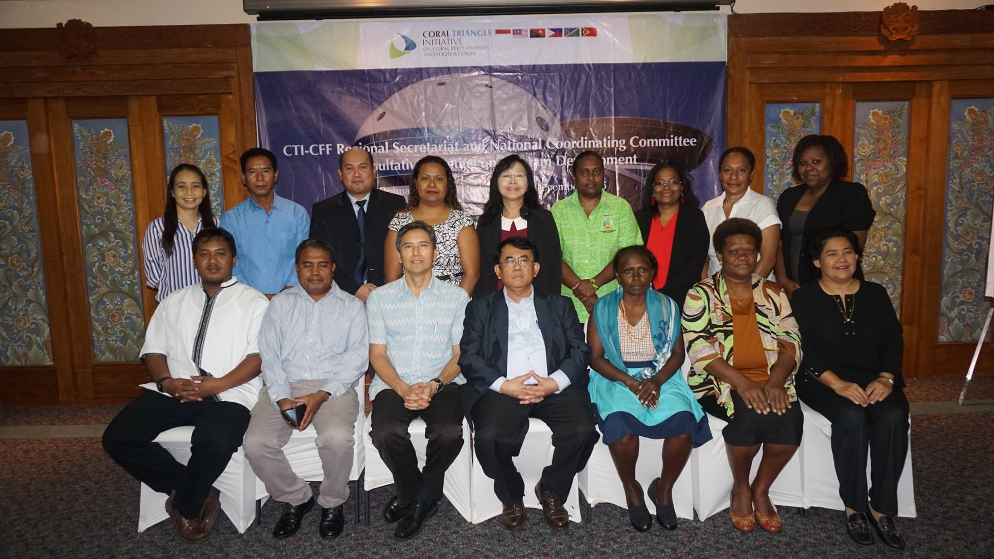

Following up the recommendations of the Member States during SOM-12 and the 6th Ministerial Meeting to share and consult with the CT6 over future activities and programs, the Regional Secretariat organized a consultative meeting between the representatives from the CT6 Member States with relevant Development Partners. The objectives of the meeting are to obtain NCC’s insights and guidance to improve the proposed work plans and identify gaps; while keeping in mind the targets of the Regional Plan of Action (RPOA).
The meeting program was planned over two-days; from 2-3 December 2016 in Bali, Indonesia, immediately after the Seascape Working Group Meeting led by Conservation International. The meeting was attended by NCC representatives from Indonesia, Malaysia, Papua New Guinea, Solomon Islands, and Timor-Leste; the Chair of the Local Government Network (LGN); Development Partners - the United States Agency for International Development (USAID); and World Wide Fund for Nature (WWF).
The first day of the meeting focused on the potential support from USAID Regional Development Mission for Asia (RDMA) based on the draft USAID/CTI Work Plan. The agenda for the second day focused on the discussion over the Terms of Reference for the 3rd Fisher Forum; the Regional Workshop on the Sustainable Management of Shared, Straddling and Highly Migratory Fish in the Coral Triangle Region (Tuna Governance); the COASTFISH Workshop; and CTI-CFF University Partnerships for Capacity Building.
The United States Agency for International Development (USAID) was represented by Mr. Alfred Nakatsuma, the Regional Environment Office Director. In essence, Mr. Alfred explained to the meeting that USAID is very keen to continue supporting the Coral Triangle Initiative since the Coral Triangle Support Program (CTSP) ended in 2013.

On August 5, 2015, Secretary of State John Kerry announced that the U.S. Agency for International Development's Oceans and Fisheries Partnership (USAID Oceans) project with an initial commitment of $4.3 million that will combat illegal, unreported, and unregulated (IUU) fishing and seafood fraud in the Asia-Pacific region.
"The catch documentation and traceability system established by USAID Oceans will improve the transparency of Asia's seafood supply chains, ensuring that fish is legally and sustainably harvested," said Secretary Kerry at the 22nd Association of Southeast Asian Nations Forum in Kuala Lumpur, Malaysia. "Traceability is an essential part of our global fight to conserve marine resources and protect the health of our oceans."
USAID is partnering with the Southeast Asian Fisheries Development Center (SEAFDEC) and the Coral Triangle Initiative (CTI) to strengthen regional, sustainable fisheries management by developing an electronic catch documentation and traceability system to track species at a high risk of being illegally traded or mislabeled. This system will harness the latest science, technology, and innovation to ensure that fish, shrimp and other marine resources are legally caught and properly labeled. Eliminating IUU fishing, which undermines efforts to conserve and manage shared fish stocks, will level the playing field for legitimate fishers and ensure the sustainability of our shared ocean resources (find link here).
In addition, Mr Alfred informed the meeting that in December, a final rule shall be announced to implement the Seafood Import Monitoring Program to address illegal fishing and seafood fraud in the United States. The final rule will require imported seafood at risk of illegal fishing and seafood fraud to be traced from the fishing boat or farm to the U.S. border, helping to stop illegally caught and mislabeled seafood from entering the United States (please see here for more information).

Therefore, the Coral Triangle Initiative is a great platform to introduce, inform and build capacity within the CT region in light with the new rule on seafood imports. This new rule shall impact on many fisheries export countries in terms of administrative procedures, legal implementation; and enforcements. The meeting further discussed how this ruling shall impact existing catch, documentations, and traceability programs such as those imposed by the European Union through its own IUU Regulations and those designed by ASEAN; i.e. the ASEAN Catch Documentation System (ACDS). Whilst the European Union IUU approach heavily depended on government implementation through rigid enforcement procedures, the U.S approach to IUU shall be grounded on public-private partnerships. The burden of compliance shall be on the fisheries-based companies for them to be able to export into United States.

As such, the draft USAID/CTI Work Plan focuses its programs on IUU and CDT matters in terms of capacity building within the CT region, leveraging on the experts already working on the USAID Oceans Program. Other relevant CTI programs such as further development of the CT Atlas to include IUU and CDT elements are explored; cross-cutting themes such as the Women Leaders’ Forum (WLF); the Regional Business Forum (RBF) and the Local Government Network (LGN) were also discussed and agreed on principal to be included in the draft USAID/CTI Work Plan to complement the proposed sustainable fisheries management programs.
In conclusion, the Regional Secretariat is tasked to amend the draft USAID/CTI Work Plan in accordance to the discussion of this meeting and re-submit and distribute to all NCC members including the Minutes of Meeting for final approval and submission to USAID for its further process.

The following day, on 3rd December 2016, a separate session led by Ms. Astrid Lim, the Technical Working Group Coordinator with support from Dr. Ingles (WWF Coral Triangle Program) were held to discuss on four (4) matters; (i) the Terms of Reference (TOR) for the Third Fishers Forum; (ii) Terms of Reference (TOR) for the Regional Workshop on the Sustainable Management of Shared, Straddling and Highly Migratory Fish in the Coral Triangle Region (Tuna Governance); (iii) Terms of Reference (TOR) for the COASTFISH Workshop; and (iv) presentation on CTI-CFF University Partnership for Capacity Building: MOU with Universities. These were brought to the attention of the NCCs based on Senior Officials’ Meeting decisions to meet with the targets set out in the CTI Regional Plan of Action.

- EAFM SOM-12 Decision #1: Endorsed the conduct of the 3rd Fishers Forum with the theme, “Sustainable Coastal Fisheries Through Local Innovation: Scaling Up Effective Models for IUU Reduction, Catch Documentation and Local Investments” subject to endorsement by member countries, the Terms of Reference for the 3rd Fisheries Forum was presented to the CT6 focal points for their review, comments, and approval. The Coral Triangle Fishers Forum is a regional platform hosted by the CTI-CFF, designed to enable fishers and other industry stakeholders to share experiences and perspectives about the issues in the CT Region that affect them, and find common ground in achieving sustainable and equitable fisheries. Initiated by WWF Coral Triangle Program, the forum gathers regional stakeholders, especially local fishers and industry representatives, to share experiences and identify solutions around specific problems faced by fisheries in the region. The Forum is proposed to be conducted in the second quarter of 2017.

- Under Target 3 of Goal 2 in the RPOA: ‘Effective measures in place to help ensure exploitation of shared tuna stocks is sustainable, with tuna spawning areas and juvenile growth stages adequately protected.’ To achieve this, two Regional Actions were identified and they are: 1) Develop a collaborative work program on this topic that covers a wide range of activities, such as jointly supported research, information-sharing, strategies for protection of spawning and juvenile growth areas, and financing mechanisms, and 2) Establish an informal CTI Forum on Tuna Governance.

EAFM SOM-11 Decision #2: Tasked the EAFM WG to coordinate with the Regional Secretariat in planning for a regional workshop on Sustainable Management of Tunas in 2016. The priority actions as mention before reflect the importance of tuna among the CT countries as an economic driver, as an important food security stabilizer, and as provider of livelihoods to significant number of small scale fishers. A regional collaboration on managing tunas is imperative since tunas found in the CT Region are either highly migratory, straddling or shared between countries. The economic value of tunas in the CT is staggering with exports alone placed at almost a billion dollars in 2011. These figures may be underestimates considering the volume of unreported and under reported catch.

- Target 2 of Goal 2 of the RPOA: Improved income, livelihoods and food security in an increasingly significant number of coastal communities across the region through a new sustainable coastal fisheries and poverty reduction initiative (COASTFISH). Pursuant to EAFM SOM12 Decision #2, Endorsed the conduct of COASTFISH Workshop in 2017 subject to the endorsement of member countries. The focus of the workshop is to develop a ‘common regional framework for the CTI COASTFISH Initiative’ and to develop a financial investment strategy at regional and national levels.

- Lastly, the Program Coordinator, Dr. Muhammad Lukman presented an initiative by the Regional Secretariat to initiate the Scientific Advisory Group (SAG); the CTI-CFF University Partnership. The role of universities in national and regional capacity building development is well-recognized as they provide a pathway to improve human resource capacity and much of the science and technology innovations needed to foster the development of humanity.

In 2016, CTI-CFF signed MoUs with prominent universities from Indonesia - Bogor Agricultural University; Institut Teknologi Sepuluh Nopember; Sam Ratulangi University; and Hasanuddin Univeristy. Others include MOUs with University Malaysia Terengganu (Malaysia) and James Cook University (Australia). The CTI-CFF University Partnership aim to promote marine conservation, sustainable fisheries, and food security through educational and professional accredited capacity building, research, and outreach activities within CT6 Member States under the CTI framework . All of the Member States have committed, through CTI-CFF, to lead effective, highly participatory multi-stakeholder alliances and to achieve a rapid improvement in institutional and human capacity.

Investment opportunities for Nature-Based tourism in Coral Triangle destinations
Since the establishment of the CTI-CFF in 2009, popular media and scientific papers have come out to confirm something that hundreds of thousands of travellers to the Coral Triangle already knew: Coastal areas, islands and the village communities and wildlife around this vast region provide plenty of opportunity for action-packed adventures, special encounters with different cultures and unique ways to be inspired by the beauty of this regions’ biodiversity and people.
Tourism has become an economic growth engine and vehicle for development in the region. This has not come without negative impacts particularly in mass tourism destinations but fortunately, ‘nature-based’ and ‘eco’ tourism have also seen rapid growth. Nature-based and adventure tourism are growing annually by 10-30%, currently accounting for up to 25% of the world’s tourist market according to the UNWTO. This provides an argument to minimize impacts of mass tourism in areas with high conservation value and invest instead in the preservation of natural areas and support for community stewardship over their reefs and coastal environments.
In recent years, tourism related coastal developments increased rapidly across the region, particularly in areas of high conservation value that appeal to the visitor looking for a beach holiday “off the beaten track” or scuba-diving. This is due to many factors, including increased accessibility of some areas from airport or harbor infrastructure developments and the demographic growth of financially-able domestic and international travellers. However, rapid and poorly planned coastal development is putting pressure on available resources and polluting coastal ecosystems. The very developments that are being established to entice visitors can damage the very resources the visitors are coming to see.
As the six CTI-CFF countries are at varying stages of tourism development (http://wwf.panda.org/what_we_do/where_we_work/coraltriangle/publications/?260690/Developing-and-Promoting-Sustainable-Nature-based-Tourism-in-the-Coral-Triangle ), the wide range of benefits and risks inherent with tourism can be found in each country. Whilst each has unique challenges and opportunities, the CTI-CFF provides a unique opportunity to work together and use the growing potential of Coral Triangle tourism to benefit conservation of important places and provide for community needs.
A key objective of the CTI-CFF is to encourage industries that depend on the Coral Triangle’s resources to co-invest in the ocean’s natural capital, thereby securing their business. Examples do exist of low impact, low volume, sustainable, high value or high profile nature-based tourism in the Coral Triangle. These range from small-scale local enterprises catering to the backpacker market, to high-end eco-lodge, cruise and liveaboard operations. The low-end local enterprises tend to serve a small not-well organised market of backpackers and more adventurous travellers that go to great lengths to visit remote areas where nature and wild life are relatively untouched. Some of these enterprises are initiated by local communities or engage local communities throughout the enterprise. Conversely the higher-end operations existing in the region have generally been developed with international investment, establishing their brand through marketing the unique high value nature and community related experience for elite travellers.
There is an important opportunity to increase understanding of the importance for governments and private sector to invest in protecting the natural capital of the Coral Triangle for tourism benefits. Such investors can benefit from a regional profile that positions this region as offering the world’s best sustainable coastal and marine tourism experiences with environmental, economic, social, and cultural benefits involving communities, governments and private enterprise.
Developing and Promoting Sustainable Nature-based Tourism in the Coral Triangle is an Australian government-funded initiative implemented by WWF. It aims to assist the six countries of the Coral Triangle to develop a long-term regional approach to more sustainable tourism that supports the protection and sustainable use of high conservation value places. It provides an opportunity to harness a dynamic tourism industry to preserve one of the world’s most unique ecosystems and areas while providing benefits to people and communities.
As a first step, sites have been identified in Timor-Leste, Solomon Islands and Papua New Guinea, selected for their high marine conservation value and low levels of existing tourism development. All three countries have the natural assets required to support nature-based tourism. Papua New Guinea and Solomon Islands have very high levels of endemic birds and terrestrial wildlife, and in all three countries natural areas are very extensive. With relatively low populations - compared to countries such as Indonesia, Malaysia, and the Philippines - the wilderness in these countries is mostly uninhabited, and in most places undisturbed and in its original state. In all three countries, tourism has been identified as an important sector for development. Tourism ministries have dedicated budgets and staff resources to implement and review multiple-year tourism strategies that focus primarily on the careful development of conditions to ensure that development supports benefits for communities and businesses through nature-and culture-based tourism. In fact, Atauro Island in Timor-Leste was recently awarded as one of the 100 Global Green Destinations (http://greendestinations.info/top100-2016/?dest=atauro-island ).

From Nov 22-24 in Manila, the Asian Dvelopment Bank will organize the first Green Business Forum for Asia and the Pacific (https://www.adb.org/news/events/first-green-business-forum-asia-and-pacific) with the aim to bring together experts, business practitioners, and key stakeholders to share knowledge and identify avenues for promoting green business solutions in the region. Within this program, on Thursday November 24, the ADB and WWF will co-organise a session dedicated to discussing investment opportunities in Nature-Based Tourism development in the Coral Triangle with a focus on marine related tourism destinations in Timor-Leste, Papua New Guinea and Solomon Islands.
The wheels of sustainable nature-based tourism in the Coral Triangle have started to turn and we hope to gain more momentum as we enjoin more partners to contribute to this worthwhile endeavor to ensure the welfare of nature and people in this globally-significant region.

CTI-CFF Contributes Critical Points and Actions to Achieve Sustainable Developing Goals 14 on Oceans and Seas

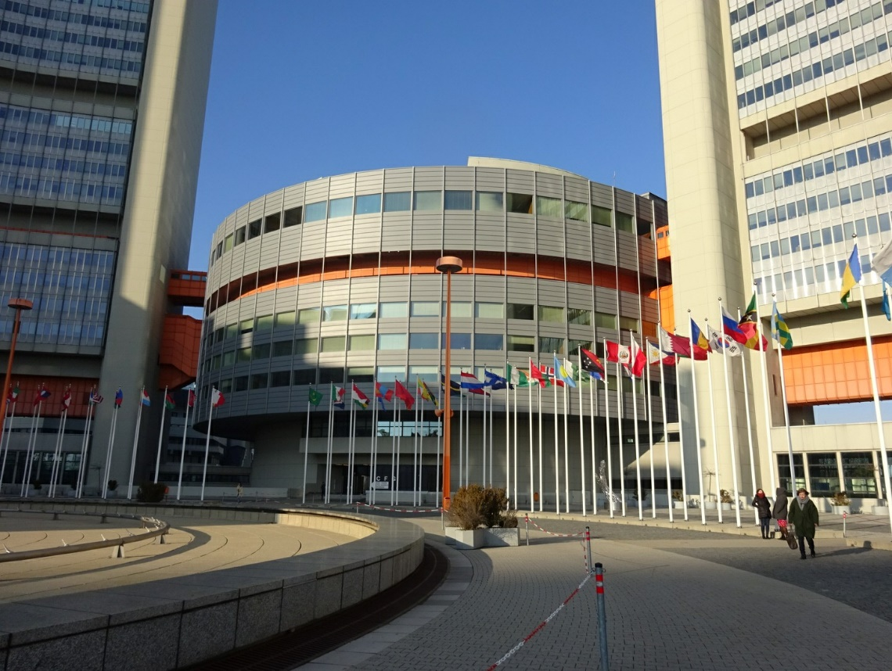
UNIDO Headquarters in Vienna International Center

On 14-16 December 2016, CTI-CFF’s Executive Director, Widi Agus Pratikto, Ph.D is invited by The United Nations Department of Economic and Social Affairs (DESA) and the United Nations Industrial Development Organization (UNIDO) to become one of the panelist experts at Expert Group Meeting (EGM) at the UNIDO Headquarters in Vienna, Austria.
Executive Director of CTI-CFF highlighted and conveyed 2 (two) critical points of ocean governance, including 2 (two) action points of ocean governance, which presented in Panel 7 - integrated actions for oceans that can contribute to achieving Sustainable Development Goals (SDG) No. 14 on oceans and seas.
The 2 (two) critical points of ocean governance, which presented by Dr. Widi are as follows:

- Preservation of outstanding marine and fisheries resources along with its biodiversity requires bold action, political commitment at all levels (i.e. local, national and regional levels), including grass-root level through NGOs engagement as well as global partnerships. In this regard, solid partnerships are essential to support marine resources and initiatives of communities.
- A solid and effective Monitoring and Evaluation (M&E) systems in the ocean governance is mostly needed in order to determine what structure is most practical and to track progress towards the goals of the regional and national plans of action. However, at the level of local scale, it was found that the capacity to collect strategic data, systematically store and align with regional and national plans of actions were weak. This should be synergized by collective efforts through coordinated manners in regional and national programs. For instance, the establishment of Local Government Network (LGN) and Women Leaders Forum (WLF) to strengthen activities at local communities.

While the 2 (two) action points of ocean governance are as follows:
- The management of ocean governance is essential to properly integrate into the national planning system because the ocean governance has substantial elements to interlink between policies/approaches and the outcomes/impacts to national socio-economic development and reduction of poverty while in the same time facing a number of threats.
- The M&E shall overview indicators based on outcomes and impacts so that the status of coastal and marine environment, fisheries resources and economic values to coastal communities can be measured. In addition, it is imperative to synergize collective efforts between regional and national plans of actions in terms of targets and alignment with the SDG No.14 of Conserve and sustainably use the oceans, seas and marine resources for sustainable development.

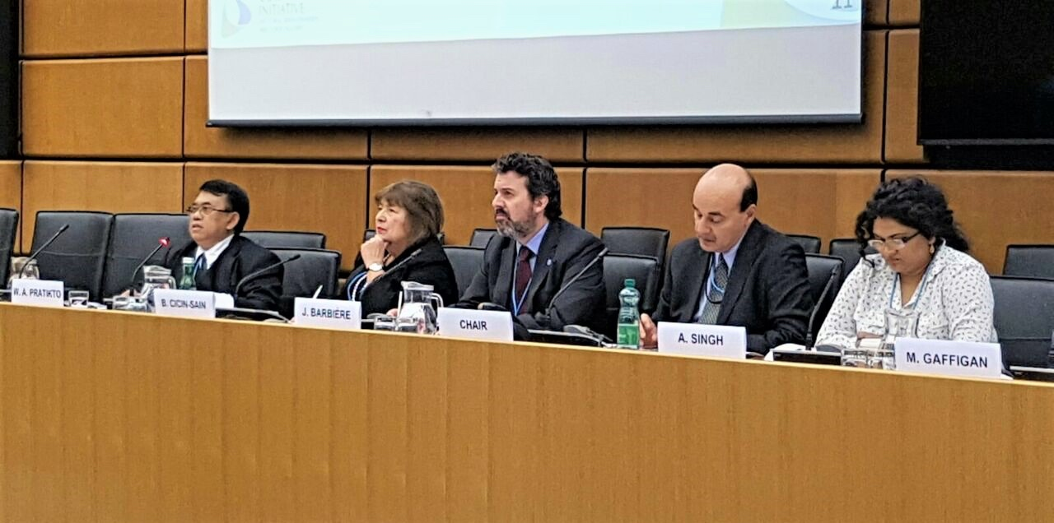
CTI-CFF Executive Director, Widi A. Pratikto represented CTI-CFF
During Expert Group Meeting at UNIDO Headquarters
The Expert Group Meeting, titled ‘Readying institutions and policies for integrated approaches to implement the 2030 Agenda’, aims to explore what relevant institutions, actions, mechanisms are necessary to develop integrated plans and policies for implementing the SDG. The results will become a basis for High-Level Political Forum meeting under the auspices of UNDESA in July 2017.
Along with Dr. Widi as the panelist experts were Mr. Mark Gaffigan, Managing Director, Natural Resources and Environment, Government Accountability Office, United States and Ms. Biliana Cicin-Sain, President, Global Ocean Forum, and Director, Gerard J. Mangone Center for Marine Policy, College of Earth, Ocean and Environment, University of Delaware.
The discussion on panel 7 was led by Ms. Asha Singh, Head, Oceans Governance, Organization of Eastern Caribbean States Commission and accompanied by Mr. Julian Barbiére, Head, Marine Policy and Regional Coordination Section, Intergovernmental Oceanographic Commission, UNESCO as the moderator during the meeting

The three day meeting was organized jointly by UNDESA and UNIDO and attended by numerous high-level invitees including The United Nations Under-Secretary-General for Economic and Social Affairs and the Director General of UNIDO, President of the General Assembly and the President of ECOSOC, the Minister of Women of the Dominican Republic, the Minister of Planning and External Cooperation of Haiti, the Vice Minister of Environment of Peru, and the Undersecretary of Health of the Philippines, and of the Executive Director of CTI-CFF attended this important event. As well as United Nations Member States, Representatives of international organizations, academia and other non- State actors.
SUSTAINABLE MARINE TOURISM
IN THE CORAL TRIANGLE MARINE PROTECTED AREAS SYSTEM

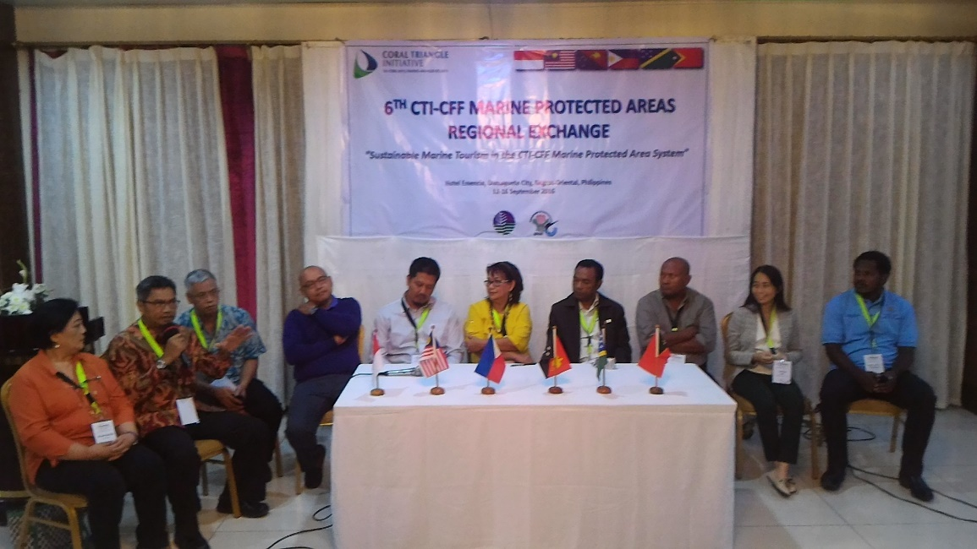

The Coral Triangle Initiative on Coral Reefs, Fisheries and Food Security (CTI-CFF) Marine Protected Area Technical Working Group (MPA-TWG) conducted the sixth MPA Regional Exchange on September 12-16, 2016 in Dumaguete City, Negros Oriental, Philippines. The theme of the workshop was focused on “Sustainable Marine Tourism in the CTI-CFF Marine Protected Areas System”. The Workshop was hosted by the Philippine National CTI-CFF Coordinating Committee (NCC) with funding support from the Department of Environment and Natural Resources (DENR, Philippines), CTI-CFF Regional Secretariat, GIZ and ADB RETA 7813, with technical support from the Coral Triangle Center (CTC), World Wildlife Fund for Nature (WWF), National Oceanic and Atmospheric Administration (US) (NOAA) and Sustainable Ecosystems Advanced (SEA-Project).

It was attended by around seventy six participants coming from the six CTI-CFF member countries (CT6), namely, Indonesia, Malaysia, Papua New Guinea (PNG), Philippines, Solomon Islands and Timor-Leste, including local government leaders from Siargao Island and Turtle Islands, Philippines, and from Raja Ampat, Indonesia, as well as the resource persons, observers and representatives from development partners.
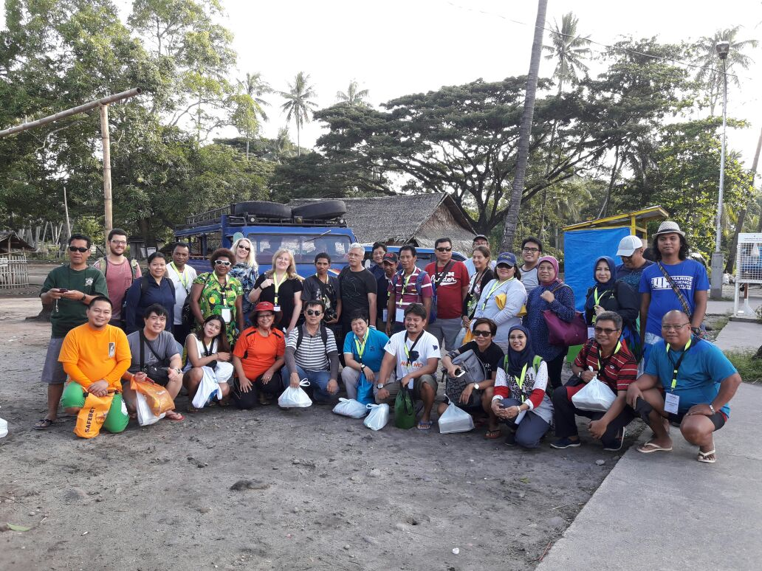
Group photo during study tour at the nearby Dauin Network of MPAs and
Apo Island Protected Landscape and Seascape

The overall objective of the 5-day workshop was to introduce sustainable marine tourism in the Coral Triangle Region with the following specific objectives:

- To review the progress on the implementation of the Coral Triangle Marine Protected Area System Framework (CTMPAS nomination process, CT Atlas Training, Recognition of CTMPAS Sites);
- To review the implementation of the CT6 roadmap prepared in the previous Marine Protected Area Regional Exchange (MPA Rex 5);
- To review the status of MPA Management Effectiveness Assessment Tools in the CT6;
- To share concepts, knowledge and practices on Sustainable Tourism in MPAs that contribute to and build on the Coral Triangle MPA System;
- To review the draft Terms of Reference of the CTI-CFF Marine Tourism Task Force;
- To conduct a study tour to an MPA learning site on sustainable tourism in the Philippines; and
- Develop the Agenda for the 6th MPA Technical Working Group (MPA TWG) Meeting.

Generally, the workshop provided an opportunity for the participants to share their experiences on various aspects of MPA management and best practices on sustainable marine tourism through breakout group activities, open forum, plenary discussions, and a study tour at the nearby Dauin Network of MPAs and Apo Island Protected Landscape and Seascape. The study tour also provided the participants an opportunity to observe and interact with the communities to be able to gather information regarding successes, challenges and recommendations on sustainable marine tourism programs of the two learning sites, of which one is locally managed while the Apo Island PLS is under the national government.

The Result of the Workshop Include:

- Progress on the implementation of CT6 MPA roadmaps;
- Learnings on sustainable marine tourism;
- Updates on the result of the 1st and 2nd round of CTMPAS site nominations;
- Learnings on best practices from other countries on CTMPAS site selection and nomination;
- Road maps both in-country and regional for the 3rd round of CTMPAS nomination;
- CT6 focal points for the CT Atlas were designated and trained to update the CT Atlas MPA database;
- Priority activities for MPA management effectiveness monitoring;
- Updates on various MPA monitoring and evaluation tools developed and implemented in the CT region;
- Revised draft terms of reference of the Marine Tourism Task Force and their priority activities;
- Priority activities for the capacity needs on sustainable tourism;
- Short and long term sustainable tourism targets;
- Learnings on the concept of new CoralCloud platform on project preparation and financing mechanism;
- Provisional Agenda for the 6th MPA TWG Meeting; and
- Built/strengthened regional camaraderie among LGUs, MPA managers, NCC members, tourism enthusiasts, Regional Secretariat and Technical Advisers/Resource Persons.

The Major Recommendations Developed in the Workshop Include:

- Countries to continue to work hard for the implementation of the MPA roadmaps prepared during the 5th and 6th CTI-CFF MPA REX;
- Participants to present their country roadmaps for the 3rd round of CTMPAS site selection and nomination in 2017 to their respective NCCs for adoption and timely implementation;
- Implementation of the 3rd round of CTMPAS site selection and nomination;
- Nomination for CTMPAS sites should be streamed down to the site level;
- The MPA TWG to prepare a program for recognition of CTMPAS sites subject to the time and venue that will be agreed upon for implementation;
- Countries through their CT Atlas Focal Points to continue to update the CT Atlas MPA database;
- Countries to continue to develop, implement and refine the MPA monitoring and evaluation tools;
- Encourage the partners for the continued support for the MPA Coordinator;
- Apply/adopt the various concepts and learnings on sustainable marine tourism programs in the CT region;
- Continue to support the Sustainable Marine Tourism Task Force; and
- Raja Ampat as the possible venue for the succeeding MPA REX as offered by the Vice Mayor of Raja Ampat, Indonesia.

The First Malaysian Women Leaders' Forum

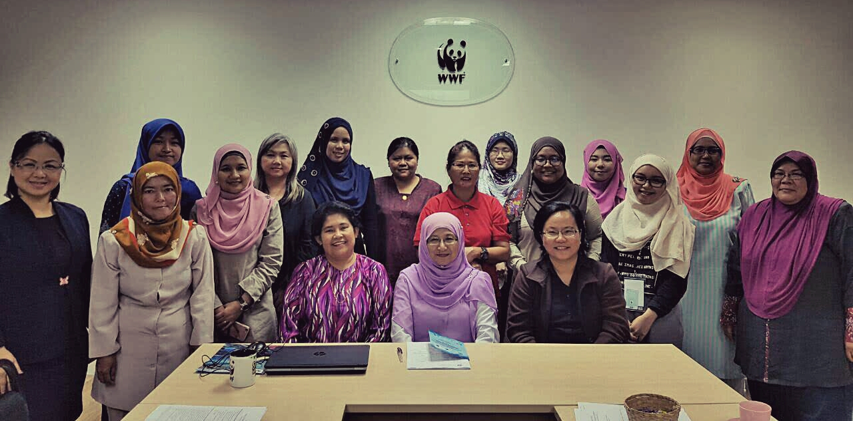
Figure 1 Meeting Participants to the first Malaysian Women Leaders Forum Meeting led by Prof. Dato' Dr. Nor Aeini Hj Mokhtar and supported by Dr. Robecca Jumin and her team from WWF Sabah, Malaysia
Kota Kinabalu, Sabah; 7th November 2016 – Women representatives from local NGOs; government representatives and university experts gathered in WWF Sabah, Malaysia office to attend the first Malaysian Women Leaders’ Forum (WLF) under the auspices of the Coral Triangle Initiative for Coral Reefs, Fisheries and Food Security (CTI-CFF).
Following the Sustainable Development Goal 5 (SDG-5) - “to achieve gender equality and empower all women and girls” , the WLF Malaysia meeting aimed towards the finalization of its Terms of Reference. With the formal establishment of the WLF in Malaysia, it is hoped that more support from the public, government agencies, international initiatives and private organizations could be pooled together and combat gender bias at all levels. Importantly, as mandated by the CTI-CFF Council of Senior Officers during the 11th and 12th Senior Officials’ Meeting, gender issues have been identified and actions have been identified to ensure gender mainstreaming into decision-making processes at all levels.
The meeting was chaired by the interim Chair of WLF, Prof. Dato’ Dr. Nor Aieni Hj Mokhtar, the Vice Chancellor of Universiti Malaysia Terengganu, previously the Under-Secretary of the National Oceanographic Directorate, Ministry of Science, Technology and Innovation (MOSTI) serving as the Malaysian National Secretariat for CTI-CFF. Participants from various organizations attended this meeting including Dr. Norasma Dacho from the Department of Fisheries Sabah who is also the Project Management Coordinator for the Asian Development Bank RETA 7813 Project; representatives from Universiti Malaysia Sabah (UMS) as the CTI Sabah branch; local NGO representatives and representative from the CTI-CFF Regional Secretariat.
Other agenda during the meeting include: (i) Introduction of CTI-CFF by the Regional Secretariat and Regional WLF current status since SOM-12; (ii) Briefing by WWF Sabah on its activities both in Sabah and Melaka in Peninsular Malaysia; (iii) presentations by local organizations led by women leaders --- Kudat Turtle Conservation Society, Padang Kemunting Turtle Friendly Village, Wanita Pulau Omadal and Green Semporna.
The meeting has agreed for the WLF Interim National Secretariat to be undertaken by WWF Sabah, Malaysia and led by current Chair or the WLF Malaysia until the next meeting for further discussion on the establishment of the WLF Malaysia National Secretariat and its work plan.
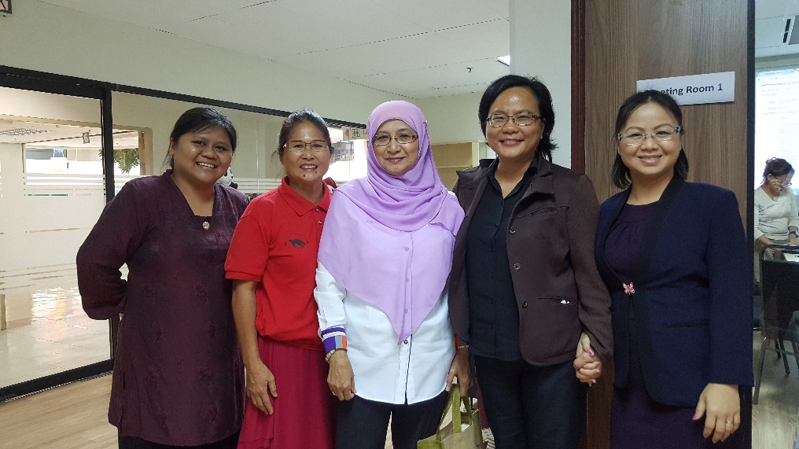
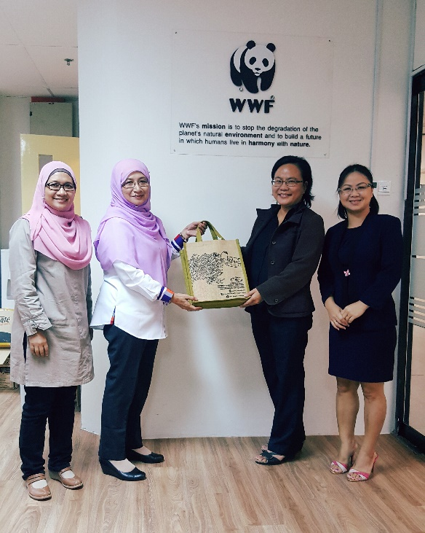
Figure 2 With the first Small Grant Award recipient from Malaysia, Ms Francesa Winfield of the Kudat Turtle Conservation Society
Figure 3 Token of appreciation from Universiti Malaysia Terengganu

UMT Conferred the Title of Doctor Honoris Causa to Indonesian Scientist, Widi A. Pratikto, Ph.D
On the heels of the signing of the Memorandum of Understanding (MOU) between the Coral Triangle Initiative Regional Secretariat and the Universiti Malaysia Terengganu (UMT) which was held on 16th November 2016, the Executive Director of CTI-CFF, Widi A. Pratikto, Ph.D is also one of the recipient of the UMT’s Doctor Honoris Causa award for his notable achievements on scientific field on ocean engineering, marine and fisheries science.
On 19th November 2016, Kebawah Duli Yang Maha Mulia Sultanah Nur Zahirah, Queen of Terengganu who is also the Chancellor of UMT, confers the Doctor (Scientific) Honoris Causa award to Widi A. Pratikto at UMT campus, Kuala Terengganu, Malaysia.
Widi A. Pratikto, Ph.D becomes the first Indonesian scientist to receive the highest award of Doctor (Scientific) Honoris Causa from UMT.
The combination of scientific expertise and hands-on experience as government bureaucrat has made Widi A. Pratikto Ph.D a well respected leader in his field. His contributions in the form of scientific papers, books, and case studies presented at various national, regional and international scientific have been referred to in the advancement of marine and fisheries world. One of his major achievement include a legal product (Act No. 27, Year 2007 on the Management of Coastal and Small Islands) was developed during his leadership years in the Ministry of Marine Affairs and Fisheries, when he was the Director General of Marine, Coastal, and Small Islands in 2002-2006.
"This title of Doctor Honoris Causa that I receive, is my dedication to the advancement of marine and fisheries sciences and technology, especially for the Coral Triangle area," Widi said.
Prof. Dato’ Dr. Nor Aieni Mokhtar, the Vice Chancellor of the UMT said: "UMT appreciated the figure of Widi A. Pratikto as part of the solution to the world of marine fisheries in the Coral Triangle region, and Malaysia in particular."

Port Moresby witnesses the Coral Triangle Initiative’s 12th Senior Officials’ Meeting and the 6th Ministerial Meeting
The Coral Triangle Initiative had its 12th Senior Officials’ Meeting (SOM-12) and 6th Ministerial Meeting (MM-6) on 1-2 November 2016; and 3rd November 2016 respectively. Additionally, working group meetings were held on 31 October 2016 to discuss and agree on recommendations to be forwarded during SOM-12 and MM-6 for endorsement.

The 12th Senior Officials’ Meeting (SOM-12)
Papua New Guinea, as the chair of both the Council of Senior Officers (CTI-CSO) and Council of Ministers (CTI-COM) hosted both meetings. The SOM-12 was chaired by Mr. Gunther Joku, Managing Director of Conservation and Environment Protection Authority (CEPA) on the first day; and Ms. Kay Kumaras Kalim, Director for Sustainable Environment Programs of CEPA on the subsequent day.
Over the years, these meetings have become an essential forum to review and discuss progress made by CTI-CFF Regional Secretariat; Member States; the five Technical Working Groups; the Governance Working Groups; and Cross-Cutting Themes towards achieving the Regional Plan of Action (RPOA) with concerted efforts from Member States and Development Partners; as well as the respective National Plan of Actions.
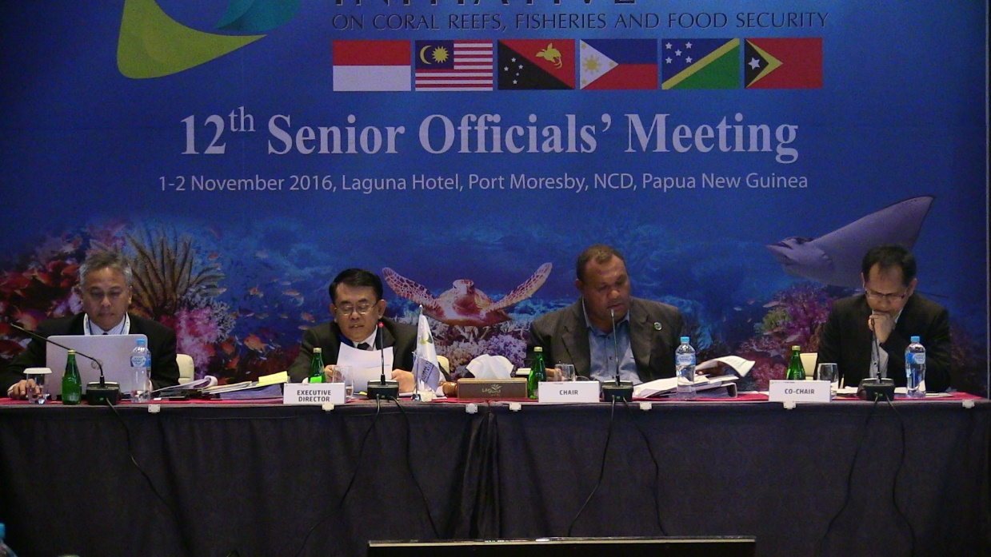
Mr. Widi A. Pratikto (2nd left), CTI-CFF Executive Director, reporting Regional Secretariat activities during the 12th Senior Officials’ Meeting.

“The SOM-12 is a unique platform for CTI-CFF National Coordinating Committee, Regional Secretariat and Development Partners to move forward with previous decisions as well as solicit consolidation and coordination in implementing the Regional Plan of Action (RPOA)” said CTI-CFF’s Executive Director, Widi A. Pratikto.

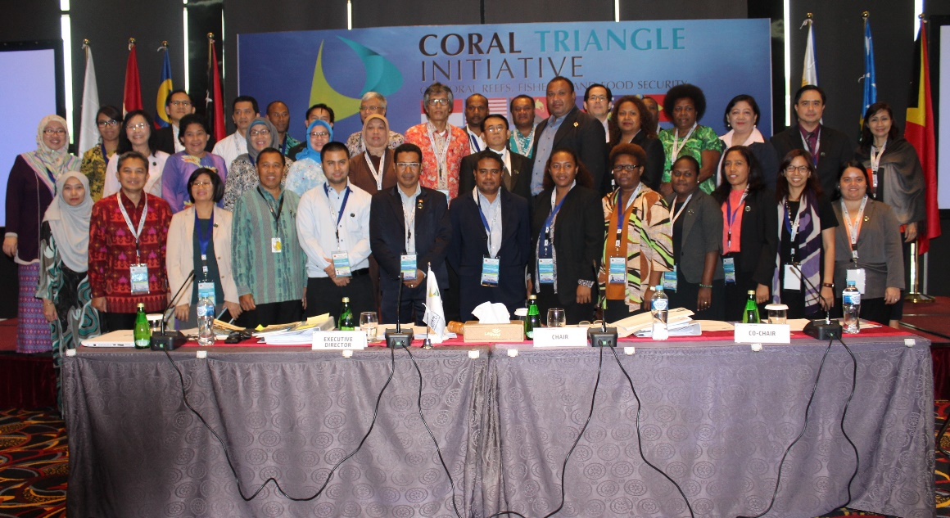
The Senior Officials of CTI-CFF National Coordinating Committee attended the SOM-12.

The 6th CTI-CFF Ministerial Meeting
The 6th CTI-CFF Ministerial Meeting was chaired by Hon. John Pundari, CMG, MP; Chair of CTI Council of Minister (CTI-COM) who is also the Minister for Environment and Conservation & Climate Change. Also in attendance were Hon. Datuk Seri Panglima Madius Tangau, Minister of Science, Technology and Innovation of Malaysia; Hon. Samuel Manetoali, Minister of Environment, Climate Change, Disaster Management and Meteorology of Solomon Islands; Hon. Estanislau Aleixo da Silva, Minister of State, Coordinating Minister for Economic Affairs and Minister of Agriculture and Fisheries of Timor-Leste; H.E. Dr. Suseno Sukoyono, Minister’s Advisor to the Ministry of Marine Affairs and Fisheries of Indonesia for Public and Inter-Agency Relations; and H.E. Marcial C. Amaro, Jr, Assistant Secretary for Field Operations of Department of Environment and Natural Resources of the Philippines.
“I welcome all of you, colleagues and friends, who have come to join me at this 6th Council of Ministers meeting in Port Moresby. I believe our discussions will focus on addressing many of the issues Papua New Guinea has raised and which are of similar nature to many of the issues in your own countries” said Excellency John Pundari, PNG Minister for Environment and Conservation & Climate Change.

“Papua New Guinea is a party in this initiative, and I am proud to say that we too have come a long way in ensuring that our marine resources are managed and sustainably used for our economy and livelihood” added Excellency John Pundari during his welcome speech.

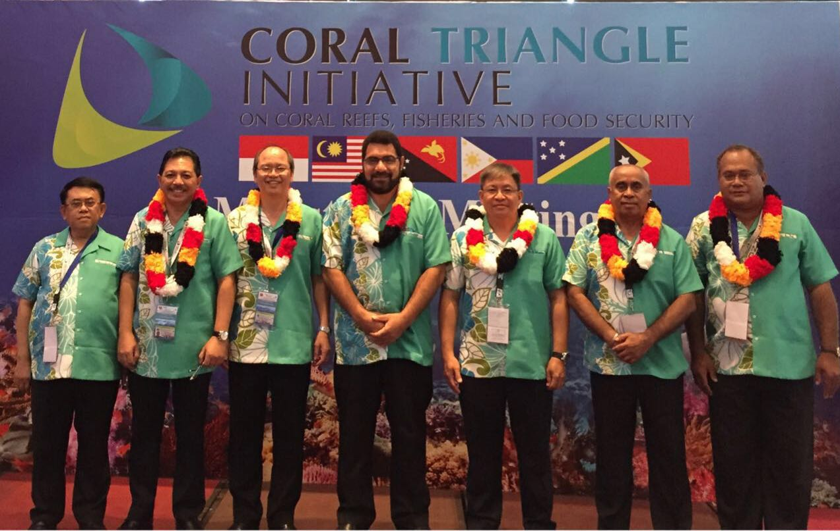
CTI-CFF Executive Director (1st from the left) and CTI-CFF Council of Minister attended the 6th Ministerial Meeting in Port Moresby.

The participating ministers welcomed the ratification of the Agreement on Establishment of CTI-CFF Regional Secretariat by all the CTI-CFF Member States and acknowledged the signing of the Host Country Agreement (HCA) between the Government of Republic of Indonesia as the Host Country and Regional Secretariat in Manado, Indonesia.

The CTI COM is the principal decision-making body of the CTI-CFF, responsible for maintaining the CTI-CFF vision and promoting regional priorities, considers, approve or disapprove decisions made by the CTI Committee of Senior Officials (CTI-CSO) on proposals, recommendations, plans, programs, projects and activities of the Regional Secretariat.

CTI-CFF future commitments and resolve
The Ministers recognized that CTI-CFF plays an important role towards conserving the world’s coral reef and securing food security considering increasing threats that leads to degraded reefs and marine resources. The Member States recalled the commitments of CTI-CFF to pursue the implementation of Regional Plan of Action (RPOA) and appreciated the progress made by the National Coordinating Committee (NCC) of each CTI-CFF Member States towards implementing their respective National Plan of Action (NPOA) and encourage them to expedite the full implementation of the NPOAs.
They also acknowledged the achievement and progress made by the Technical Working Groups (TWGs); Governance Working Groups (GWGs) and Cross-Cutting Themes (CCT) with the support of Development Partners towards meeting the goals of the RPOA. The Ministers further tasked the CTI Committee of Senior Officials (CTI-CSO) and Regional Secretariat to seek ways and means to strengthen the National Coordinating Committees (NCCs) and Regional Secretariat as well as to empower TWGs and CCT with a view to hasten the full implementation of the RPOA effectively.
The members of the Council of Ministers have also agreed to appoint, based on the advice of the Council of Senior Officers, the Deputy Executive Director for Program Services. They also acknowledged the effort made by the Regional Secretariat to establishe cooperation arrangements through Memorandum of Understandings (MoU) with SEAFDEC; CTC; SPREP; and GIZ; as well as with renowned universities in October 2016 namely Bogor Agricultural University; Institut Teknologi Sepuluh Nopember Surabaya; Hasanuddin University; and Sam Ratulangi University from Indonesia to strengthen CTI-CFF to achieve its goals in terms of support for research, education, and outreach programs for capacity building. These University Partnerships is an effort towards the establishment of the Scientific Advisory Group (SAG). The ministers also acknowledge upcoming cooperation arrangements with PEMSEA; Universiti Malaysia Terengganu (UMT) from Malaysia; James Cook University and University of Queensland from Australia; Solomon Islands National University from Solomon Islands and other potential cooperation arrangements to be established and pursued by the CTI-CFF Regional Secretariat in the near future.

Handover of CTI-COM Chairmanship
The members of the Council of Ministers (CTI-COM) welcome the new Chair from Philippines and Vice Chair from Solomon Islands and extended its deepest appreciation of Papua New Guinea’s leadership throughout the two-years of its Chairmanship since 16th May 2014.
The chairmanship of the CTI-COM is rotated in accordance to a predetermined two-years period per term among the Member States in alphabetical order; and the same applies to vice chairmanship.
“It is an honor for the Philippines to become the Chair of the CTI-CFF for this coming two years. Through this multilateral cooperation with the Governments of Indonesia, Malaysia, Papua New Guinea, Solomon Islands, and Timor Leste” said Assistant Secretary, Marcial Amaro, Jr.
“The Philippines is committed and aims to actively do its part in safeguarding the world’s richest marine area, the Coral Triangle” he added.
The members of the CTI-COM and CTI-CSO would like to put on record its appreciation to all Development Partners for its invaluable support thus far and welcomes future contribution towards maintaining and conserve this biologically diverse and ecologically rich region.

October 2017 Edition
1. CTI-CFF Actively Involves in the United Nations/UN Forums and Gains A Wide Recognition from International Societies
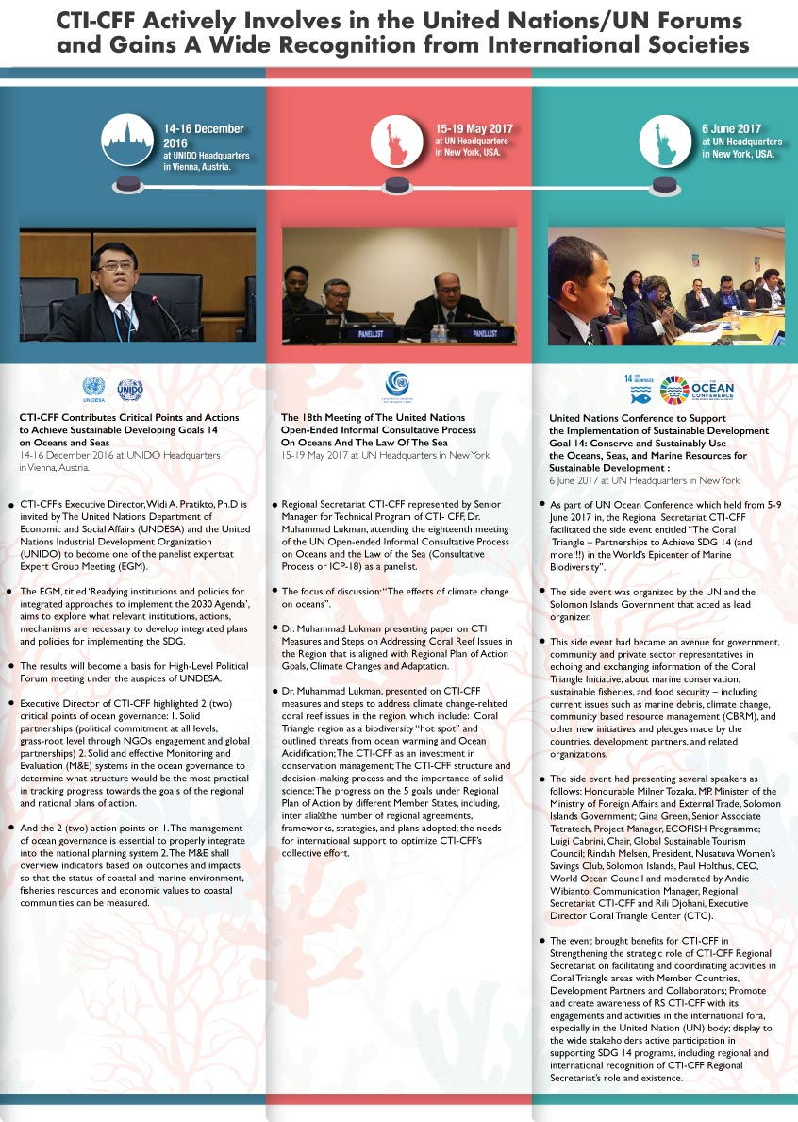
2.Building-Up a Regional Catch Documentation and Traceability System and Advancing Fisheries Management for Strengthening Food Security in Coral Triangle Region
USAID/RDMA and CTI-CFF Regional Secretariat are holding the inception meeting as part of the Work Plan entitled Strengthening Organizational and Administrative Capacity for Improved Fisheries Management (SOACAP IFM), in the CTI-CFF Regional Secretariat, Manado, start from September 25th to 26th.

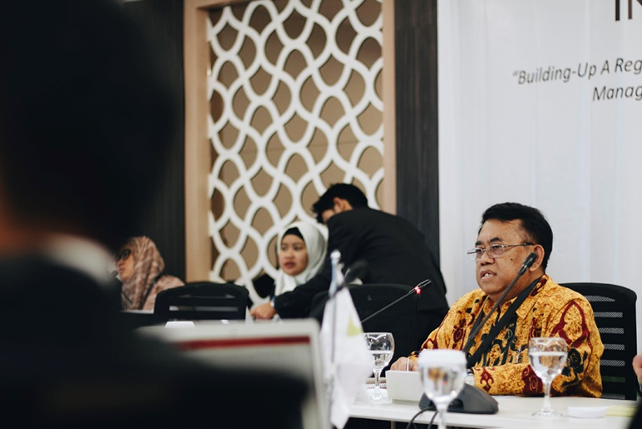

USAID/RDMA through US Department of Interior (DOI) for the period of 2017 – 2019 supports CTI to introduce and develop fisheries related activities that can promote sustainable fisheries practices in the CTI region, in order to combat illegal, unreported and unregulated fishing (IUUF), promote sustainable fisheries, and conserve marine biodiversity.

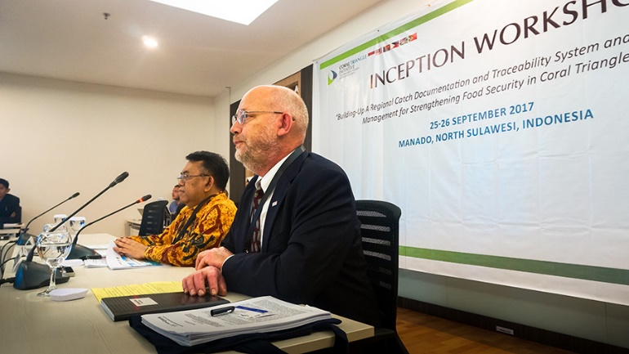

The meeting is commenced by Dr. Craig Krikpatrick (USAID/RDMA's Regional Wildlife Conservation Advisor) conveying the supports to CTI-CFF and officially welcomed by the Executive Director of CTI-CFF RS, Dr. Widi Pratikto. The attendances are coming from the NCC CT6 Member states, and the resource persons such as NOAA,The Oceans Partnerships, SEAFDEC, USDOI-ITAP, Universities, and some private sectors related to the work plan program.
3.
3. Capacity Strengthening for NCC Indonesia: Technical Guidance on Communication Strategy and on Proposal Writing

The National Coordination Committee of CTI-CFF in Indonesia recently held a Technical Guidance on Communication Strategy and on Proposal Writing. The event took place at the Ministry of Marine Affairs and Fisheries (MMAF) facility in Jakarta suburb, Depok, on last September 27th to 29th, 2017. The event was officially opened by Mr. Agus Dermawan of NCC Indonesia. Sri Atmini of the NCC Secretariat also expressed her remark at the opening ceremony. Both encouraged the participants to maximize their learning, and emphasized on the importance of having excellent communication skill. Such skill is highly needed especially in the context of NCC Indonesia when they are partaking at the CTI-CFF regional forum.
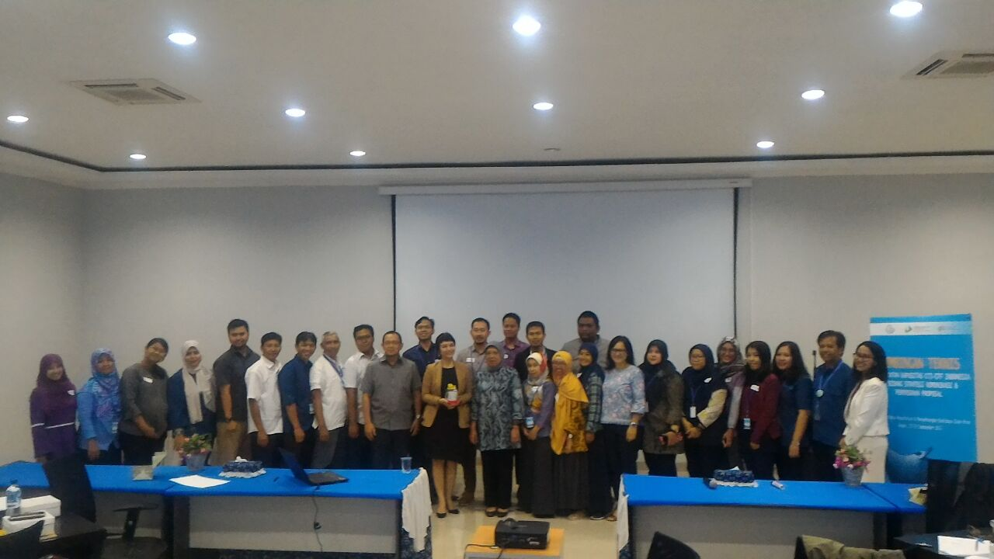
Participants of the technical guidance comes from across directorates of the MMAF, NCC Indonesia Secretariat, and 2 staff from the Regional Secretariat of CTI-CFF. The target participants are those who are responsible for internal and external communication of their directorate, for inter/external agencies cooperation, and program and technical units.
The technical guidance’s agenda was tailored to accommodate participants needs, as have been previously discussed and learned through the previous Capacity Needs Assessment done by the Sulu-Sulawesi Seascape Project. Of the 3 days training, the agenda covers a range of topics such as: stakeholder/ target audience analysis, including what specific information is relevant to be provided for those identified stakeholders; overall communication strategy, which include personal skills on public speaking, on media relation strategy, and on various outreach program with different target groups. On each session on day 1 and 2, while learning about the overall communication strategy, the participants were actively involved in group work, role play, simulation, and individual presentation. Acting as facilitator and resource person for the sessions were Ketut Udi Prayudi, an accredited BRIDGE Facilitator, Lala Tangkudung, a trainer/lead facilitator from Talk.Inc., and Agus Sudibyo of the Indonesia Press Council.

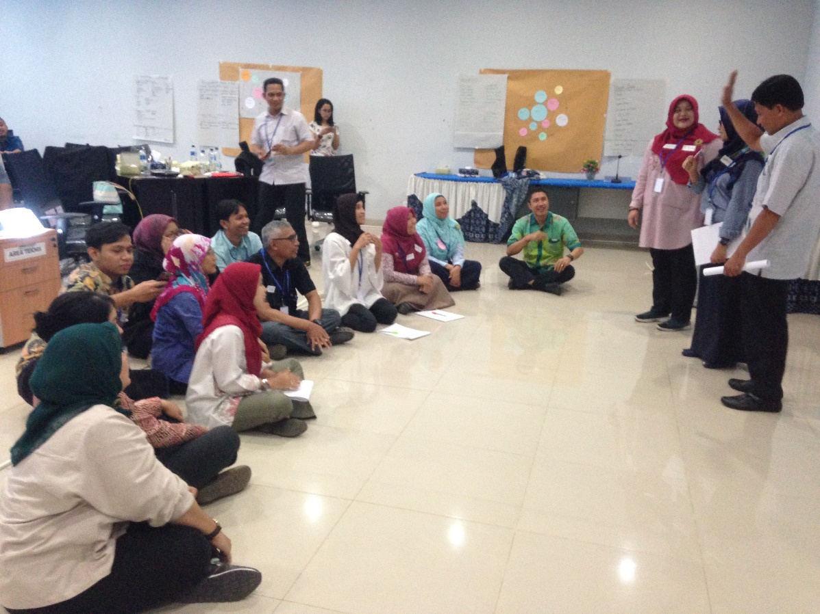
On the 3rd day of the training, led by GIZ Advisor, Mareska Mantik, the participants learned about the principles of proposal writing, priority issues identification followed by how to develop strategic objectives hence strategic plan based on the identified issues. The participants further strengthen their skill for proposal writing by exercising the use of the Logical Framework Matrix to develop their particular proposed project based on the strategic objectives they have.
While learning about proposal writing, during a panel presentation participant also had the chance to have a discussion with Mr. Zulazmi, Deputy Country Director, from GIZ Indonesia, Mr. Darmawan Triwibowo, the Executive Director of TIFA Foundation, and Mr. Diman Simanjuntak, Sr. ASEAN Affairs Specialist of the USAID Mission to ASEAN. Based on the grant making and funding procedure information presented by the 3 speakers, the participants were highly interested and motivated to design various programs that are based on their set priorities, while still in line with these agencies’ priority support areas. Some potential partnerships were also discussed during the session.
At the closing ceremony, numbers of participants were selected by their fellow participants as “The Most Active”, “The Most Discipline”, “The Funniest”, “The Most Active in Asking Question” and “The Most Helpful”. Three participants were also selected as the overall best achievers of the technical guidance: Imam Fitrianto, Udin Rojudin, and Arik Sulandari.
Based on the evaluation done by the facilitators of the technical guidance and the organizer from the NCC Indonesia Secretariat, most participants expressed how they appreciate the learning environment created, the participatory training method used, the practical skills they learn, and most importantly, how they were encouraged to exercise what they have learned while still in the training venue. As one participant said, she never had any training like this. The training was so much fun that she did not realized she had learned so much. Another said: attended the training she did not only learn about various things, and how she is starting to use what she had learned to improve her work. Now she had also widened her networking, and this helps her future communication with others.
The technical guidance was jointly organized and funded by Marine Spatial Management Directorate General of MMAF, NCC Indonesia Secretariat, and BMUB Sulu-Sulawesi Seascape Project.

4. New Program to Promote Sustainable Fishing Practices in the Arafura Sea
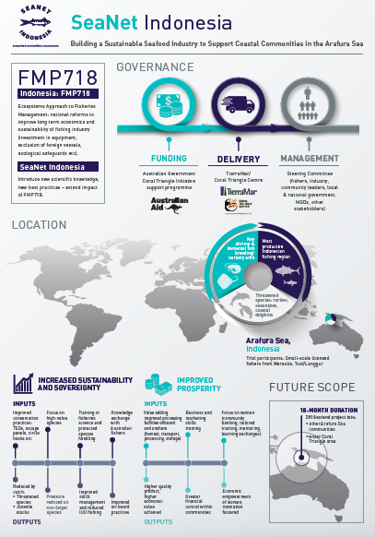
A new project that supports local fishing communities adopt sustainable fishing methods and promote the sustainable harvest of marine resources in the Arafura Sea has begun in the first quarter of 2017.
The project entitled, 'Building a Sustainable Seafood Industry to Support Coastal Communities in the Arafura Sea' (SeaNet Indonesia), aims to introduce small-scale Indonesian fishermen to sustainable fishing methods, reduce fish entanglement and bycatch of threatened species, and help fishing communities increase the value of their fisheries products through improved post-harvest handling. It will also focus on improving financial returns for women engaged in fish processing and sales.
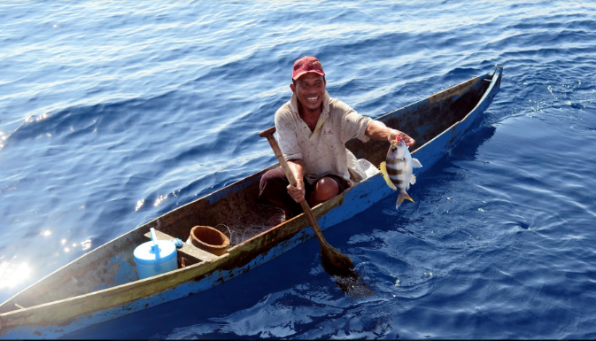
The 18-month project is being implemented by Tierra Mar, in partnership with the Coral Triangle Center, which will host the program within Indonesia. It is funded by the Australian Government's Coral Triangle Initiative Support Program.
SeaNet Indonesia also supports the Indonesian Government’s sustainable fisheries management reform programs to improve the long-term economic viability of its fishing industry and the sustainability of its fish stocks. The reforms introduced by the government, such as exclusion of foreign fishing vessels, prohibition of trawling and government investment and provision of new vessels and on-shore storage facilities, provide a unique opportunity to introduce new knowledge on fisheries science and new practices such as the use of exclusion devices, focus on high value catch, to fishers and their communities.
The Arafura Sea is one of the most productive fisheries region in Indonesia and supports key shrimp and demersal fish breeding and nursery grounds. It also hosts large populations of threatened species that often become fisheries bycatch such as sea turtles sea snakes and dolphins.
SeaNet Indonesia, which is patterned after SeaNet Australia, is a pilot program for the Coral Triangle as a potential model for fisheries extension across the broader region. The success of the SEANET project will determine the effectiveness of such an extension program to small-scale fishers and their communities and indicate the suitability of extending the program to other communities in the Arafura Sea and elsewhere in the Coral Triangle.
5.Coral Triangle Day 2017: Bringing Bloggers and Vloggers to Combat Plastic Waste
As part of CTI-CFF, Coral Triangle Day (CT Day) is being held on annual basis on June 9th. For year 2017, a strong call to action against plastic pollution of the oceans is the highlight of this year’s Coral Triangle Day Celebration. Themed ‘Curbing Marine Debris – Reduce Your Plastic Waste!’ this year’s Coral Triangle Day Celebration is celebrated by NNC Indonesia at Goethe Haus, Jakarta. The event was done under coordination with the Regional Secretariat of CTI-CFF, and is supported by GIZ BMUB Sulu-Sulawesi Seascape Project, WWF Indonesia, RARE and Change.org.
One way of saving the ocean is combating marine debris. And as the 2nd biggest producers of marine debris in the world, 3.22 million metric tons of plastic waste a year, it is the responsibility of Indonesian on how to reduce solid land waste that will eventually flown into the ocean. Aiming to save the ocean by advocating using less plastic also means raising awareness to change people’s way of life style, people’s habit, and even more, people’s culture.
To further drive home the message that simple actions make a big difference, taking a form of an interactive talk show, the event features 4 speakers: Ujang Solihin Sidik from the Ministry of Environment and Forestry, Dr. Nani Hendriati from Coordinating Ministry of Maritime Affairs, Dr. Ir. Aryo Hanggono, DEA from the Ministry of Marine Affairs and Fisheries, Hamish Daud, a marine enthusiast and a famous Indonesia actor, and Trinity, a well-known best seller book author and an avid traveler. The talk show was moderated by Dayu Hatmanti, Miss Scuba International in 2011, who is also a marine enthusiast and a TV host.
The main target participants for this event are young influencers, bloggers and vloggers, and environment activists and marine enthusiast. These young individuals are actively engaged with their dedicated followers whether on social media as well as in other medias; they have the ability to reach out to hundreds and thousands of followers, whom may resonate the campaign message that this event is advocating on; these young individuals have become young people role model on current life style, hence can become good ambassador for the reduce your plastic usage campaign.
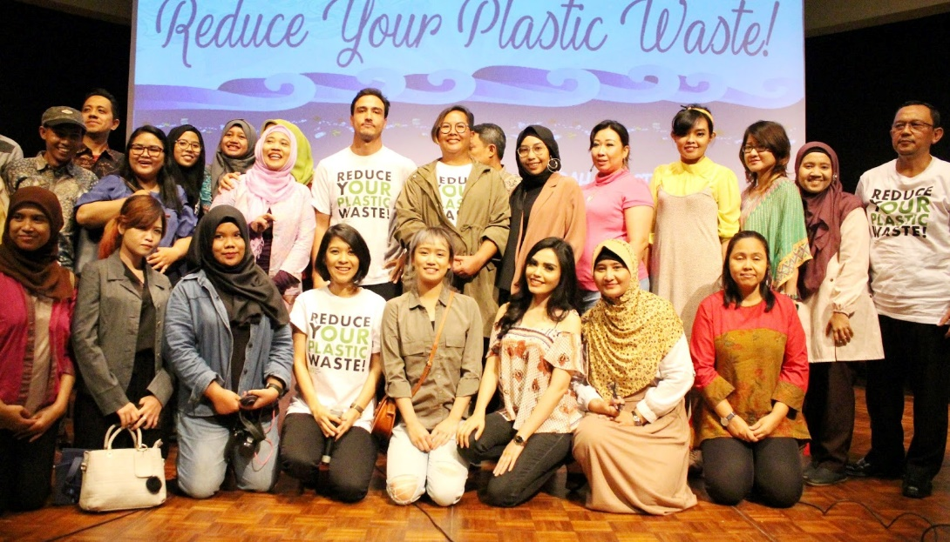
Official welcome remarks were delivered by Mr. Agus Dermawan, representing NCC Indonesia, and Mr. Zulazmi, Deputy Country Director of GIZ Indonesia. A heartwarming opening started by Jamaliyah, a little girl from Bawean Island. She read her letter for the Minister, which she wrote as her way to “Express Your Love for the Ocean”. Through the question and answer session, numerous participants expressed how they are unaware of most how vast the amount of garbage Indonesia produce that is badly contributing and damaging marine environment. In between the sessions, a percussion music band, Baturara, using used goods such as gallon, pots/pans, and bucket, took the stage and perform. Closing the event, a fasting break was held with all invitees and participants.

Starting from the event, post event the bloggers and vloggers continue posting on social media and through their own channel, the take home messages from the event. The hashtags used were #CTDayJkt, #sayno2plastic, #curbingmarinedebris and others. One posting from the resource person, Hamish Daud, said “We have the most diverse coral and marine biodiversity on the planet. It is of the utmost important for us to preserve it, while also showing it to world what we have.” He got 86,471 Likes on Instagram.

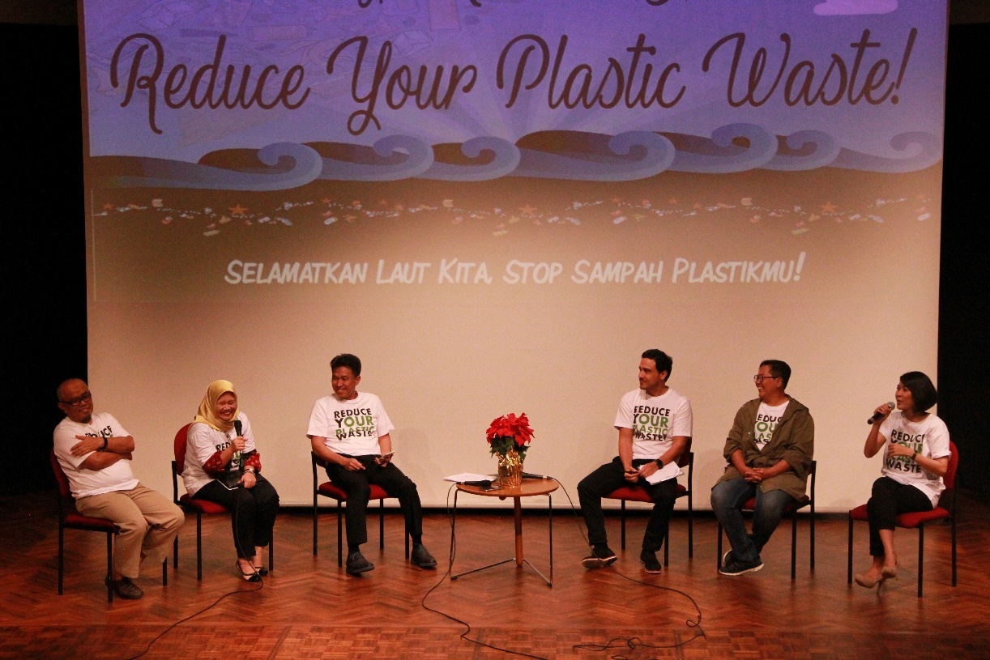
From Left:
Ujang Solihin Sidik from Ministry of Environment and Forestry
Dr. Nani Hendriati from Coordinating Ministry of Maritime Affairs
Dr. Ir. Aryo Hanggono, DEA from Ministry of Marine Affairs and Fisheries
Hamish Daud, a marine enthusiast
Trinity, a book author and traveler
Dayu Hatmanti, Miss Scuba Internation 2011

6. Advancing Women’s Leadership in the Coral Triangle
ADB’s 50th Annual Meeting, Yokohama, Japan
7th May 2017 | Civil Society Program

Panelist
- Agnetha Vave-Karamui, Ministry of Environment, Climate, Disaster Management and Meteorology, Government of Solomon Islands
- Geua Kevau, Pari Women’s Development Association, Papua New Guinea
- Jasmin Mohd Saad, Coral Triangle Initiative Regional Secretariat
- Lourdes Wagan, Department of Environment and Natural Resources, Government of the Philippines
- Xianbin Yao, Director General, ADB Pacific Department
Moderator
- Robyn James, The Nature Conservancy Melanesia Program and Gender Expert

Summary
The Coral Triangle Initiative Women Leaders Forum (CTI-WLF) have recently been profiled at the 50th ADB Annual Meeting – Civil Society Program session on 7th May 2017 in Yokohama, Japan.
The Coral Triangle Initiative for Coral Reef, Fisheries and Food Security (CTI-CFF) objectives and targets to preserve and manage the marine resources within the region was heavily supported by donor governments’ agencies; development organizations and NGOs since its inception in 2007. The CTI-CFF also focuses on cross-cutting issues such as women’s equality that leads to the formation of the Women Leaders’ Forum (WLF) with the aims to establish its own network of women; to recognize women leaders in their respective fields and empower more women in decision-making processes; and ensure that more affirmative actions are taken towards gender mainstreaming.
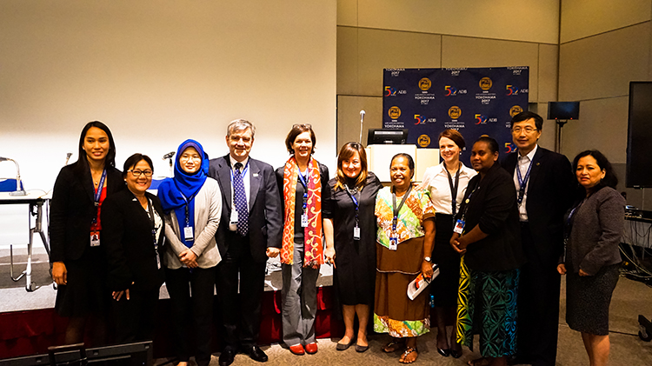
The first presentation by Ms. Jasmin Saad from the CTI-CFF Regional Secretariat focuses on the challenges as a women manager working in an inter-governmental organization such as the CTI entails issues such as: (i) continuity of programs; (ii) achieve recognition & equal representation; (iii) availability of comprehensive peer-network; (iv) ensure gender mainstreaming; and (v) equal opportunities. However, the WLF can move forward working together with Development Partners and future partners through: (i) establishment of a platform for a women network; (ii) expanding partnerships to advance capacity building; (iii) embracing men as advocates; (iv) investments in youth; (v) private sector partnerships; and (vi) gender mainstreaming.
CTI would like to implore ADB especially, to consider a longer-term relationship with CTI and help achieve the SDG goal on (SDG 5) achieving gender equality especially towards implementation of gender mainstreaming programs and policies and invest in youth for all CTI future programs.
Presentations from three (3) other panellists highlights the challenges, issues and best-practices for women inclusion on their own capacity in their workplace and throughout their experience in the respective countries. Ms. Agnetha and Ms. Lourdes highlights women issues from the perspective of a public / government officer; and programs that have been implemented in Solomon Islands and Philippines respectively. Ms. Geua Kevau from the Pari Women’s Development Association based in Papua New Guinea highlights the plight and challenges of women wanting to be heard and taken seriously in most decision-making processes for the benefit of their own welfare and their children’s future.
Lastly, Mr. Yao – ADB’s Director General for the Pacific Department recognize the significant economic contribution that women and youth can provide, both nationally and internationally. He reassured everyone that gender quality and youth involvement shall always be taken seriously when planning its strategic programs.
In conclusion, the panel agreed that gender mainstreaming have to be taken seriously and implemented at all stages of planning; to recognize youth as the driver for women’s agenda and identify men as advocates / supporters to empower women and girls; and educating boys to respect the opposite sex and their potential.

For more profile information on the panellist, please visit: https://www.adb.org/annual-meeting/2017/events/womens-leadership-coral-triangle

List of Acronyms and Abreviations

ACAMCA Arnavon Community Marine Conservation Area
ADB Asian Development Bank
ADB-RETA Asian Development Bank Regional Technical Assistance
AG Attorney General
*AIESEC Association Internationale des Étudiants en Sciences Économiques et
Commerciales
AIMS Australian Institute of Marine Science
APEC Asian-Pacific Economic Cooperation
ASEAN COST ASEAN Committee of Science and Technology
ATSEF Arafura and Timor Seas Expert Forum
AWGCME ASEAN Working Group on Coastal and Marine Environment
AYF Asian Youth Forum
BAC Business Advisory Council
BBC British Broadcasting Corporation
BIOPAMA Biodiversity and Protected Areas Management
BFAR Bureau of Fisheries and Aquatic Resources
BMKG Meteorology, Climatology and Geophysics
BSSE Bismarck Solomon Seas Ecoregion
CBA Cost-Benefit Analysis
CBRM Community-based Resource Management
CCA Climate Change Adaptation
CCC Climate Change Commission
CCCB Center Climate Change and Biodiversity
CCD Cross Cutting Capacity Development
CCDA Climate Change and Development Authority
CCT Cross-cutting Themes
CDS Catch Documentation System
CDT Catch Documentation and Traceability
CEPA Conservation and Environment Protection Authority
CEO Chief Executive Officer
CFC Constituency Fisheries Centre
CI Conservation International
CITES Convention on International Trade in Endangered Species
CMEMP Coastal and Marine Ecosystems Management Program
CMG “Call Me God”
CMS-COP Conference of the Parties to the Convention on the Conservation of Migratory
Species of Wild Animals
CMWG Coordination Mechanism Working Group
COASTFISH coastal fisheries and poverty reduction
COBSEA Coordinating Body on the Sea of East Asia
COE Centers of Excellence
CreSOS Center for Remote Sensing and Ocean Sciences
CSIRO Commonwealth Scientific and Industrial Research Organisation
CSO Council of Senior Officers
CTC Coral Triangle Center
CTI Coral Triangle Initiative
CTI-CFF Coral Triangle Initiative for Coral Reefs, Fisheries and Food Security
CTMPAS Coral Triangle Marine Protected Area System
CTSP Coral Triangle Support Program
CT6 Coral Triangle (six) countries
DBP Dewan Bahasa dan Pustaka
DED Deputy Executive Director
DENR Department of Environment and Natural Resources
DFAT Department of Foreign Affairs and Trade
DJAG Department of Justice & Attorney General
DMF Design and Monitoring Framework
DOALOS Division of Ocean Affairs and the Law of the Sea
DOEE Department of Energy and Environment
DOF Department of Fisheries
DSWD Department of Social Welfare and Development
EAFM Ecosystems Approach to Fisheries Management
EBM Eco-based Management
EBSA Ecologically or Biologically Significant Marine Areas (EBSA)
EOIs Expression of Interests
ERSI Environmental System Research Systems
FAO Food and Agriculture Organization
FfG Fish for Good
FoFMS Faculty of Fisheries and Marine Sciences
FRWG Financial Resources Working Group
GAFSP Global Agriculture and Food Security Program
GCCA Global Climate Change Alliance
GCF Green Climate Fund
GCF-AE Green Climate Fund- Accredited Entities
GEF Global Environment Facility
GIZ Deutsche Gesellschaft für Internationale Zusammenarbeit GmbH (German
Corporation for International Cooperation GmbH^{[n}
GIZ BMUB Federal Ministry for the Environment, Nature Conservation, Building and
Nuclear Safety
GOTL Government of Timor Leste
GSTC Global Sustainable Tourism Council
GWG Governance Working Group
HCA Host Country Agreement
HPM Honorary Park Manager
HQ Headquarter
ICM Integrated Coastal Management
ICP International Comparison Programme
IFAD International Fund for Agricultural Development
IL Intergenerational Learning
IOC/UNESCO Intergovernmental Oceanographic Commission/United Nations Educational,
Scientific and Cultural Organization
IORA Indian Ocean RIM Association
IPB Institut Pertanian Bogo (Bogor Agricultural University)
IPCRBC Indo-Pacific Coral Reefs Biodiversity and Conservation
ITS Institut Teknologi Sepuluh Nopember
IUCN International Union for Conservation of Nature
IUU illegal, unreported and unregulated
JAXA Japan Aerospace Exploration Agency
JICA
JCU James Cook University
LGN Local Government Network
LLCAP Local Climate Change Action Plan
LLG Local-level government
LME Large Marine Ecosystem
LSS Lesser Sunda Seas
MACBIO Marine and Coastal Biodiversity
MCIA Ministério do Comércio, Indústria e Ambiente
MCS monitoring, control, and surveillance
M&E monitoring and evaluation
MECDM Ministry of Environment, Climate Change, Disaster Management & Meteorology
MFMR Ministry of Fisheries and Marine Resources
MESW Maritime Environment Security Workshop
MEWG Monitoring & Evaluation Working Group
MKBA Marine Key Biodiversity Area
MM Ministerial Meeting
MMAF Ministry of Marine Affairs and Fisheries
MMEA Malaysia Maritime Enforcement Agency
MOSTI Ministry of Science, Technology and Innovation
MOTAC Ministry of Tourism and Culture Malaysia
MP Member of Parliament
MPA Marine Protected Areas
MPGIS Ministry of Provincial Government and Institutional Strengthening
MOA Ministry of Agriculture & Agro-based Industry Malaysia
MoU Memorandum of Understanding
MSP Marine Spatial Planning
MSSIF Makem Strong Solomon Islands Fisheries
MTPAN Marine Turtle Protected Area Network
MyCARAH Conference on Artificial Reef and Related Aquatic Habitats
MYOB Mind Your Own Business Accounting Software
NBSAP National Biodiversity Strategy and Action Plan
NCC National Coordinating Committee
NFA National Fisheries Authority
NFRDI National Fisheries Research and Development Institute
NKSNP Nino Konis Santana National Park
NOAA National Oceanic and Atmospheric Administration
NMPA Network of Marine Protected Areas
NPOA National Plan of Action
NRA Natural Resources Assessment
PA Protected Area
PCCC Philippine Climate Change Commission
PES Payment for Environmental Services
PEMSEA Partnerships in Environmental Management for the Seas of East Asia
PhilWAVES Philippine Wealth Accounting and Valuation of Ecosystems
PIO Public International Organization
PIS Project Initiation Specialist
PMTMEM Professional Masters in Tropical Marine Ecosystems Management
PNG Papua New Guinea
PoWPA Programme of Work on Protected Areas
PPF Project Preparation Facility
PRIMEX Pacific Rim Innovation and Management Exponents, Inc.
PROP Pacific Islands Regional Oceanscape Program (PROP)
PSSA Particularly Sensitive Sea Area
RBF Regional Business Forum
REAP Region-wide Early Action Plan
REX Regional Exchange
RPOA Regional Plan of Action
RS Regional Secretariat
SAG Scientific Advisory Group
SAPIP Strengthening Agricultural Productivity
SDG Sustainable Development Goals
SDS-SEA Sustainable Development Strategy for the Seas of East Asia
SEA Southeast Asia
SeaNet Support Coastal Communities in the Arafura Sea
SEAFDEC Southeast Asian Fisheries Development Center
SI Solomon Islands
SIMP Seafood Import Monitoring Program
SINU Solomon Islands National University
SICCP Solomon Islands Community Conservation Partnership
SMT Sustainable Marine Tourism
SMT-TF Sustainable Marine Tourism Task Force
SOACAP IFM Strengthening Organizational and Administrative Capacity for Improved
Fisheries Management
SOM Senior Officials’ Meeting
SPC Secretariat of the Pacific Community
SPREP Secretariat of the Pacific Regional Environment Programme
SSME Sulu-Sulawesi Marine Ecoregion
SWG Seascapes Working Group
TEEB The Economics of Ecosystems and Biodiversity
TIHPA Turtle Islands Heritage Protected Area
TMP Tun Mustapha Park
TNC The Nature Conservancy
TOMAK To’os ba Moris Diak
ToR Terms of Reference
TS Threatened Species
TWG Technical Working Groups
UKM Universiti Kebangsaan Malaysia
UMS Universiti Malaysia Sabah
UMT University Malaysia Terengganu
UN United Nations
UNFCC United Nations Framework Convetion on Climate Change
UNCLOS United Nations Convention on the Law of the Sea
UNDESA United Nations Department of Economic and Social Affairs
UNESCO United Nations Educational, Scientific and Cultural Organization
UNHAS Universitas Hasanuddin (Hasannudin University)
UNIDO United Nations Industrial Development Organization
UNSRAT Universitas Sam Ratulangi (Sam Ratulangi University)
UNTL Universidade Nacional Timor Lorosa'e
UNWTO United Nations World Tourism Organization
UPD University of the Philippines Diliman
UPMSI-MSN UP Marine Science Institute-MPA Support Network
UPNG University Of Papua New Guinea
UQ University of Queensland
USAID United States Agency for International Development
USAID-SEA Sustainable Ecosystems Advanced (SEA)
USAID RDMA United States Agency for International Development/Regional Development
Mission for Asia
USDOI-ITAP United States Department of Interior – International Technical Assistance
Program
VA Vulnerability Assessment
V&A Vulnerability and Adaptation
WDPA World Database on Protected Areas
WLF Women Leaders’ Forum
WMO World Meteorological Organization
WOC World Ocean Council
WOCAN Women for Organizing Change in Agriculture and Natural Resources
WPRFC Western Pacific Regional Fishery Management Council
WWF World Wide Fund for Nature
ZMT Leibniz Centre for Tropical Marine Research

*Note: AIESEC is no longer used as an acronym but simply as the name of the organisation

The phenomenon was observed, among others, in Australia (Berkelmans et al. 2004), Carribean (Wilkinson and Souter 2008), and most parts of Indian Ocean (Sheppard et al. 2002; Wilkinson 2008).
Using economic price, present valued at US$1.55 million.
Using economic price, present valued at US$14.51 million.

