Progress Report
January – November 2018
CTI-CFF Regional Secretariat
2018
Contents

INTRODUCTION 2
I. TECHNICAL WORKING GROUPS 2
A. Seascape Working Group 2
B. Ecosystem Approach to Fisheries Management (EAFM) Working Group 6
C. Marine Protected Areas Working Group 7
D. Climate Change Adaptation Working Group 8
E. Threatened Species Working Group 9
II. GOVERNANCE WORKING GROUPS 9
A. Coordination Mechanism Working Group & Financial Resources Working Group 9
B. Monitoring and Evaluation Working Group 11
III. CROSS-CUTTING THEME WORKING GROUP 14
A. Local Government Network 14
B. Women Leaders Forum (WLF) 14
IV. PARTNERSHIPS AND POTENTIAL REGIONAL PROGRAMS 15
A. USAID Strengthening Organizational and Administrative Capacity for Improved Fisheries Management (SOACAP) 15
B. Other Regional Cooperation Activities 16
V. PARTICIPATION IN INTERNATIONAL/REGIONAL EVENTS 23
VI. Corporate and Financial Management Activities 28
VII. COMMUNICATION AND OUTREACH ACTIVITIES 29
VIII.PLANNED NOVEMBER & DECEMBER 2018 ACTIVITIES 31
1. Sustainable Blue Economy Conference 31
2. 33rd International Coral Reef Initiative (ICRI) General Meeting 32

INTRODUCTION
In 2018, the CTI-CFF through its Technical Working Groups and Regional Secretariat with support from Development Partners organised, co-hosted, and implemented activities/conferences/workshops that were all aimed to realize the goals of the Regional Plan of Action (RPOA).
Further, in 2018, the CTI through its Regional Secretariat participated in international and regional fora to further promote CTI as well as forge stronger partnerships that will benefit communities and coastal areas while share information on developed/generated tools on ecosystem management, food security and sustainable livelihood.
This Progress Report highlights the activities that have taken place between January to November 2018 and mentions the planned activities for December 2018. Once accepted by the Committee of Senior Officers (CSO) at the 14th Senior Officials’ Meeting (SOM-14), it will be converted to an Annual Report format for 2018 and published in 2019.

TECHNICAL WORKING GROUPS
The five working groups continue to meet, build capacity, exchange insights, and plan activities throughout 2018 to meet the targets identified in each goal.

Seascape Working Group
- Multilateral Meeting on the Nomination of Lesser Sunda and Bismarck Solomon Seas Ecoregion as Priority Seascapes
Jakarta, Indonesia
20 April 2018
- Reaffirm to jointly nominate Lesser Sunda and Bismarck Solomon Seas Ecoregion as priority seascapes of CTI-CFF based on the mandate of SOM 13.
- Acknowledge the progress made by Indonesia, Papua New Guinea, Solomon Islands, and Timor Leste towards the nomination of Lesser Sunda and Bismarck Solomon Seas Ecoregions as priority seascapes of CTI-CFF and noted the participation of Malaysia in the meeting as an observer.
- Agree to compile and complete the required data and information to support the nomination of Lesser Sunda and Bismarck Solomon Seas Ecoregion as priority seascapes of CTI-CFF based on the draft proposals proposed by Indonesia by July 2018.
- Contact persons for data exchanges and proposal refinement for Papua New Guinea, Solomon Islands, and Timor Leste will be the NCCs and SWG Focal Points, and copies shall be circulated to the Embassies of member countries.
- Regional Seascapes Working Group to circulate the draft proposal on Lesser Sunda and Bismarck Solomon Seas Ecoregions to the NCCs and SWG Focal Points of Papua New Guinea, Solomon Islands, and Timor Leste for inputs and comments by July 2018.
- Commit to follow the schedule of the designation process of Lesser Sunda and Bismarck Solomon Seas Ecoregions as priority seascapes of CTI-CFF.
- Agree to conduct Seascapes Working Group meeting tentatively in August or September 2018 with the aims to finalize the Rules and Procedures of Seascapes Working Group and to approve the nomination of Lesser Sunda and Bismarck Solomon Seas Ecoregions as priority seascapes of CTI-CFF. Funding options include: a) if held in Indonesia, the Government of Indonesia agrees to cover the meting package and accommodation, but not transportation, b) if not held in Indonesia, alternative sources of funding to be identified.
- Regional Secretariat of CTI-CFF to discuss with the University of Queensland and James Cook University as part of the CTI-CFF University Partnership program to align their project with the current activities of Seascapes Working Group on Lesser Sunda and Bismarck Solomon Seas Ecoregions.

- Regional Sulu-Sulawesi Seascape Convergence Meeting and the Review of the Sulu-Sulawesi Seas EAFM Plan
Cebu, Philippines
3-6 July 2018
In this meeting, Sulu-Sulawesi Seascape countries reiterated the need to continue and further develop the collaboration within the Sulu-Sulawesi under Coral Triangle Initiative on CTI-CFF.
In summary, the countries agreed on the following priority actions after the meeting:
- Following the CTI-CFF protocols, the Convergence Report will be circulated and discussed within NCCs and the SWG.
- SWG Meeting agenda will include updated TOR of SWG plus structure; rules and procedure, including proposed details on the seascape coordinating mechanisms such as the sub-regional working group and the seascape manager.
- Draft Sulu-Sulawesi Seascape EAFM Framework Plan will also be discussed with the NCCs and the EAFM WG as a parallel process
©GIZ/Marion Daclan/2018

As a show of unity, the countries signed a joint communique to the CTI-CFF Regional Secretariat to reiterate the importance of sustaining the collaboration within the Sulu-Sulawesi Seascape. The Seascapes work includes coming up with a Sulu-Sulawesi Ecosystem Approach on Fisheries Management Framework Plan, which was also reviewed during the Convergence Meeting.

The Meeting was organized by the CTI-CFF Seascape Working Group with support from the USAID Oceans, Conservations International Philippines and the Sulu-Sulawesi Seascape Project on behalf of the Federal German Ministry for the Environment, Nature Conservation and Nuclear Safety.

Full Report of the Convergence Meeting can be found at https://www.seafdec-oceanspartnership.org/resource/proceedings-from-the-cti-cff-convergence-meeting for download.

- 5th CTI-CFF Seascapes Working Group Meeting
Banten, Indonesia
18-19 October 2018
The event was aimed at bringing together Seascapes TWG focal points from CT6 countries as well as development partners and collaborators to follow up and evaluate the nomination of Lesser Sunda and BSSE as CTI-CFF priority seascapes and finalize the Rules of Procedure of the CTI-CFF Seascapes Working Group, including the proposed coordination structure for each of the priority seascape under the Seascapes WG.
The following decisions came out of the 5th Seascapes TWG:
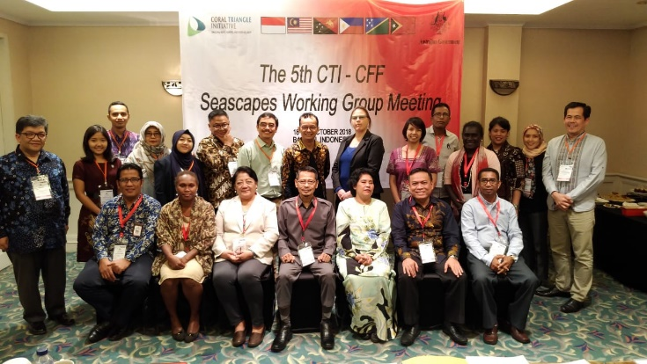
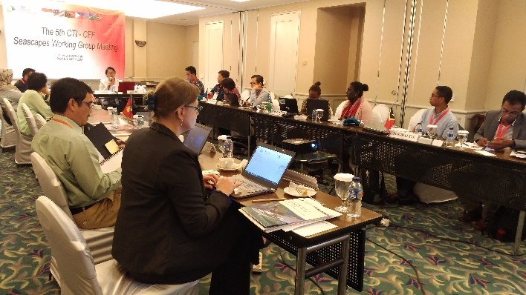
- The Seascape TWG acknowledges the initiative of NCC Indonesia in preparing the draft proposals on the nominations of Lesser Sunda and BSSE as priority seascapes;
©MMAF/Dinah Yunitawa/2018
- The Seascape TWG agrees to propose Lesser Sunda as CTI-CFF priority seascape to be adopted at the SOM14, with the requirement to complete the proposal at least two weeks prior to the pre-SOM14;
- Note that Solomon Islands shall follow up the nomination process of BSSE as CTI-CFF priority seascape, including the national mechanism leading to the endorsement at least two weeks prior to the pre-SOM14;
- Task the Chair of Seascapes Working Group to communicate with Papua New Guinea to follow up the nomination process of BSSE as priority seascape no later than two weeks after the 5th CTI-CFF Seascapes Working Group Meeting;
- The Seascape TWG endorse the Rules of Procedure of the CTI-CFF Seascapes Working Group, including the development of sub-working groups for priority seascapes under the Seascapes Working Group, to be reported to the SOM14 in compliance with the decision of the SOM13;
- Acknowledge the work of NCC Philippines with support from the Sulu Sulawesi Seascape Project in developing the coordination mechanism on the Seascapes sub-working groups and task the RS to circulate to the Parties for comments and inputs;
- The Seascape TWG appreciate the support of development partners, including the Australian Government for the funding support and the NCC Indonesia for hosting the meeting;
- The Seascape TWG appreciate the Interim Executive Director of CTI-CFF Regional Secretariat for facilitating the meeting.

Ecosystem Approach to Fisheries Management (EAFM) Working Group
- Regional Training Workshop on EAFM with CMAR
Bali, Indonesia
7-10 August 2018
The 4-day workshop gathered officials from conservation, environment, fisheries and maritime agencies of Costa Rica, Colombia, Ecuador, Panama, Indonesia, Malaysia, Solomon Islands and Timor-Leste. Participants were provided with concepts, principles of EAFM and its application. They were also taught to develop and implement and monitor EAFM Plan to sustainably manage fisheries resources.

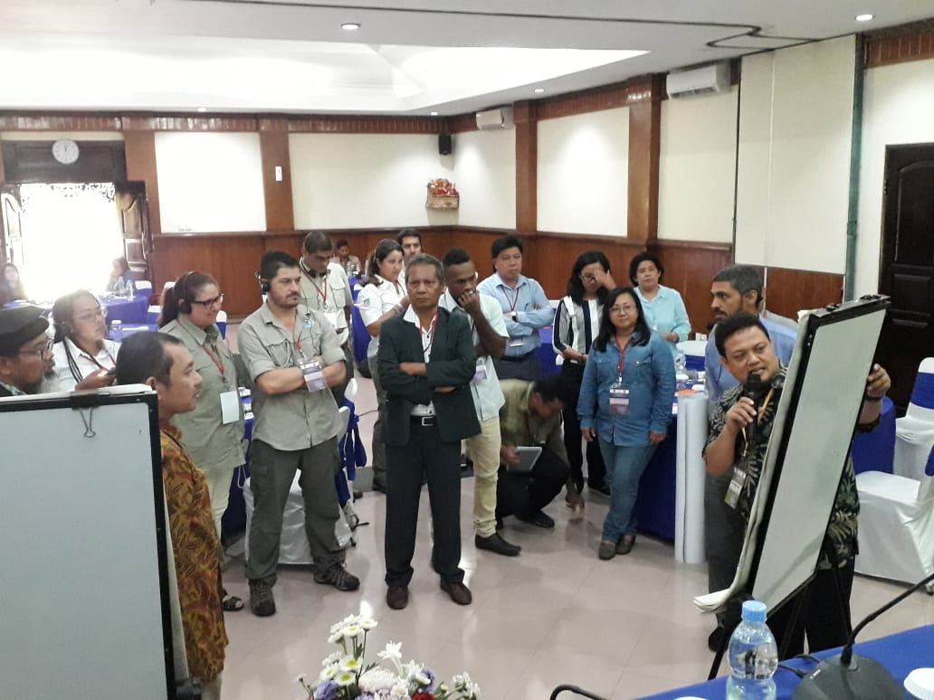
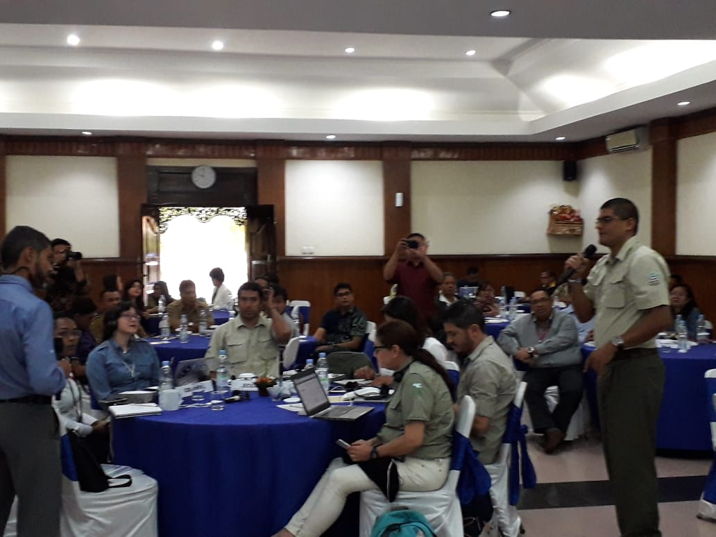
With the workshop, Indonesia NCC hoped that CT6 and South American countries will continue to coordinate, especially in terms of sharing experiences in the implementation of EAFM in their countries and foster cooperation in various fields of marine natural resource management in the future.
© CTI-CFF Regional Secretariat/Dr. Sharifah Nora Ibrahim/2018

Note: Further training in Columbia with CMAR was planned to be conducted in 2019, however, due to budget constraints, the CT6 have decided to put this on hold until further notice or if Partners are willing to support this activity.

Marine Protected Areas Working Group
- MPA Regional Exchange
Sorong and Raja Ampat, Indonesia
30 September – 5 October 2018

In this activity, the MPA TWG revisited and updated the MPA M&E indicators and database as well as their implementation. The group also discussed the criteria and the branding for Sustainable Marine Tourism in CTI-CFF MPA System. The intention is to come up with a unique ‘brand/image’ for MPAs in the CTI region district from other MPAs in the world. It will also serve as a guide for CT6 countries in the management of sustainable tourism in their respective countries.

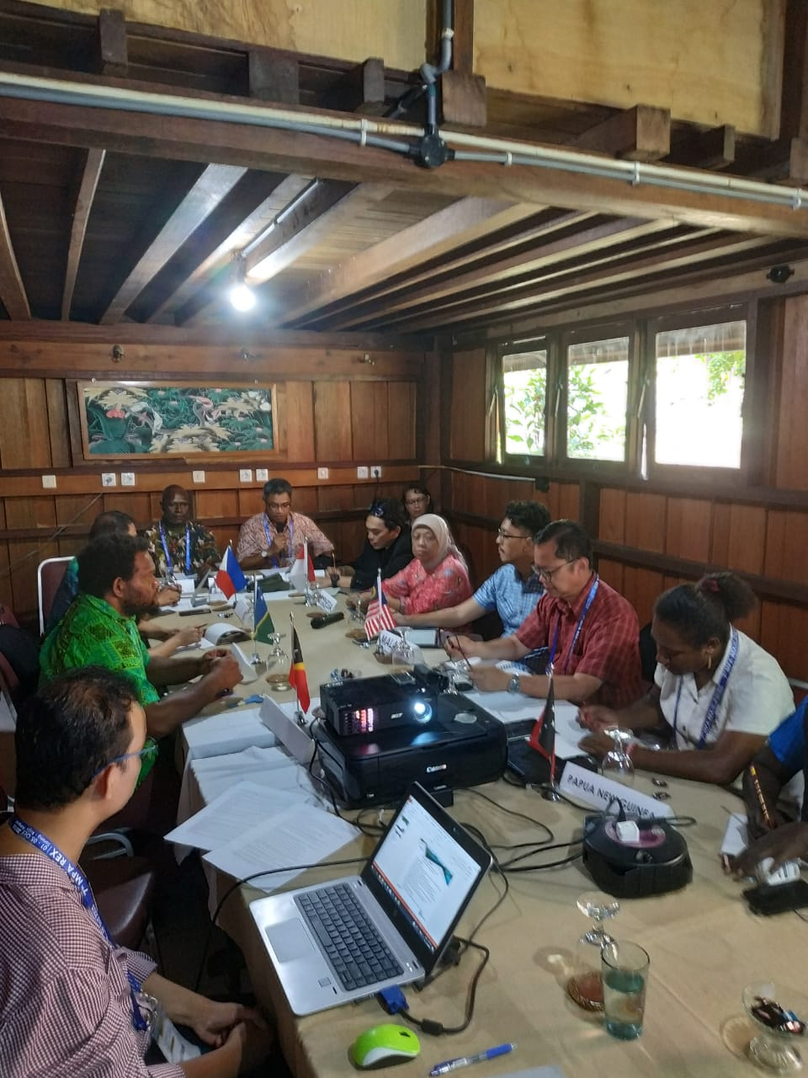
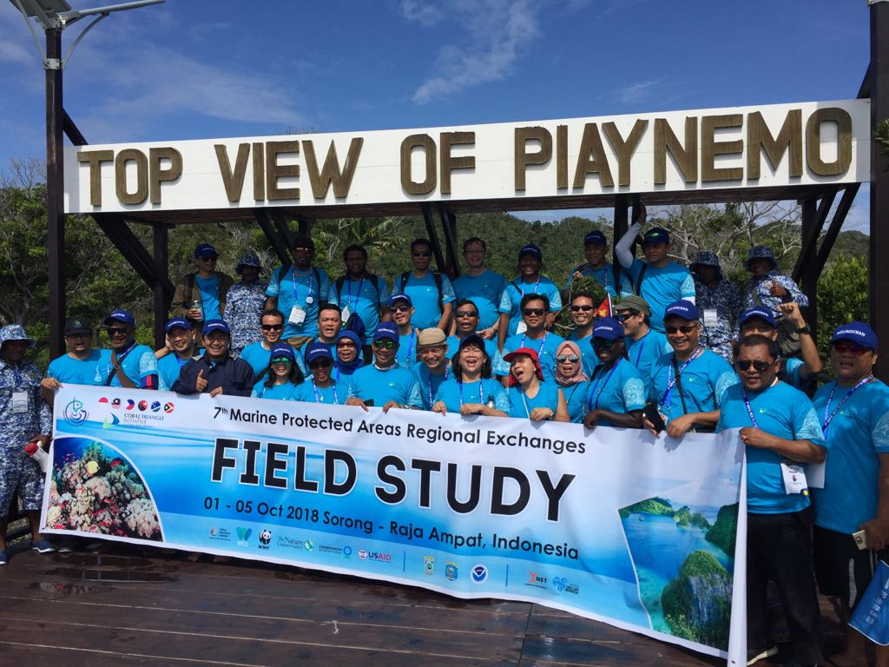
The following are decisions that came out of the 7th MPA-TWG meeting on the 4th October in Raja Ampat.
©CTI-CFF Regional Secretariat/2018
- The Meeting tasked the NCCs to update and submit the list of CT Atlas Focal Points to the Chair of MPA TWG.
- The Meeting tasked the Regional Secretariat to facilitate capacity building for the CT Atlas Focal Points
- The Meeting tasked the Regional Secretariat to resolve the issues in accessing the CT Atlas.
- Recommendation to extend the implementation of the roadmap for the third round of CTMPAS nomination until 2019 and to start the creation of the External Advisory Committee in November 2018.
- The Meeting recommended to invite the South Pacific Regional Environment Program (SPREP), International Union for the Conservation of Nature (IUCN), International Coral Reef Initiative (ICRI), Great Barrier Reef Authority (GRBA), James Cook University (JCU), and ASEAN Working Group on Coastal and Marine Environment to be part of the CTMPAS External Advisory Committee (EAC) to review and adopt the roadmap of the 3rd Round of CTMPAS nomination.
- The Meeting recognized and endorsed the program for the Recognition of Effectively Managed MPAs.
- The Meeting recommends that the Sustainable Marine Tourism Task Force begin their duties by reviewing the Global Sustainable Marine Tourism Council’s guidelines and criteria.
- The Meeting acknowledged the urgency to constitute the Sustainable Marine Tourism Task Force (SMT-TF) and request the NCCs to submit the names of their respective focal points to the Chair on or before November 9, 2018 for endorsement at SOM 14.
- The Meeting recognized the efforts and performance of the MPA Coordinator and recommend to Regional Secretariat and Partners for continuous engagement.

Climate Change Adaptation Working Group
- The 5th CTI-CFF Climate Change Adaptation Working Group Regional Exchange and Grant Workshop
Promenade Hotel, Kota Kinabalu, Sabah, Malaysia
10-13 April 2018
The activity recalled and reviewed the priority actions outlined in the REAP –CCA, both at the country and regional levels as well as discussed and assessed the status of implementation in order to identify what needs to be done to achieve the REAP objectives. It also developed and ﬁnalized the draft Terms of Reference for the establishment of the Regional COE on CCA; developed the course outline for the Executive Course on CCA designed for local governments based on the LEAP Guide; and strengthened or enhanced the skills of the participants in terms of proposal-writing to increase chances of winning grants to support the national CCA programs and activities.

Threatened Species Working Group (TSWG)
- The 1st Threatened Species (TS) Working Group Regional Exchange
Eastwood Richmonde Hotel, Quezon City, Philippines
24-26 April 2018
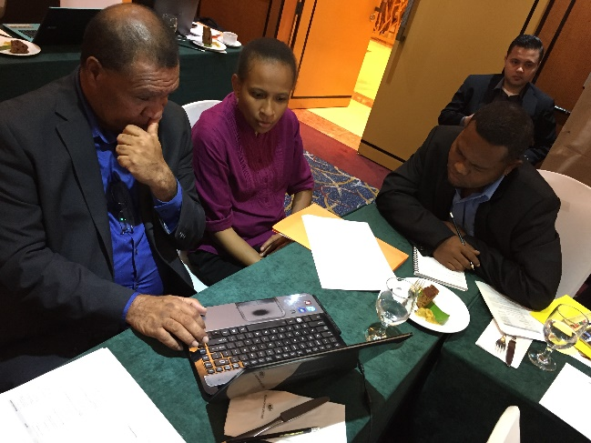
The meeting finalized the draft TOR for the creation of a pool of experts on threatened species and initiated the drafting of the TSWG M&E indicators. Additionally, the targets of Goal 5 were discussed particularly on how to complete the region-wide conservation plans on TS and the region-wide TS status report.
©CTI-CFF Regional Secretariat/2018
The activities were implemented based on the approved work plan of each working group. The work plan is formulated by each working group and endorsed to SOM for approval.

The implementation of the work plan is largely dependent on the availability of the budget and to some extent technical capacity and leadership.

GOVERNANCE WORKING GROUPS

Coordination Mechanism Working Group & Financial Resources Working Group
- Financial Resources and Coordination Mechanism Working Group Meetings
Jakarta, Indonesia
  - April 2018

The meeting brought together two (2) governance working groups to deliberate on internal CTI-CFF matters such as: (i) Staff Regulations & Rules and Procedures; (ii) Financial Regulations & Rules and Procedures; (iii) Budget 2018 and 2019; and (iv) Audit matters. Additionally, the meeting also deliberated and assessed the possibility of establishing an independent committee to oversee internal financial matters such as preparation of budget and audit. The meeting agreed for the Regional Secretariat to complete several tasks and report back to the CSOs within a set period of time.

- Special Senior Officials’ Meeting (S-SOM)
25 – 26 July 2018
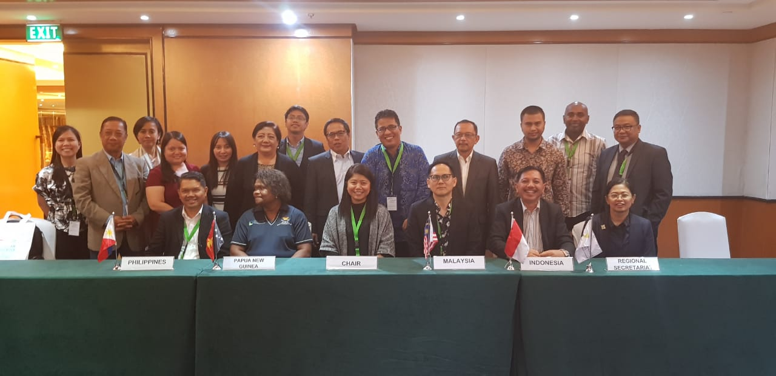
Quezon City, Philippines
©Philippines NCC/2018
A Special SOM was called by the Chair of CSO to deliberate and decide on several interim measures due to the resignation of the Executive Director, Widi A. Pratikto. These are: (i) Identify interim management measures to address operational challenges related to change in leadership of Regional Secretariat; (ii) Evaluate and decide on the proposed 2018 Budget of the CTI-CFF Regional Secretariat which was put on hold due to issues on financial management; and (iii) Discuss and present the proposed amendment of the Financial and Staff Regulations of the CTI-CFF Regional Secretariat.
Some pertinent points were the continued support from the U.S Government to fund and support several key consultants to evaluate and solve financial issues in the Regional Secretariat; acknowledge the efforts of the Acting Executive Director, Dr. Sharifah Nora Ibrahim; freezing of new staff appointments the request to the Government of Indonesia to designate an Interim Executive Director from Indonesia; approval for audit process to be implemented for 2017 and special audit to be done for the years 2014 to 2016 focusing on countries and Partners’ contributions. The Special SOM also expressed its gratitude to the US Government for the funding support.

Monitoring and Evaluation Working Group
- RPOA Review and Presentation of its Results
May – October 2018

The CTI-CFF through its Regional Secretariat assisted the RPOA Review lead consultant, Dr. Lida Pet-Soede in coordinating with NCCs, development partners and other stakeholders to carry out consultations for the Review. The Inception Report was submitted in June 2018 while the Final Report was submitted and presented to the RPOA Review Committee in October 2018 during the MEWG and FRWG Meetings in Jakarta, Indonesia.

The RPOA Review was led by Dr. Lida Pet Soede from the Marine Unit of PT Hatfield Indonesia while Dr. Sharifah Nora Ibrahim, CTI-CFF Regional Secretariat’s Deputy Executive Director for Program Services was the RPOA Review Manager. The RPOA Review was funded by the US Government together with the Australian Government ad Asian Development Bank, The Nature Conservancy, World Wildlife Fund, and Wildlife Conservation Society.

- Preparatory SOM.MM Meeting (MEWG & FRWG Meetings)
Jakarta, Indonesia
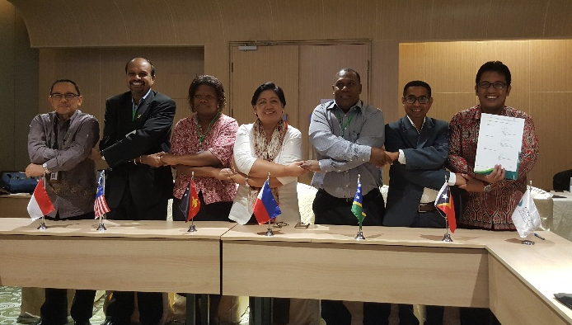
9-12 October 2018

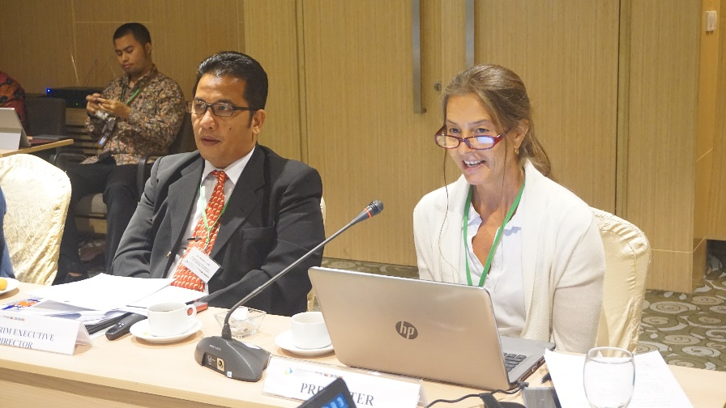
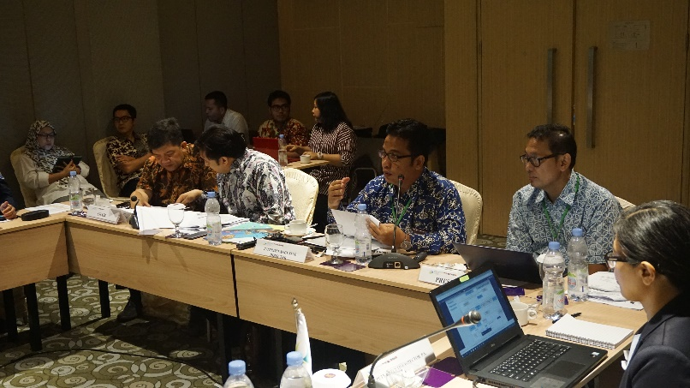
The meetings aimed to do the following: (i) to be briefed and to deliberate on the findings from the Review of RPOA activity and initiate discussion for the development of RPOA 2.0; (ii) to be briefed and to deliberate on the findings and recommendations of the Senior Strategic Finance, Administrative, and Operational Consultants; to approve the 2018 organization chart; (iii) to deliberate on and finalize the 2019 Organization Chart to be presented at the 14th Senior Officials’ Meeting (SOM-14) including discussion on the establishment of the Appointment Committee for the positions of the Executive Director and Deputy Executive Director (Corporate Services); (iv) to discuss and approve the 2018 financial forecast; budget for 2019 & forecast budget of 2020 as per Financial Regulation (3) on Budget; (v) to be briefed and to deliberate on Audit Reports findings (special audit for 2015 and 2016; and 2017 general audit); (vi) to finalize all four institutional and operational documents on: Financial Regulations; (Financial Rules and Procedures; Staff Regulations; and Staff Rules and Procedures; and to finalize pre-SOM; SOM-14 and the 7th Ministerial Meeting (MM-7) Agenda; including discussion on the handover process for incoming Chair of the Council of Ministers (CTI-COM) and Chair of the Committee of Senior Officials (CTI-CSO).
©CTI-CFF Regional Secretariat/2018

The Australian Government representative Dr. Andrew Chek presented on behalf of the development partners.

Key decisions made at this meeting was the acceptance of the RPOA Review findings and recommendations and agreed for this to put forward at the upcoming SOM-14 and MM-7 for acceptance. Other decisions were the acknowledgement and appreciation of the Acting Executive Director, Dr. Sharifah Nora Ibrahim; the acknowledgement of the Interim Executive Director, Dr. Hendra Yusran Siry; the lifting of the staff hiring process; acceptance of 2018 budget; acceptance of the findings from the audit process; and acceptance of the temporary proposed 2018 organization chart; and agreement of the revised 2019 organization chart for SOM-14 and MM-7 acceptance and endorsement.

The meeting also agreed and welcoming of the fact that the CTI-CFF spirit be brought back to the table, with the inclusion of Development Partners in programs and decision processes, and to re-evaluate the role of the Regional Secretariat.

The meeting was fully supported by the U.S. Government, and gratefully acknowledged.

- Meeting with the Director General of WorldFish - CT Atlas
8th November 2018
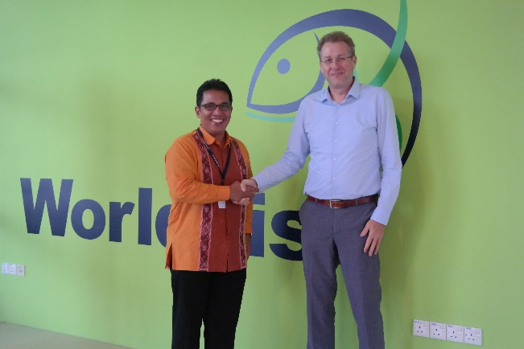
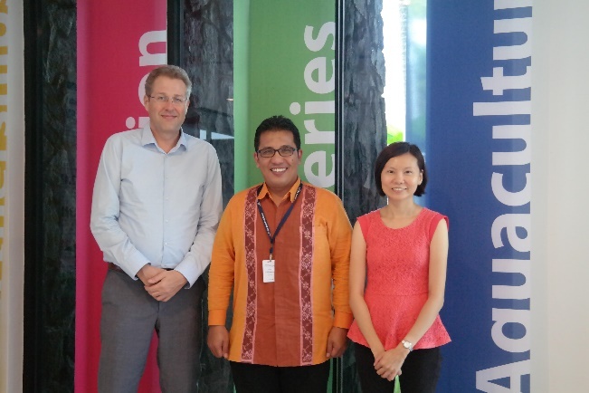
WorldFish, Penang, Malaysia
©CTI-CFF Regional Secretariat/2018
The meeting between the Interim Executive Director and the Director General of WorldFish is in response to the requests from all TWGs and members of CSO for the CT Atlas to be re-operationalized and maintained.
The meeting acknowledged that the CT Atlas is linked to the ReefBase database and WorldFish in principal, agreed that CT6 data in ReefBase can be migrated to CT Atlas when it is moved to Manado. A Concept Note shall be prepared for MEWG consideration that would describe a two (2) years program of redesigning, training and migrating the CT Atlas to the RS’s headquarter.
A Consultation or Planning Workshop and Business Plan with CT6 is being planned.

CROSS-CUTTING THEME WORKING GROUP

Local Government Network
- LGN Workshop - The Role of Local Governments in Sustainable Fisheries Management in Coral Triangle Areas
Jakarta, Indonesia
9 May 2018
A workshop was conducted for the local governments of Coral Triangle (CT) member countries namely, Indonesia, Malaysia, Papua New Guinea, Philippines, Solomon Islands and Timor-Leste to develop a local government plan of action that will ensure coastal and marine management and protection. Moreover, the workshop envisaged to localize the Ecosystem Approach to Fisheries Management (EAFM) and encourage other local governments to develop a plan that is aligned with the national and regional plans of action for the Coral Triangle.

The workshop was supported by the Coral Triangle Centre (CTC) through the USAID-DOI.
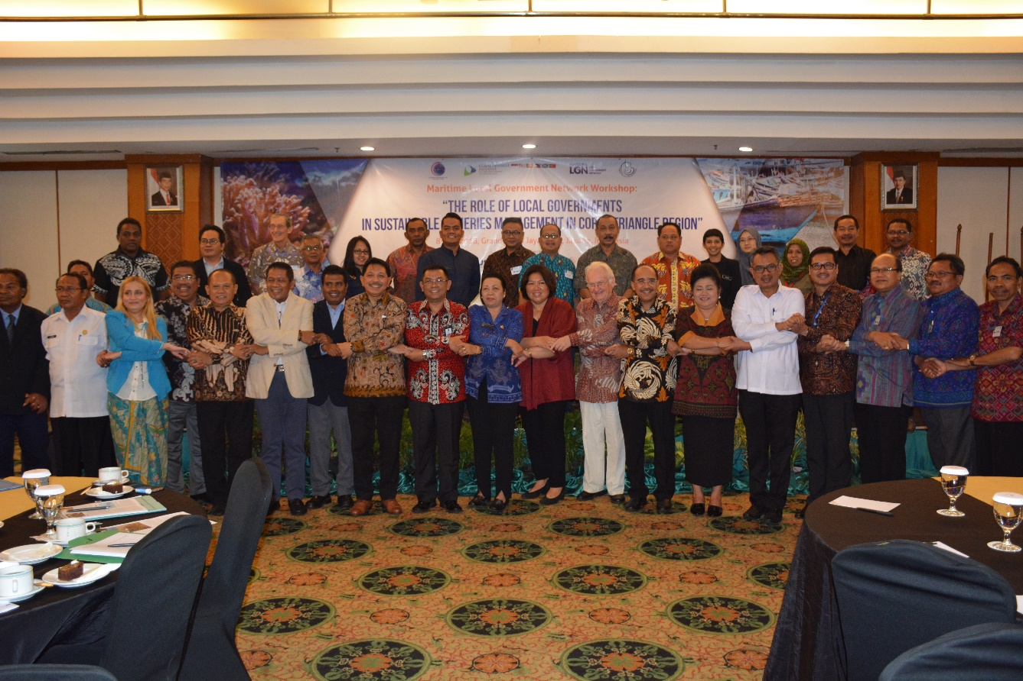
©LGN Coordinator/2018

Women Leaders Forum (WLF)
WLF Call Meetings: Several call meetings were conducted with CTI Partners to attempt at initiating the development of a CTI-CFF Gender Policy as per SOM-13 decision. A preliminary scoping report was prepared and found that indeed a CTI-CFF Gender Policy is critically needed to ensure mainstreaming of gender matters into program implementation and to drive the development and implementation of gender legislations. However, this would need full and committed participation by all CT6 with the support from Partners with adequate resources. A call would be made for all future CTI programs to incorporate gender elements and indicators at all stages of its implementation.
Intergenerational Learning: This leadership program is implemented by the Coral Triangle Centre (CTC) through the support from the U.S. Government. It was concluded at the recent Our Ocean Conference (OOC) on 30th October 2018 with a side event highlighting the work of the mentor-mentee pairs from the respective CT6 member countries. It was agreed that continued work to develop and empower more women leaders especially at the local community level is needed.

PARTNERSHIPS AND POTENTIAL REGIONAL PROGRAMS
The development partners have been very valuable in supporting and ensuring the sustainability of efforts by the CTI-CFF providing technical and scientific expertise; funding for priority conservation and sustainability projects; and activities at the regional, national and community levels. The following are activities implemented in collaboration with development partners:

USAID Strengthening Organizational and Administrative Capacity for Improved Fisheries Management (SOACAP)

- Activity 2.1: CTI-CFF Public Private Partnership Preparation: Expert Consultation Meeting on PPP design and arrangement
Aryaduta Hotel, Jakarta, Indonesia
4-5 April 2018
The activity was aimed at introducing and building better understanding concept of PPP in sustainable fisheries to CT member countries through National Coordination Committee of CTI-CFF; develop better and suitable PPP arrangement which allows member countries to actively participate in the development of PPP activities related to improve sustainable fisheries practices i.e. CDT systems in seafood value-chains; and establish a quasi PPP task force to assist development and preparation of countries PPP proposals and arrangement.
The consultation meeting was attended by representatives from the CT6 member countries. Resource persons were PPP specialists namely, Ms. Lisa Peterskovsky (GIZ), Mr. Koichi Yamashita (JICA), Mr. Michael Abbey (NOAA Fisheries), Mr. Kongpathai, Dr. Yuttana Theparoonrat (SEAFDEC) Mr. Geronimo Silvestre, Ms. Araya Poomsaringkan, Mr. Len Garces, and Mr. John Parks (The Ocean and Fisheries Partnership), Mr. Craig Kirkpatrick (USAID RDMA), Mr. Ryan Yulhendri and Mr. Syarif Syahrial (Directorate of Venture Capital Management).

Observers were from USAID Sustainable Ecosystems Advanced, USAID Indonesia, US DOI, US-DOI-ITAP and WWF.

- Activity 1.2 Learning Exchanges for CT6 Countries at USAID Oceans Learning Site
Manado-Bitung, North Sulawesi, Indonesia
25-28 June 2018
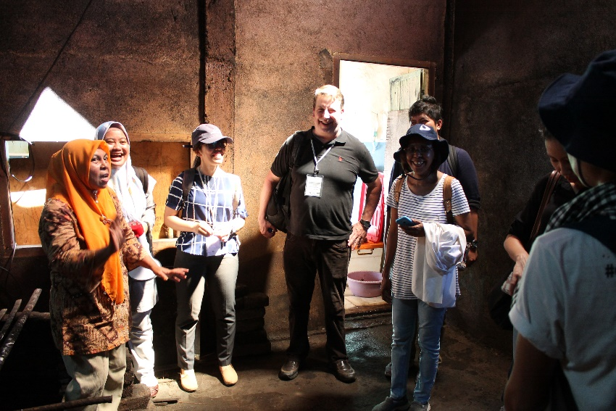
The CTI-CFF Regional Secretariat and the USAID Oceans have partnered to conduct a learning exchange focusing on the application of catch documentation and traceability (CDT) system for fisheries and seafood products. In the Learning Exchange, participants gained insights on the implementation of the USAID Oceans self-developed CDT schemes at one of their sites in Manado, Indonesia.
©USAID Oceans/Melinda Donnelly/2018
They learned how CDT systems can be properly developed, implemented and integrated into their local fisheries development plan.
The Learning Exchange is part of the many activities lined up under the Strengthening Organizational and Administrative Capacity for Improved Fisheries Management (SOACAP IFM) partnership program between the CTI-CFF Regional Secretariat and USAID through its US Department of Interior. The SOACAP-IFM is a plan aligned with USAID Oceans and Fisheries Partnerships (USAID Oceans) and USAID SEAFDEC project towards strengthening regional cooperation to combat illegal, unreported and unregulated (IUU) fishing, promote sustainable fisheries, and conserve marine biodiversity in the Asia-Pacific region.

Other Regional Cooperation Activities

- Third Targeted Regional Workshop for GEF IW projects in east Europe and Asia-Pacific
The Chatrium Hotel, Bangkok, Thailand
30 April – 2 May 2018

Together with the International Commission for the Protection of the Danube River (ICPDR), the International Union for the Conservation of Nature (IUCN) and the United Nations Industrial Development Organization (UNIDO), as well as representatives from Partnerships in Environmental Management for the Seas of East Asia (PEMSEA) and the Capturing Coral Reef & Related Ecosystem Services (CCRES) project, the workshop was held for capacity building on several topics. These topics are on Knowledge Platforms, Innovative Tools, Legal and Institutional Frameworks, Benefit Sharing, and Economic Valuation.
- Ocean and Fisheries Partnership Technical Working Group Planning
Bangkok, Thailand
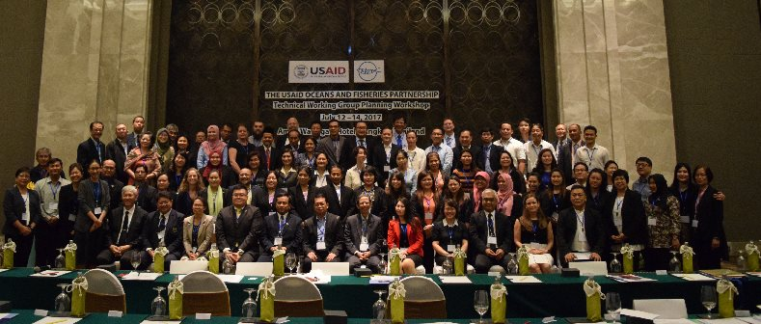
16-18 July 2018
© Oceans/Melinda Donnelly/2018

The CTI-CFF Regional Secretariat participated in the USAID Oceans organized activity that convened its Regional Technical Working group members, partner organizations and
US government representatives to gather inputs for the development of a set of regional guidelines on the adoption and use of electronic catch documentation and traceability system (e-CDT) that would support sustainable fisheries management, human welfare, and leverage public-private partnership.

- Maritime Environmental Security - US Pacific Command Maritime Fusion
Cell Table Top
Manado, Indonesia
31 July- 3 August 2018

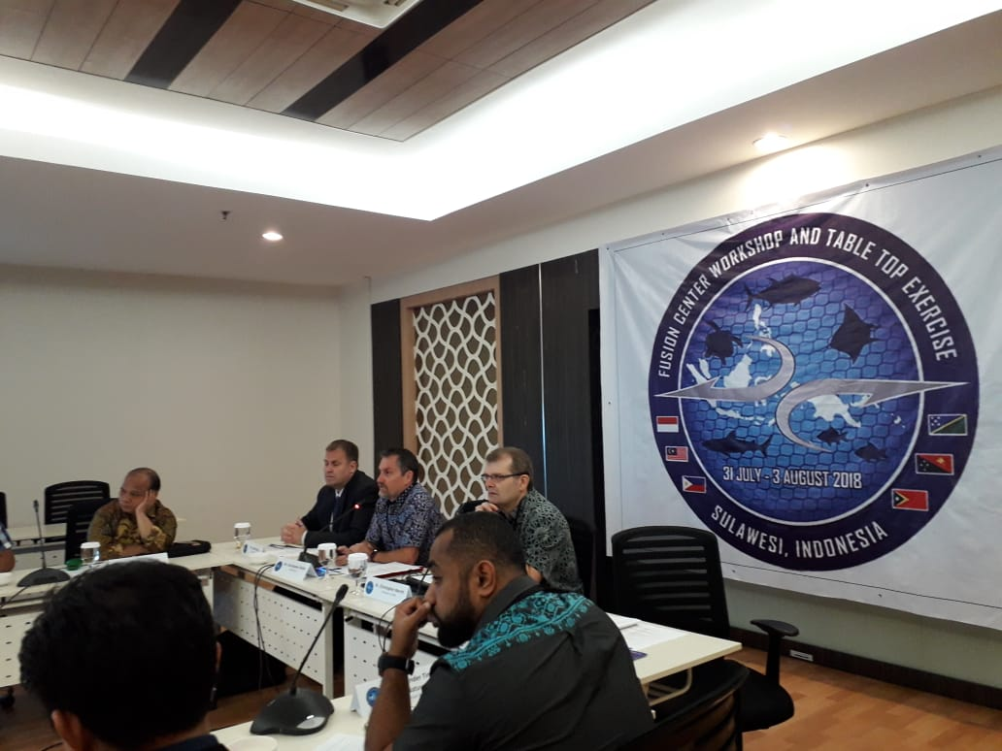
US INDOPACOM hosted the 2018 Fusion Center Workshop and Table Top Exercise at the Coral Triangle Initiative Headquarters in Manado, North Sulawesi, Indonesia: 1-2 August 2018.
©USINDOPACOM/2018
The table-top exercise (TTX), which demonstrated the value of information sharing for countering Illegal, Unregulated and Unreported (IUU) Fishing, advanced maritime domain awareness and information sharing among Indo-Pacific partners.

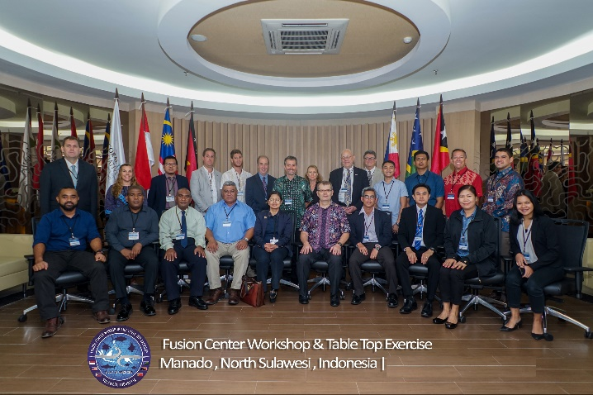
This approach allowed partners to consider information sharing of a non-contentious topic. Additionally, the workshop emphasized the importance of marine environmental protection which is of shared interest to our regional partners. Of most importance, it demonstrated that environmental security and maritime domain awareness are intrinsically linked. The workshop emphasized the following:

- The benefits of information-sharing internationally through national Data Fusion Centers, and
- The link between IUU fishing and other transnational crimes including wildlife trafficking, human trafficking, and drug smuggling.
- The link between Environmental Security and Maritime Domain Awareness (MDA).

US INDOPACOM’s environmental security program will continue to advance fusion center development and data sharing concepts in the region. Future workshops will incorporate this message and emphasize the link between environmental security and MDA. The program team will further facilitate linkages between stakeholders and subject matter expert exchanges.

- Managing Reef Resilience Under Climate Change in the Sulu-Sulawesi Marine Ecoregion (SSME)
Manado, Indonesia
7-9 May 2018

Marine experts and conservation experts from Australia, Indonesia Malaysia, and the Philippines gathered for a three-day workshop towards a transboundary management strategy for coral reefs and fisheries within the Sulu-Sulawesi Marine Ecoregion (SSME). Also, they discussed the problems coral reefs are experiencing under climate change and how they affect fisheries and people’s livelihoods.
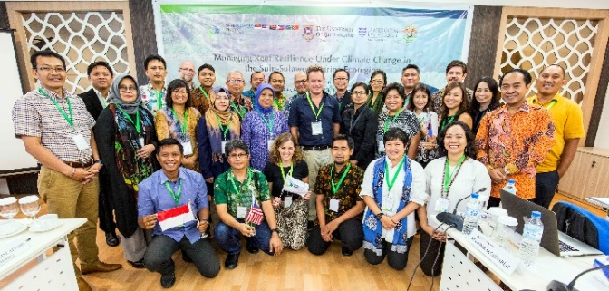
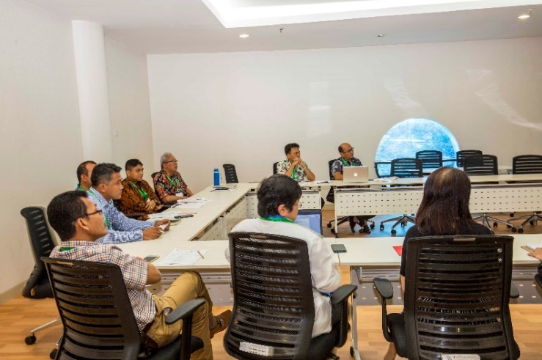
The three-day workshop was organised by University of Queensland, James Cook University and Hasanuddin University in cooperation with CTI-CFF Regional Secretariat and other university partners - Deakin University, University of Borneo, University of Malaysia Sabah, University of the Philippines, and University of Sam Ratulangi.
©CTI-CFF Regional Secretariat/2018

A project proposal in light of this workshop was prepared by Prof. Peter Mumby of Queensland University and shall be further taken up by the Seascape TWG for further process through GEF-7 cycle.

- Managing Reef Resilience Under Climate Change in the Bismarck Solomon Marine Ecoregion (BSME)
Brisbane, Australia
13-15 August 2018
Scientists, managers and conservation practitioners from CT member countries namely, Papua New Guinea, the Solomon Islands and Timor-Leste as well as selected Australian Universities namely, James Cook University, Deakin University and Queensland University gathered at James Cook University Campus in Brisbane, Australia to discuss the needs and feasibility of developing a transboundary management strategy for coral reefs and fisheries within BSME.

©CTI-CFF Regional Secretariat/2018
The 3-days workshop particularly identified issues and challenges facing reefs and associated fisheries within the BSME region, both at regional and national level and how these can be translated into a proposal for implementation.

The activity was also an opportunity for CTI-CFF to raise appreciation and understanding on the value of a ‘seascape’ approach to marine resource management in the context of BSME.

- 41st Meeting of the SEAFDEC Program Committee (41PCM) and 21st Consultative Group of the ASEAN-SEAFDEC Strategic Partnership
Langkawi, Malaysia
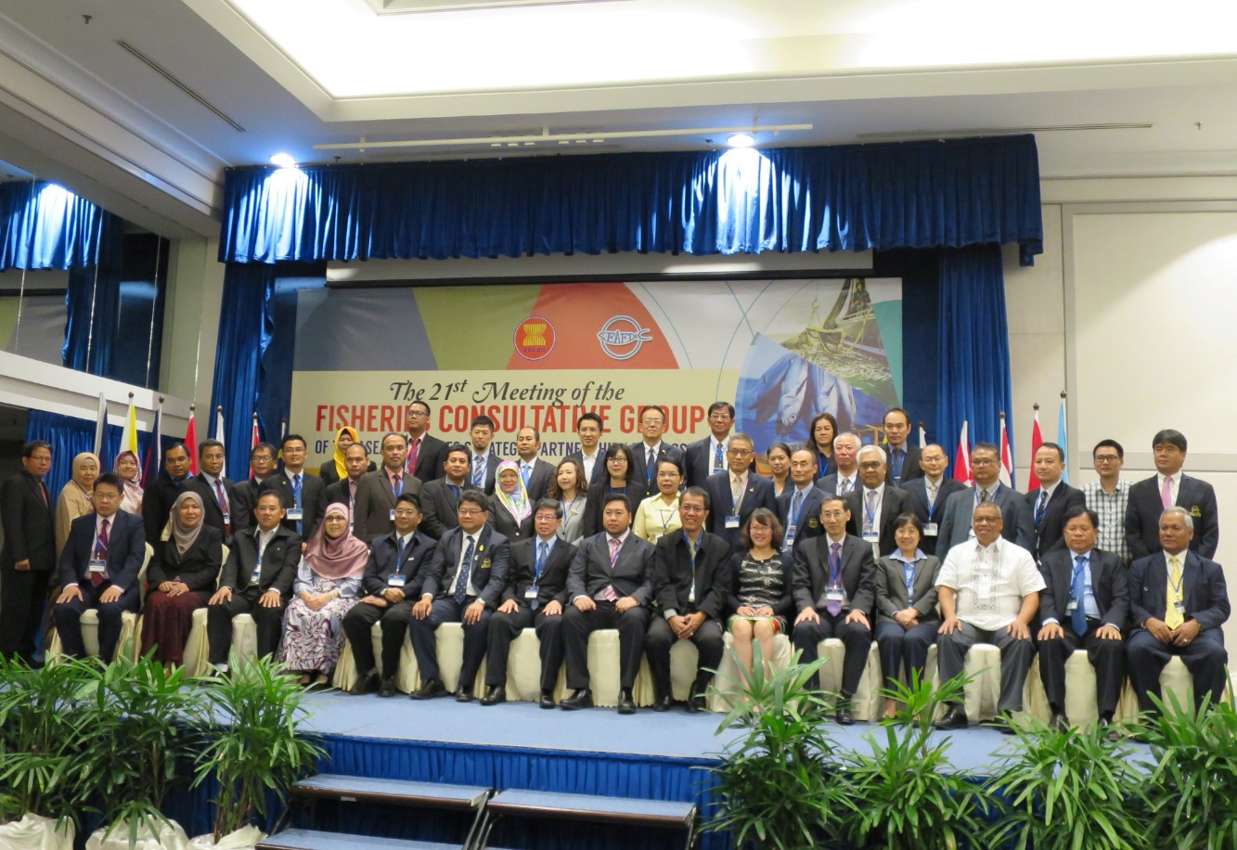
5-7 November 2018
©SEAFDEC/2018
The meeting was aimed at reviewing the programs of SEAFDEC that have been implemented through the year 2018 and discuss new projects and activities for the coming year 2019.
CTI-CFF was invited as a partner to SEAFDEC through the Memorandum of Understanding (MOU) signed in 2015 for a five (5) years period. The CTI-CFF was represented by the Interim Executive Director, Dr. Hendra Siry where he made an intervention to call for focus on the issue of illegal trade of Live Reef Fish for Trade (LRFFT); and to work closely with SEAFDEC on activities that would benefit the CT6 countries such as capacity building trainings and workshops particularly in EAFM practices.

- Courtesy Meeting to the Maritime Institute of Malaysia (MIMA)
Kuala Lumpur, Malaysia
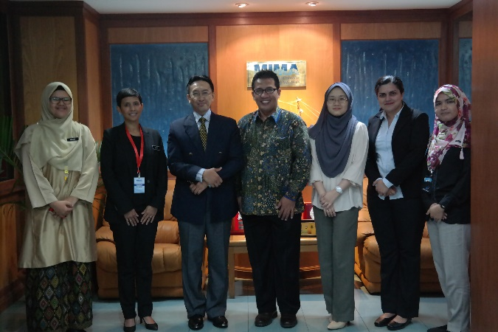
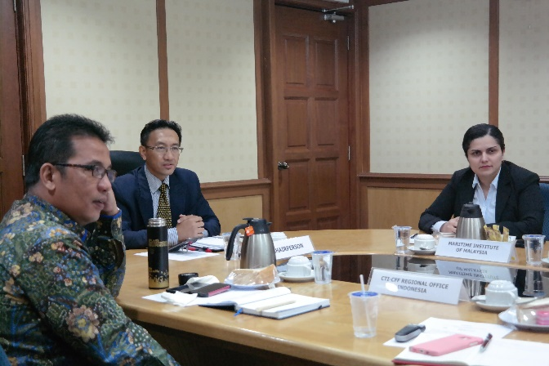
9th November 2018
© Regional Secretariat/2018
The courtesy meeting to the Deputy Director General, Dr. Rizal Abdul Kadir at the Maritime Institute of Malaysia (MIMA) was also attended by NCC Malaysia representatives.
The meeting agreed that MIMA can be one of policy resource organizations both for Malaysia and to contribute to CT6 discussions through the various Technical Working Groups and esspecially during the development of RPOA 2.0 phase.
MIMA’s niche areas are similar to the goals and objectives of the CTI-CFF and thus able to leverage of its vast network across the countries and in the region to add value to CTI-CFF.

PARTICIPATION IN INTERNATIONAL/REGIONAL EVENTS
The CTI-CFF through its Regional Secretariat participated in the following events in order to share information and promote goals of the CTI-CFF to other regional groupings that share or in congruence with the goals of the CTI. Moreover, the CTI has participated in these activities to build new alliance and attract support to the initiatives of the CTI.

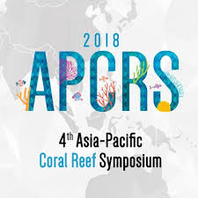
- 4th Asia-Pacific Coral Reef Symposium 2018
Cebu City
4-8 June 2018
The Asia Pacific Coral Reef Symposium provided a forum for scientists, educators, managers, environmentalists, and relevant local stakeholders from key organizations in the Asia-Pacific region to share their knowledge and experiences on all aspects of coral reef biology, ecology, management, and conservation.
The activity was organized by the Marine Protected Areas Network.
Dr. Crisanta Marlene P. Rodriguez, DENR’s Biodiversity Management Bureau Director and CTI-CFF MEWG Chair and Prof. Peter Mumby from University of Queensland were two of the speakers at the event.
Dr. Rodriguez said in a pre-conference that through ‘effectively reducing the drivers and pressures on coastal and marine ecosystems, which led to its continuous degradation, the coastal and marine ecosystem’s condition will improve thereby enhancing ecosystem functions and services. (From DENR-V webpage)

- Pacific SIDS Regional Preparatory Meeting
Nuku’alofa, Tonga
19- 21 June 2018

The Regional Secretariat joined representatives of the Small Island Developing States (SIDS) in the Pacific met in Nuku’alofa, Tonga, from 19 to 21 June 2018 in preparation for the inter-regional preparatory meeting.
The Meeting provided an invaluable opportunity for SIDS in the Pacific to share their national experiences and best practices as well as identify opportunities to address major challenges at this important juncture in the implementation process. The SIDS also emphasized the importance of full ownership and leadership of their sustainable development priorities with the support of global and regional partners. This was discussed under the three broad pillars of: sustainable development as well as the means of implementation including through partnerships.

- Sustainable Ocean Initiative – Convention on Biological Diversity Workshop
Jakarta, Indonesia
31 July – 3 August 2018
In this forum, the CTI-CFF through its Regional Secretariat expressed commitment to contribute towards the achievements of Aichi Biodiversity Targets 10 and 11 and the Priority Actions during the Convention on Biological Diversity Sustainable Ocean Initiative (CBD-SOI) Sub Regional Capacity-Building Workshop Coral Triangle.
The CBD Aichi Target 10 and its Priority Actions are very similar to the past and current activities of the CTI-CFF member countries in working together to sustain the extraordinary coastal and marine resources in the Coral Triangle by addressing crucial issues such as food security, climate change and marine biodiversity.
©CBD-SOI/2018
Particularly, the CTI-CFF committed to provide the enabling environment for better articulation and coordination among marine environment-related national strategies and action plans of its member countries

- Our Ocean Conference 2018
Bali, Indonesia
29-30 October 2018

The CTI-CFF through its Regional Secretariat participated in the 5th Our Ocean Conference particularly in the following activities:

Hosting and organizing of the following two (2) Ocean Talks:
- Ocean Talk “Strategic Direction for Coral Triangle: Update and Way Forward for Regional Plan of Action

This OCEAN TALK provided information on the RPOA review in a talk show format – the findings and recommendations and discussions on the potential ways forward in the RPOA 2.0. The ‘host’ was Dr. Lida Pet Soede, RPOA Review Lead Consultant with notable panelists, namely: Prof. Dr. Ove Hoegh-Guldberg, Director of the Global Change Institute at the University of Queensland; Dr. Sharifah Nora Ibrahim, Deputy Executive Director of the CTI-CFF Regional Secretariat; Dr. Nagulendran a/l Kangayatkarasu, UnderSecretary and head of the Strategic Technology and Application Division for the Ministry of Energy, Science, Technology, Environment and Climate Change (MESTECC) of the Government of Malaysia; Mrs Agnetha Vave-Karamui, is Chief Conservation Officer at the Environment, Conservation Division (ECD), Ministry of Environment, Climate Change, Disaster Management; Meteorology (MECDM) of the Government of the Solomon Islands; and Mr Farid Maruf – Catch documentation and traceability specialist for The Oceans and Fisheries Partnership (USAID Oceans).
©Dr.Lida Pet-Soede/2018

- Ocean Talk “Legacy for Coral Triangle – Towards International Recognition for Marine Megabiodiversity Area”

This OCEAN TALK provided information and awareness to the Coral Triangle Initiative Member Countries and others on:
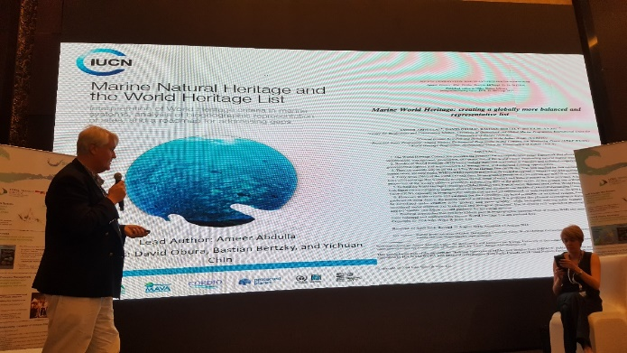
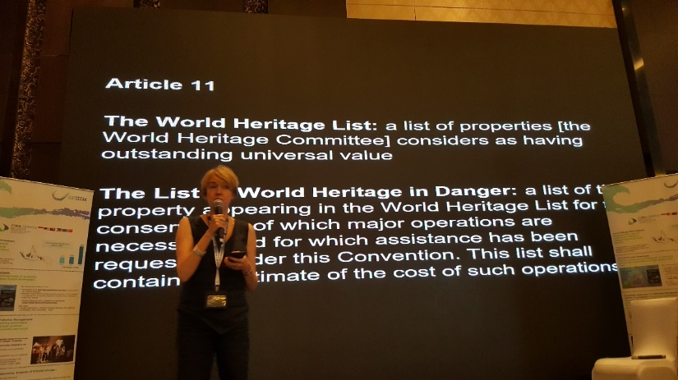
  - the ecological, socioeconomic, cultural and other benefits of Listing unique CT marine areas that fulfils the requirements as a marine World Heritage Site (mWHS) under the UNESCO World Heritage Convention;
©CTI-CFF Regional Secretariat/Jasmin Saad/2018
  - the ecological, socioeconomic, cultural and other benefits of unique CT marine areas that are vulnerable to damage from maritime activities or international shipping to receive special protection as a Particularly Sensitive Sea Area (PSSA) under the
  - International Maritime Organization (IMO);
  - the procedures on how to go about the above, in achieving international recognition;
  - Ways on how to involve coastal communities and women in the areas; and
  - Ways on how to achieve sustainable funding for the WHS and/or PSSA.

Notable speakers were Dr. Fanny Douvere, UNESCO’s Coordinator for Marine Programme World Heritage Center, Mr. Carl Gustav Lundin, IUCN’s Director for Global Marine & Polar Programme, Dr. Sharifah Nora Ibrahim, CTI-CFF Regional Secretariat Deputy Executive Director, and Dr. Vladimir Ryabinin, the Executive Secretary of IOC-UNESCO.

- Side event: Women Leaders, Breaking Waves in Ocean Conservation
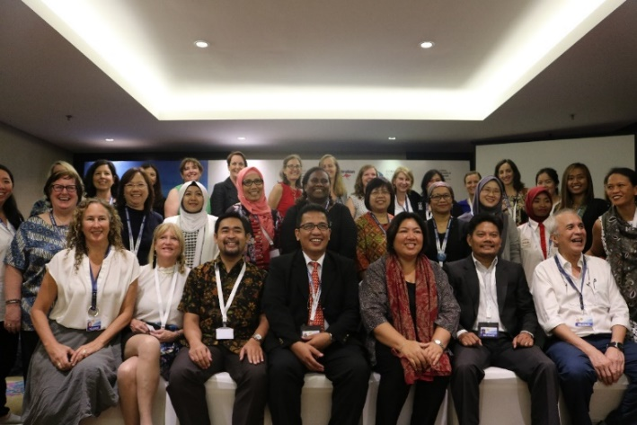
©USAID Oceans/Melinda Donnelly/2018
The forum focused on the leadership qualities of successful women leaders and was aimed to gain inspiration, insights and tools that can guide other women leaders around the globe in charting their own path in protecting our oceans.

The CTI-CFF Regional Secretariat supported the event with Coral Triangle Center as organizer.

Pledges of Commitment

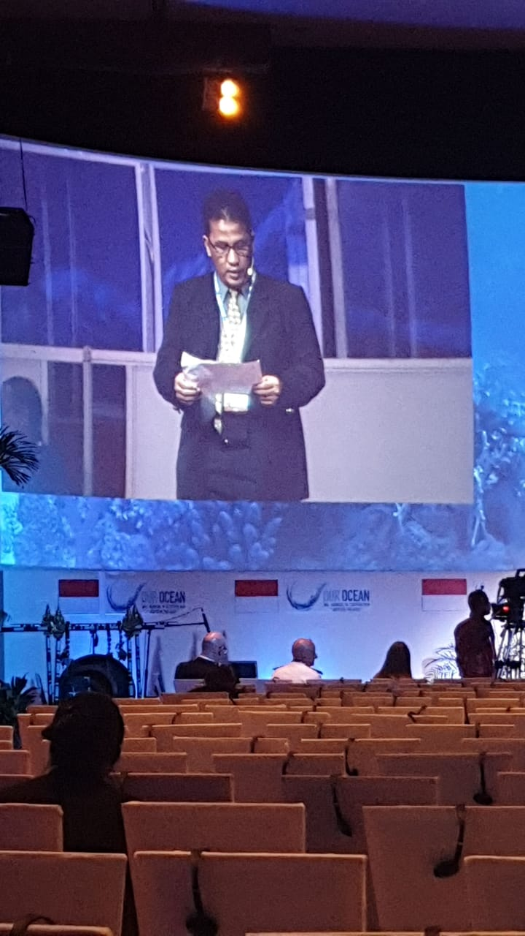
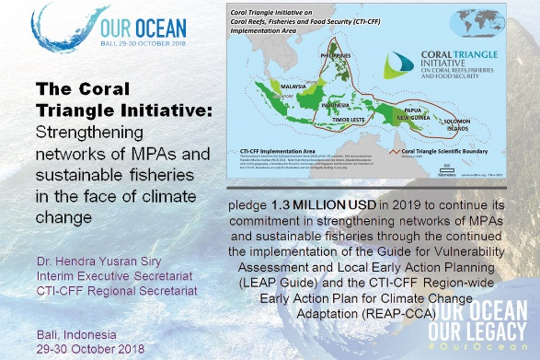
The CTI-CFF also pledged its commitment in different areas of action identified in the OOC namely, blue economy, MPAs, and sustainable fisheries. Particularly, CTI-CFF signified the following commitment:
©Indonesia NCC/Imam Fitrianto/2018
- to promulgate an improved Regional Plan of Action (RPOA) for the next decade (2020 – 2025);
- to facilitate the improvement policy on the Life Reef Fish Trade in the CTI region in 2019;
- to facilitate the CT6 countries to achieve the Convention for Biological Diversity (CBD), Aichi Target 11, Priority Actions, and Sustainable Development Goal (SDG) 14.5;
- to introduce the principles of marine World Heritage Sites (WHS) and Particularly Sensitive Sea Area (PSSA) to the CT6 countries and to encourage and facilitate the process of nomination for Tentative Listing for certain unique sites of the Coral Triangle area as one of global mega marine biodiversity.
v. Inter-Regional Partnership Dialogue
Samoa
29 October – 1 November 2018
The CTI-CFF Regional Secretariat participated in the Inter-Regional Partnership Dialogue, held in Apia, Samoa. The activity intends to review the progress and implementation of the Samoa Pathway at the national and regional levels.

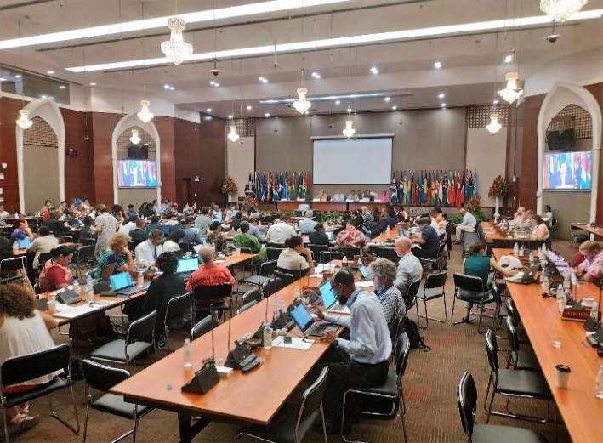
These meetings were being facilitated and supported by UN-DESA through the SIDS Unit, OHRLLS and by relevant agencies of the UN system including regional Commissions.
©CTI-CFF Regional Secretariat/Dr. Gregory Bennett/2018

The discussions were built on the outcomes of three regional partnership dialogues, with the overall objective to advance the SAMOA Pathway and the 2030 Agenda for Sustainable Development in SIDS by increasing the capacity of stakeholders in forging new, genuine and durable multi-stakeholder partnerships, and strengthening the monitoring and review process of partnerships in SIDS.

Corporate and Financial Management Activities
The CTI-CFF through its Regional Secretariat values the support and contribution of each CT6 member countries and its development partners in order to implement identified plans and activities towards realization of RPOA goals.
The Regional Secretariat facilitated the appointment of an independent audit firm to conduct special audits for 2014 to 2016 and full audit for 2017 financial transactions of the CTI-CFF. Assistance was rendered by the USAID Strategic Financial Consultant during the audit bidding analyses onwards. The final audit reports were sent to CT6 member countries in early November 2018.
The Regional Secretariat received a big support from the USAID to engage a Strategic Financial and Administrative Consultant to assist and provide interim guidance as well as recommendations on corporate and financial management activities of the Regional Secretariat.

COMMUNICATION AND OUTREACH ACTIVITIES
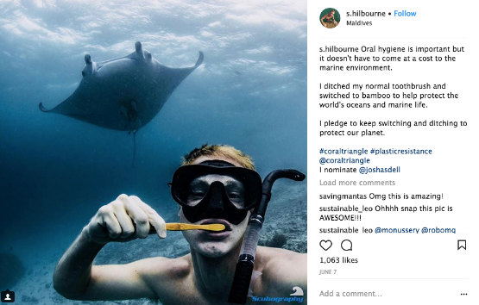
The CTI-CFF through its Regional Secretariat conducted communication and outreach activities to promote the organization’s activities to all internal and external CTI-CFF stakeholders. Various communication activities and strategies were implemented to be able to reach a wider audience. Activities implemented were as follows:

- Coral Triangle Day Celebration
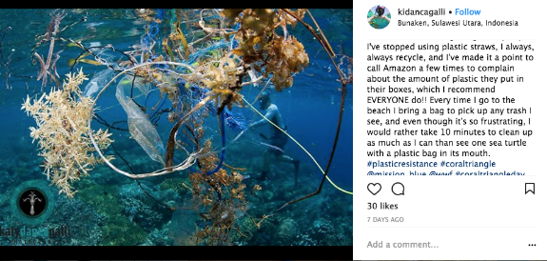
This year, the CT Day celebration focused on increasing awareness on the impacts of plastic on marine environment and the destructive wastefulness of single use plastics such as straws, coffee cup lids, cotton buds.
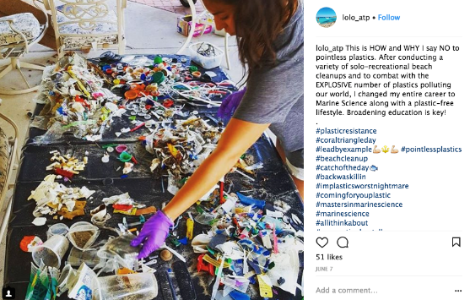
WWF in partnership with the CTI-CFF Regional Secretariat launched the Instagram contest last May 2018 to encourage Instagram users to show how they are helping to cut out single-use plastics by tagging their photo or video with #plastic resistance and #coral triangle. The Instagram contest attracted a total of 447 entries and ran until June 22. Winners were from UK and USA. The contest was supported by Raja Ampat’s Papua Diving Resort, Scuba Junkie Borneo, Conservation International, Mission Blue, Matador Network, Connect4Climate, and Bye Bye Plastic Bags.

- Bimonthly production of CTI-CFF Newsletter
The CTI-CFF Regional Secretariat produces bimonthly CTI-CFF Newsletter that features activities of TWGs, and NCCs as well as development partners. It also highlights profile of identified experts in marine conservation field. The newsletters are distributed to subscribers.

- Preparation and dissemination of Press Releases
To promote the activities/projects and other initiated efforts of the CTI-CFF to a wider public, the Regional Secretariat produces and disseminates press releases to 19 online news organizations in the CT Region.

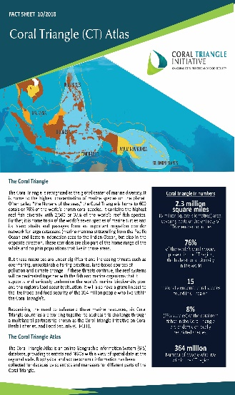
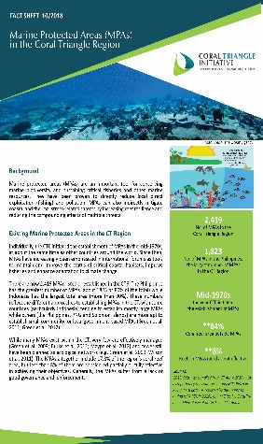
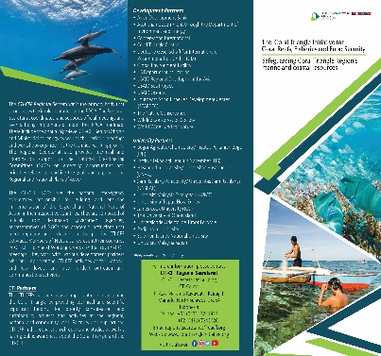
- Regular updating/maintenance of CTI Website and Social Media Platforms
Activities of the CTI are regularly posted in CTI Website and social media platforms to further inform website visitors of latest undertakings of the CTI as well as upcoming events.

- Production of IEC/Promotional Materials
To complement information drive in social media, the CTI-CFF produced (and will produce) information materials such as brochures and fact sheets. These print materials are made available in exhibitions as well as on CTI website. In the development of the IEC materials, the following were considered: relevance, uniformity, simplicity of the content and language, accuracy of information, length of the material, cultural appropriateness and target audience.

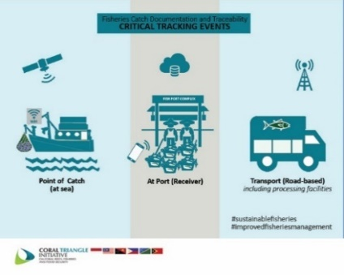
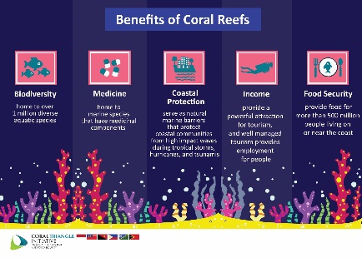
- Development of infographics
The CTI-CFF Regional Secretariat developed infographics about e-CDT, CT Day MPAs, IYOR and Sulu-Sulawesi Seascapes. The infographics are supplemental tools to allow people to easily digest information about CTI-supported initiatives through the use of visual data and statistics through proper use of color, proportion and space. The infographics were uploaded in all CTI social media accounts.

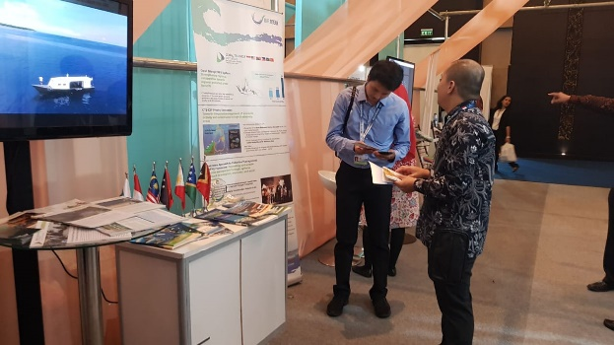
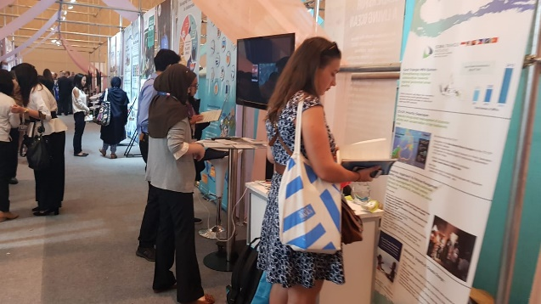
- Participation in International Exhibition
©CTI-CFF Regional Secretariat/Wiwin Joko Winarbo/2018
The CTI-CFF through its Regional Secretariat participated in the Our Ocean Conference 2018 exhibition on 29-30 October 2018 in Bali, Indonesia. Participating in exhibits helps promote the accomplishments as well as future activities of the CTI ‘closely’ to a targeted audience in a face-to face manner (interacting with exhibit visitors). It also promotes learning audience’s interests and queries about CTI activities.

PLANNED NOVEMBER & DECEMBER 2018 ACTIVITIES

1. Sustainable Blue Economy Conference
November 26-29, 2018
Kenyatta International Convention Centre
Nairobi, Kenya

Brief Description: The 2030 Agenda for Sustainable Development outlines strategies to protect aquatic ecosystems and communities’ marine resources. These strategies show global leaders how to meet development goals and create an inclusive, productive and sustainable future for all. Participants will discover:
  - The importance of marine protected areas in blue economy planning
  - How sustainable development furthers social progress and economic growth
  - How to meet the goals outlined by the 2030 Agenda for Sustainable Development
  - The challenges facing us as we move towards a sustainable economy, and how to work together to overcome them

The CTI-CFF shall be represented by the Interim Executive Director, Dr. Hendra Siry through the support from United Nations.

2. 33rd International Coral Reef Initiative (ICRI) General Meeting
December 5-7, 2018
Yacht Club de Monaco, Monaco

Brief Description: The meeting will discuss four themes – (1) promotion of effective and adaptable solutions to improve the protection of coral reefs; (2) understand the trends of coral reefs/Global Coral Reef Monitoring Network (GCRMN); (3) Live Reef Fish Trade (LRFT) and fisheries; and (4) Help to reduce anthropogenic threats to coral reefs, particularly those that occur at a global or regional scale.
The meeting will also welcome new members and observers. Apart from CTI-CFF, the Coral Triangle Center and Vulcan Inc have submitted membership application to ICRI.
Participation Objective: The CTI-CFF presence and participation is mandatory as the CTI-CFF will be accepted as one of ICRI members.

